**Green Production of Terephthalic Acid for the Synthesis of PETE**

By Team 3: Timothy Chen, Qingyuan Liu, Tom Sikorski, and Yiqi Wang

A design and economic evaluation of a novel process involving the green synthesis of p-xylene using isobutanol as a feedstock for use in production of TPA.



## **Abstract**

Recently, Triozim has been contracted by ABC plastics to evaluate the possibility of finding novel methods for the sustainable production of TPA for manufacture of “green” PETE pellets. Herein presents the documentation of a design of a novel approach that can be used for the production of green PETE from isobutanol. The proposed process is the synthesis of TPA from isobutanol in two major steps. The first step is the conversion of isobutanol to p-xylene which is then oxidized in the next step into polymer grade TPA for the synthesis of PETE. Due to time constraints, a detailed design was only performed on the synthesis of p-xylene from isobutanol with a preliminary TPA production scheme drawn based on a modified AMOCO process. This p-xylene synthesis involves the use of three reactors. The first is a multitubular reactor that uses an acidic **γ-**alumina catalyst to perform a dehydration reaction. Isobutene, the product from the previous reaction, is fed into a reactive distillation column where it is oligomerized into di-isobutylene in the presence of a Ni-Al2O3 catalyst. The di-isobutylene then undergoes dehydrocyclization to produce p-xylene, hydrogen, as well as a variety of side products. Through a series of separations, 99.7 % and 99.5% by weight p-xylene was produced. The process was scaled to run with a 26000 kg/hr inlet feed mixture of isobutanol and water; projecting to handle 145 million kg of isobutanol and produce 58 million kg of p-xylene every year. Economic analysis was done under two scenarios: selling p-xylene as the product and selling TPA as the product, by assuming there is a downstream process that oxidizes the p-xylene produced into TPA. By basing production on the works of another team (Free Radical Engineering), the combined process was projected to produce 45.8 million kg of TPA every year. Based on current isobutanol and p-xylene this project has a NPV value of -$52.31 million. Despite the apparent negative returns, the process is expected to be profitable when fossil fuel supplies dwindle in the future. When isobutanol prices are lower than $0.37/kg or p-xylene prices is above $1.77 /kg then the proposed project breaks even.

## **Acknowledgements**

Team 3 would like to thank Free Radical Engineering (Team 5) for useful discussion of economics and Team 6 for help with simulation. Team 3 would also like to thank Malek Ibrahim and Troy Vogel for useful insight and criticism in the design of the process. They always ask useful questions and have directed us toward the next step in our project. Their help has greatly improved the design of this project.

## **Table of Contents**

## **Nomenclature**

**Chapter 1:** Introduction (TS, TC)

1.1. What is Polyethylene Terephthalate? ……………………………...................8

1.2. Standard Production Method of PETE …………………………....................8

1.3. Synthesis of Terephthalic Acid and the AMOCO Process .....……………….9

1.4. Global Fossil Fuel Shortage ………………………………………………...10

1.5. Green Synthesis Methods of Terephthalic Acid …...……………………….12

1.6. Isobutanol Based Production of p-Xylene ...………………………………..15

**Chapter 2:** Process Overview and PFD (TC, TS, YW)

2.1. PFD for Conversion of Isobutanol to p-Xylene …………………………….17

**Chapter 3:** Results of Simulation (TC, TS)

3.1. Overview of Simulation Methodology……………………………………...28

3.2. Thermodynamic Model Selection…………………………………………...30

3.3. Use of component separators………………………………………………..31

3.4. Simulation of Reactors………………………………………………………32

3.5. Results of Optimization……………………………………………………..33

**Chapter 4:** Design Justification (TC, QL, TS)

4.1. Summary of p-xylene to TPA Design……………………………………….54

4.2. Catalyst Selection……………………………………………………………55

4.3. Reactor Selection……………………………………………………………55

4.4. Material of Construction…………………………………………………….56

4.5. Process Operating Conditions……………………………………………….56

4.6. Production of Value-Added Products……………………………………….57

4.7. Process Walkthrough………………………………………………………..58

**Chapter 5:** Economic Analysis (TC, TS)

5.1. Equipment Sizing……………………………………………………………62

5.2. Overall Capital Investment………………………………………………….76

5.3. Cost of Manufacturing………………………………………………………77

5.4. Profitability Analysis………………………………………………………..79

**Chapter 6:** Environmental, Health, and Safety Concerns (YW)

6.1. P&ID of Reactor………………………………………………………….....84

6.2. P&ID of Distillation Column………………………………………………..84

6.3. Chemical Safety……………………………………………………………..86

6.4. Process Hazard Analysis (PHA) …………………………………………....88

6.5. AICHE Safety Module Certifications……………………………………….89

**Chapter 7:** Sustainability (TS)

7.1. Isobutanol:Current and Future Production…………………….…………….94

7.2. Governmental Research Grants……………………………………………..94

**Chapter 8:** Conclusions (TC) …………………………………………………………………..95

**Appendix A:** PFD Review Summary…………………………………………………………...96

**Appendix B:** Alternative Designs……………………………………………………………….97

**Appendix C:** Sample Calculations………………………………………………………………98

**Appendix D:** Equipment Costs………………………………………………………………...100

## 

## 

## 

## **Nomenclature**

**Greek:**

αE - Engineering

αFIT - Freight

αL - Labor

αM - materials

α0 - Overhead

ϵbead - porosity of the catalyst bead

ϵbed - porosity of catalyst bed

μ -dynamic viscosity

ρcarbon - density of activated carbon

⍴H -density of heavy liquid phase

⍴L - density of light liquid phase

ρliquid - liquid stream density

ρPt - density of Platinum

ρvapor - vapor stream density

𝛕holding - decanter holding time

σ - surface tension

ΔTlm - Log mean temperature

Δpvessel - total pressure drop over the reactor

**Latin:**

A - area

A - Constant

Ac - cross-section area

Ad - area of downcomers

Atube - tube surface area

Al2O3 - Aluminum Oxide

B - Constant

BHET - bio-hydroxyethyl terephthalate

BP - British Petroleum (Company Name)

bp – boiling point

C - Carbon

C - Constant

CBM - Bare Module

C0BM - Base Bare Module

CGR - Grass Roots

C0p,I - purchase cost

CA - corrosion allowance

CBA - carboxybenzaldehyde

CCF - Cumulative Cash Flow

CEPCI - Chemical Engineering Plant Cost Index

ChemCAD - Simulation software name

COM - cost of manufacturing

C8 - Molecules contain 8 carbon

Cu - Copper

D Constant

D - Diameter

Dbead - diameter of the catalyst bead

Dc - estimated diameter of the column

Ddecanter - diameter of decanter

Dhorizontal - diameter of the flash tank cross-section area

Dvessel - diameter of the reactor

DIB - di-isobutylene

DMF - Dimethylformamide

DMT- dimethyl terephthalate

dP - change of pressure with respect of change of reactor length

E- Constant

EG - ethylene glyco

fflood - flooding factor

FBM – Bare Module Factor

FLV - liquid-vapor flow factor

FM – Material construction factor

FP- Pressure Factor

FCI - fixed capital investment

hdistillation - total height of the distillation column

hliquid - spacing height for holding liquid in the column

hreboiler - height for reboiler return

hskirt - height of the skirt added to the column

htray - tray spacing

htop - spacing height for vapor disengagement

htotal - height of flash tank

Hdecanter - Decanter length

HAZOP - hazard and operability study

HMF - Hydroxymethylfurfural

Kdrum - flash tank constant

k1 - capacity factor

k1,adjusted -  constant factor for distillation column

kflash - constant, equals to 4.

Lvessel - length of the reactor

LATE - Latent Heat (Model name)

mbead - mass of one catalyst bead

Mcat - total mass of the catalyst

Mvapor -  mass flow rate of vapor stream

Mliquid -  liquid stream mass flow rate

MACRS - Modified Accelerated Cost Recovery System

MWvapor - molecular weight of vapor stream

Nvapor - molar flow rate of vapor

Nnp-Number of processing units defined as compressors, towers, reactors, heaters, and exchangers

Ni - Nickle

NPV - net present value

PBR - Packed Bed Reactor

PETE - polyethylene terephthalate

PFD - Process Flow Diagram

PSRK - Predictive SRK (Model Name)

P-Pressure

Pt - Platinum

P&ID - piping and instrumentation diagram

Ru - ruthenium

Scarbon - volumetric fraction of activated carbon

SPt - volumetric fraction of Platinum

SCDS - Simultaneous Correction Distillation System

SCDS Column - Reaction column type in ChemCAD software

SRK - Soave-Redlich-Kwong (Model Name)

tmin- minimum vessel thickness

TIB - tri-isobutylene

TPA - terephthalic acid

uf - flooding velocity

uoperating - operating vapor stream flow velocity

uperm - the maximum permissible vapor velocity

UNIFAC - UNIQUAC Functional-group Activity Coefficient (Model Name)

UNIFAC LLE - UNIFAC Liquid-Liquid-Equilibria (Model Name)

UNIQUAC - Universal Quasichemical

vstream - volumetric flow rate

vheavy - volumetric flow rate of heavy phase liquid

Vcat - unpacked volume of total catalyst

Vdecanter - volume of the decanter

Vpac - volume of packed catalyst

VLE - Vapor Liquid Equilibrium

4’-CBA – 4’-Carboxybenzaldehyde

**Chapter 1: Introduction**

1.1. What is Polyethylene Terephtalate?

Polyethylene terephthalate, or PETE, is one of the most common types of polymers and holds considerable importance in the world’s plastic industry. Its lightweight, impact resistance, and chemical resistance make it an ideal material for use in food packaging and plastic bottles. PETE also finds widespread use in the textile industry where it is commonly referred to as polyester [1]. The synthesis of PETE was first patented by Dupont chemists John Whinfield and James Dickson in the 1940’s while they were searching for a new synthetic polymers that could be used to make textile fibers [2]. The production capacity of PETE in 2012 was estimated to be 28 million tons, with an annual production of 19.8 million tons. The global PETE production in 2015 was estimated to reach 24.39 million tons and is expected to continue increasing [3]. PETE is a copolymer (Figure 1.1) of monomers ethylene glycol (EG) and terephthalic acid (TPA), or dimethyl terephthalate (DMT) can substitute for TPA.

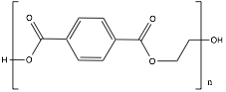

**Figure 1.1.** Structure of polyethylene terephthalate

### 1.2. Standard Production Method of PETE

The typical method to produce PETE is by repeated reactions between terephthalic acid (TPA) and ethylene glycol (EG). The two chemicals undergo a condensation reaction, where water is the molecule lost, while going through esterification vessels to form the monomer bio-hydroxyethyl terephthalate (BHET). Following the reaction in the esterifiers, BHET is pumped into polymerization reactors where it produces PETE [4]. This reaction which produces PETE is shown in Figure 1.2.

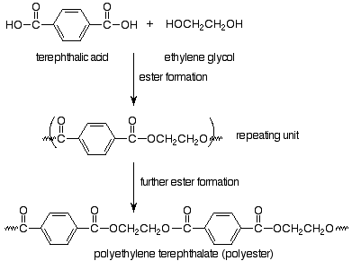

**Figure 1.2.** Chemical reaction for the formation of PETE [5].

### 1.3. Synthesis of Terephthalic Acid and the AMOCO Process

The main way to produce TPA is to convert p-xylene into TPA through the oxidation of the methyl groups on p-xylene into aldehydes and then carboxylic acids. Currently in industry the main source of obtaining p-xylene is to separate it out from other C8 (benzene, toluene, xylene isomers, etc.) compounds obtained from petroleum refining. One way this is done, is to use an absorber to create a medium-purity p-xylene stream which then enters a low temperature crystallization process to produce crystals. Next the crystals are centrifuged and melted to give out highly pure p-xylene [6].

If the oxidation of p-xylene is not completed, it will produce p-toluic acid, where only one side is a carboxylic acid, and 4-CBA, where one side is a carboxylic acid and the other is an aldehyde, along with the TPA product [7]. Figure 1.3 shows the oxidation from p-xylene to TPA. Different ways of oxidizing and separating byproducts can be seen in various processes to achieve the purity levels required to produce PETE. Three somewhat common ways to produce TPA from p-xylene are the Mitsubishi process, the AMOCO process, and the Eastman process. All three methods use a catalyst and acetic acid as a solvent. The primary difference between the three processes is how they oxidize p-xylene.

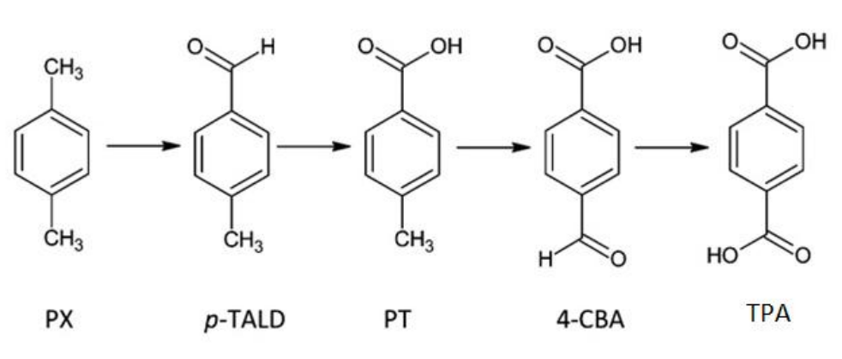

**Figure 1.3.** Representation of the oxidation steps from p-xylene to TPA [7].

The Mitsubishi process has two oxidation reactors with the second operating at a higher temperature. The heating in this second reactor increases the solubility of TPA; while the crystals dissolve, 4-CBA is released into solution. This allows for the completion of oxidation thus reducing the concentration of 4-CBA in the product. However, this process only produces medium quality TPA and the increased temperature causes acetic acid to oxidize more into carbon oxides [8]. The Amoco process only includes one oxidizer reactor, unlike the other processes. It is currently the most popular process in industry to produce TPA due to the good yield and low solvent loss in a single reactor pass. In order to get the resulting TPA pure enough for PETE, a purification section is included. To reduce the amount of 4-CBA in the product, hydrogenation is used to convert the 4-CBA to p-toluic acid, which can then be separated from TPA much easier. This purification process however, is responsible for a significant amount of costs and environmental burden in the process [9]. The Eastman process follows the main oxidation reactor with a centrifuge to remove a few impurities before the product enters post oxidizers to further oxidize the solution where it then sends the stream to another specialized process to convert the medium to high quality TPA to PETE. While the Eastman process is newer than the others, it is starting to increase in popularity [10].

### 1.4. Global Fossil Fuel Shortage

The continued synthesis of TPA from petroleum based p-xylene is not a sustainable process. It is widely accepted that the world’s oil reserves will run dry within several decades. A statistical review done by BP estimated the world’s reserves to production ratio of various countries as well as the world as a whole. The ratio represents the number of years it will take oil reserves to run out for a given location assuming current production rates.

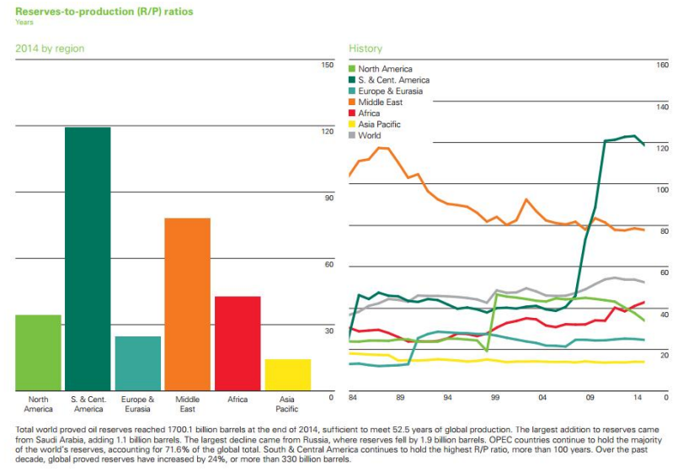

**Figure 1.4.** Reserves to production ratio from 2015 BP Statistical Review [11]

From Figure 1.4 it is apparent that although varied from country to country, oil reserves are finite. The world reserve to production ratio is estimated to be around 50 years whereas most of the world with the exception of South and Central America and the Middle East will run out before then. While one may argue that more oil reserves are always being discovered, Figure 1.5 shows that the global energy consumption has also continuously risen as well, making this an unreliable method for sustainability.

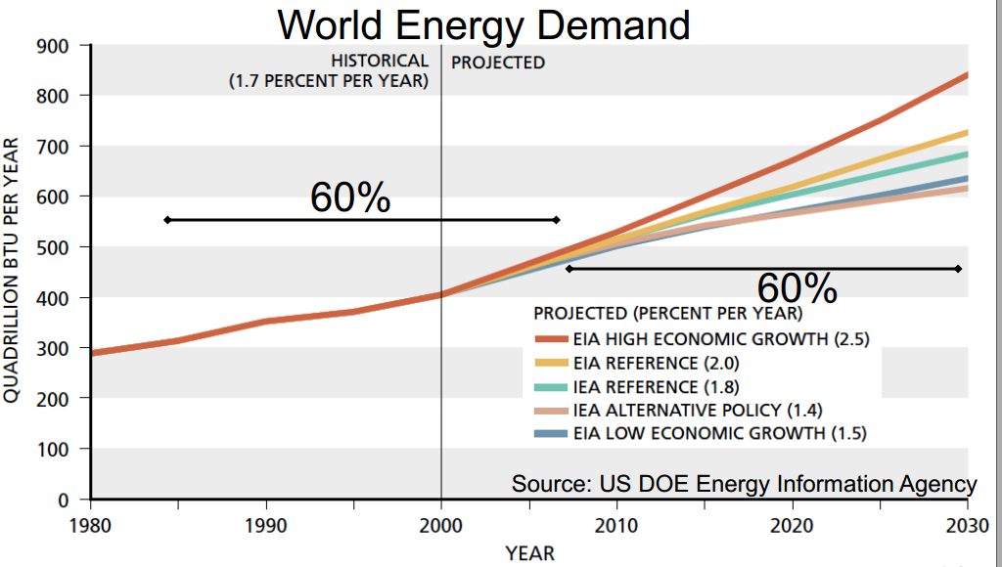

**Figure 1.5.** 2000 Study by US Department of Energy on World Energy Demand

The unequal oil distribution in the world is yet another reason why making p-xylene from green sources is attractive. Since, as shown in Figure 1.6, the Middle East has a large quantity of known oil reserves, oil may need to be exclusively imported from them in the future, making the price oil extremely sensitive to political turmoil. Consequently, the price of PETE will be driven up to under these circumstances as the price of p-xylene will also increase. Reviewing historic oil prices shows that this concern is not simply speculation either. The price of oil has been highly dependent on the occurrence of conflict within the Middle East (Figure 1.7). To avoid issues with price instability or even a cease in oil imports, a sustainable “green” approach for TPA production is proposed.

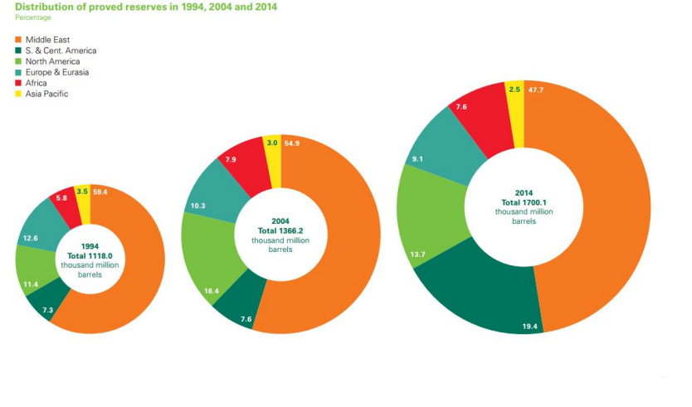

**Figure 1.6.** Distribution of proven oil reserves from 2015 BP Statistical Review [12].

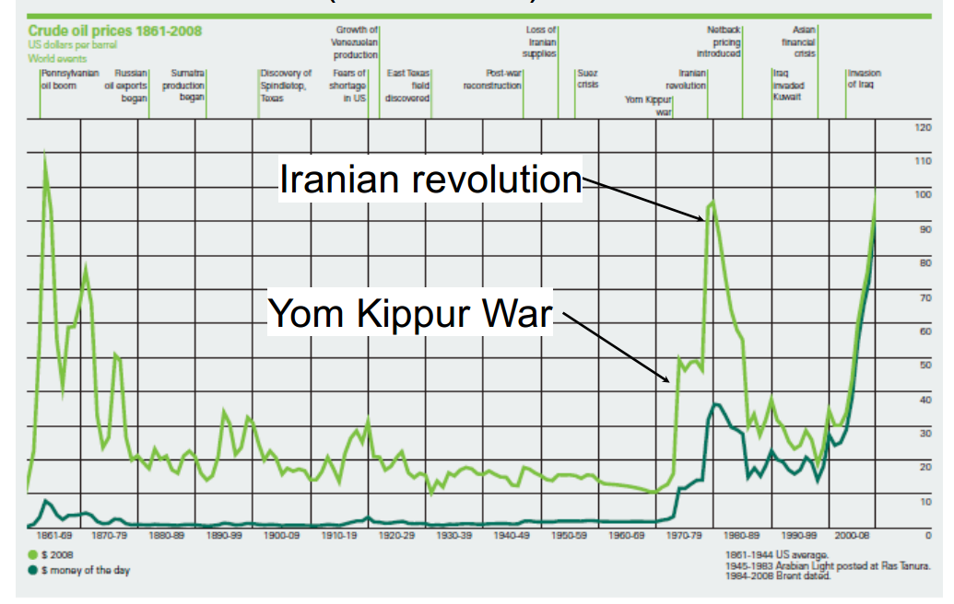

**Figure 1.7.** Historic price of oil has been greatly influenced by conflict within the Middle East [52].

### 1.5. Green Synthesis Methods of Terephthalic Acid

Seven green approaches for the synthesis of TPA were investigated. The seven approaches were: synthesis of TPA from bio-ethylene, from hydroxy-methyl furfural, from isobutanol, via pyrolysis, from isoprene and acrylic acid, from limonene, and from furfural. However, the latter four approaches could be quickly dismissed due to some problems with the availability of feedstock or poor reaction yield with current catalyst technology.

The synthesis of p-xylene via pyrolysis, isoprene and acrylic acid, limonene, or furfural all had fundamental flaws in their processes. At first glance, the pyrolysis approach appears enticing as the feedstock used in pyrolysis is plant waste material such as corn stover, which is available at very low costs. Pyrolysis involves the direct conversion of biomass into aromatic compounds via thermal degradation over catalysts [14]. The key feature of this approach is that it can take solid biomass directly to p-xylene in a single step. However, an innumerable number of side products are produced in great amounts making separation very difficult. Not only is separation difficult, the amount of p-xylene formed is 9% of the amount of feedstock inputted [14]. While this is a single step conversion to p-xylene, this process is not feasible unless large scale biorefineries become commonplace, in which case p-xylene would only be one of many chemicals produced. For a plant dedicated to in-house synthesis of TPA, this approach would not be suitable.

The synthesis of p-xylene from isoprene and acrylic acid is made infeasible due to the high cost and corrosive nature of the feedstock [15]. Although the synthesis of TPA from limonene is very simple, as it is structurally similar to p-xylene, obtaining limonene in large quantities is difficult. To make matters worse, the already small amount of limonene available has many competing uses in industry. Finally, the synthesis of TPA from furfural is not feasible because of extremely complicated reactions and low experimental conversion yield; the development of many novel catalysts that result in better yield is necessary for this process to be competitive.

The synthesis of TPA from bio-ethylene seemed promising and was seriously considered. In this process, ethylene is derived from dehydrating ethanol which has a variety of ways in which it can be mass produced from biomass. Bio-ethanol production is currently at a state where it could be seriously used as a feedstock and produce p-xylene at prices competitive with petroleum based p-xylene. However, that is assuming the reactions all have high yield and selectivity which is not the case. One of the steps in this synthesis is a Diels-Alder reaction for the cyclization of hexadiene molecules which forms a p-xylene precursor. This particular reaction has many side products that are difficult to separate from unwanted diene – dienophile pairings. Other side reactions that can occur can result in unstable intermediates which poison the catalyst [14].

The synthesis of p-xylene from hydroxymethyl furfural has the advantage of having high conversion yield in its steps. However, the feasibility of commercialization is still challenging due to the high cost of HMF, which is hydrolyzed and dehydrated from biomass. In addition, a majority of the capital and operating cost for a HMF based facility comes from purchasing and regenerating Cu-Ru/C catalyst. The catalyst is used for the hydrogenation of HMF to DMF (Figure 1.8). HMF is not a particularly popular chemical in that it is commonly found and used in small quantities at the laboratory scale, and there is relatively little large scale production of HMF. Finally, the side products formed in the conversion of HMF to p-xylene have not found use in industry and would not be able to be sold as value-added products [15].

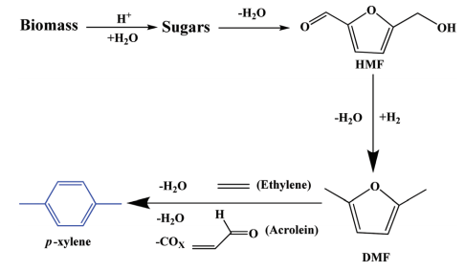

**Figure 1.8** Synthesis of p-xylene from HMF. Schematic taken from [15].

A promising route is the synthesis of p-xylene from isobutano9 (Figure 1.8). Synthesis of p-xylene from isobutanol has already been applied to a pilot scale by with the development of fermentation of biomass to isobutanol. One downfall of a fermentation produced isobutanol approach is that the feedstock, typically starch, has competing uses in the food market, which limits the economic feasibility. In addition, current fermentation techniques do not allow for cost effective production of isobutanol nor the use of substrates other than starch. An advantage of producing p-xylene from isobutanol is that many value-added side products such as o-xylene and toluene are formed which could be purified and sold to help offset the cost of the isobutanol feedstock. Currently, the estimated cost of p-xylene from isobutanol is $3,481 per metric ton which accounts for the selling of value-added side products. For comparison, the HMF pathway produces p-xylene at $3961 per metric ton, and petroleum based p-xylene is at $1,630 per metric ton [16].

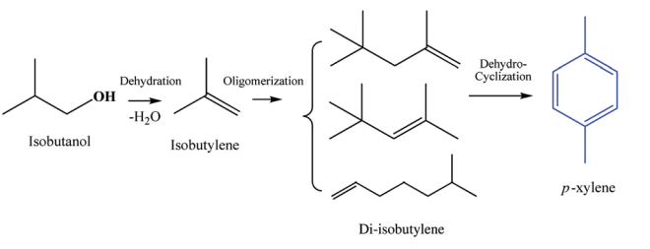

**Figure 1.9.** Synthesis of p-xylene from HMF. Schematic taken from [15].

A process was designed for the conversion of isobutanol to p-xylene. The prospect of future isobutanol production is better than that of HMF. Whereas HMF is not commonly used, isobutanol has potential uses as a gasoline alternative and could one day be mass produced, driving down its cost. In addition, there are already governmental grants supplementing the development and research of second generation biofuels which include isobutanol [17]

1.6. Isobutanol Based Production of p-Xylene

The production of p-xylene occurs in three steps: dehydration, oligomerization, and dehydrocyclization. In the dehydration step, isobutanol is dehydrated into isobutene, or isobutylene, and water. Figure 1.10 from Taylor et. al shows a mechanism for this process. This reaction takes place over acidic catalyst such as alumina with the hydroxide group being protonated in the first step of the reaction. The major side product of this reaction is linear butene [12].

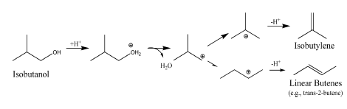

**Figure 1.10.** Simple reaction mechanism for the dehydration of isobutanol.

The second step is the oligomerization of the isobutene into di-isobutylene which typically takes place over acidic ion-exchange resin catalysts, like a styrene-divinylbenzene-based support with sulfonic acid group active sites [18]. In Figure 1.11, the two different di-isobutylene molecules produced in the main oligomerization reaction can be seen; major potential side products from this reaction are the subsequent trimerization or even tetramerization of isobutene.

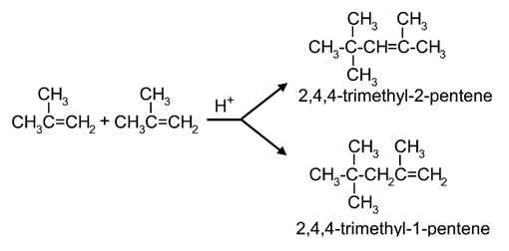

**Figure 1.11.** The main reaction in the oligomerization step of the process

Dehydrocyclization is the final step where p-xylene is produced. Dehydrocyclization generally takes place under very high temperature conditions and involves cracking of C-C bonds. Diisobutylene first undergoes a dehydrogenation reaction to form 2,4,4-trimethyl-1,4-pentadiene. The two double bonds allow cyclization reaction happening to form a 5-carbon ring as an intermediate. After cyclization, a methyl substitute joined the 5-carbon ring to form the final product: an aromatic ring with two methyl substitute.

The reaction is carried out at temperatures of about 500°C and 10 bar. As the temperature and pressure of the reactor 3 is extremely high, side reactions from cracking produce numerous side products due to C-C bond at different location can be cracked. A total of 14 side products is produced in this reaction [19].

## 

## **Chapter 2: Process Overview and PFD**

**Figure 2.1** PFD of Isobutanol to p-xylene Process

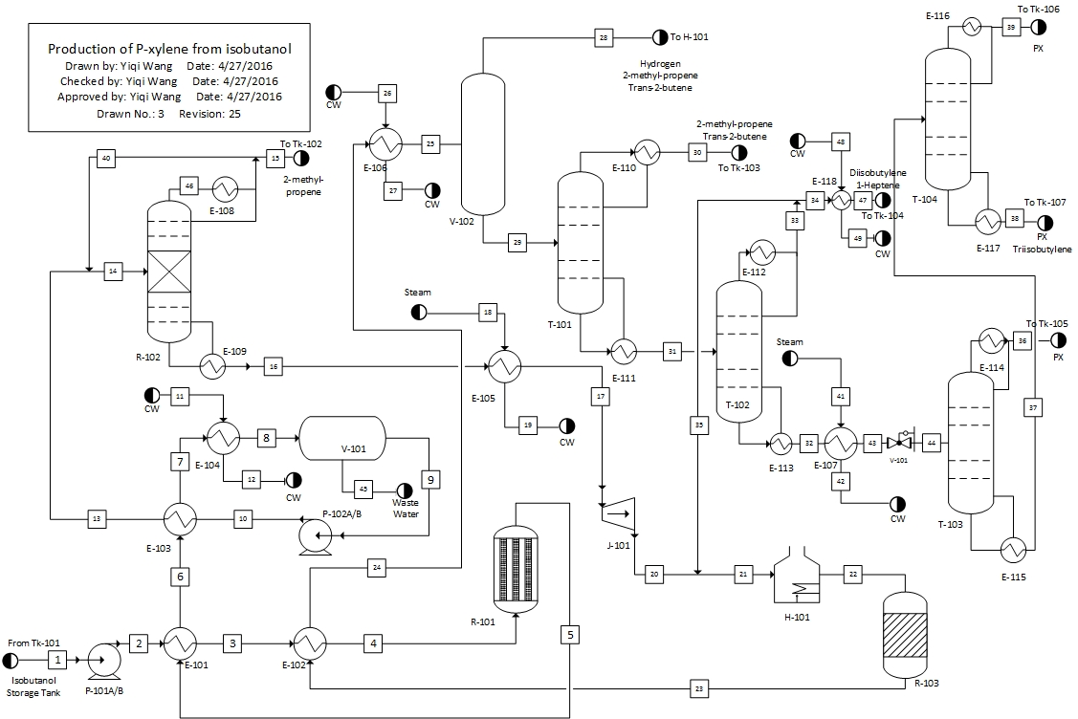

**Table 2.1** Stream Properties

|  |  |  |  |  |
| --- | --- | --- | --- | --- |
| **Stream Number** | **Pressure**  **(Bar)** | **Temperature**  **(C)** | **Flow Rate (kg/h)** | **Composition**  **(mole percent)** |
| **1** | 1 | 25 | 26839 | 30% isobutanol  70% water |
| **2** | 9 | 25.3 | 26839 | 30% isobutanol  70% water |
| **3** | 9 | 161.488 | 26839 | 30% isobutanol  70% water |
| **4** | 9 | 325 | 26839 | 30% isobutanol  70% water |
| **5** | 9 | 325 | 26839 | 0.12% isobutanol  76.9% water  21.8% 2-Methylpropene, 1.15% trans-2-butene |
| **6** | 9 | 106 | 26839 | 0.12% isobutanol  76.9% water  21.8% 2-Methylpropene  1.15% trans-2-butene |
| **7** | 9 | 92.2 | 26839 | 0.12% isobutanol  76.9% water  21.8% 2-Methylpropene  1.15% trans-2-butene |
| **8** | 9 | 30 | 26839 | 0.12% isobutanol  76.9% water  21.8% 2-Methylpropene  1.15% trans-2-butene |
| **9** | 9 | 30 | 12804.4 | 0.35% isobutanol  0.3% water  94.3% 2-Methylpropene  5% trans-2-butene |
| **10** | 15 | 30.4 | 12804.4 | 0.35% isobutanol  0.3% water  94.3% 2-Methylpropene  5% trans-2-butene |
| **11** | 5 | 20 | 106076 | 100% Water |
| **12** | 5 | 43 | 106076 | 100% Water |
| **13** | 15 | 85 | 12804.4 | 0.35% isobutanol  0.3% water  94.3% 2-Methylpropene  5% trans-2-butene |
| **14** | 15 | 86.5 | 17358 | 0.26% isobutanol  0.77% water  94% 2-Methylpropene  4.76% trans-2-butene  2% 1-Diisobutylene  2.75e-5% Triisobutylene |
| **15** | 15 | 90.5 | 1137 | 3.12e-6% isobutanol  2.1% water  93.1% 2-Methylpropene  4.1% trans-2-butene  0.73% 1-Diisobutylene  1.05e-4% Triisobutylene |
| **16** | 15 | 194.4 | 11673 | 0.71% isobutanol  0.22% water  7.5% 2-Methylpropene  9.3% trans-2-butene  82% 1-Diisobutylene  0.27% Triisobutylene |
| **17** | 15 | 255 | 11673 | 0.71% isobutanol  0.22% water  7.5% 2-Methylpropene  9.3% trans-2-butene  82% 1-Diisobutylene  0.27% Triisobutylene |
| **18** | 46.9 | 260 | 2351.86 | 100% Steam |
| **19** | 46.9 | 260 | 2351.86 | 100% Water |
| **20** | 10 | 245.9 | 11673 | 0.71% isobutanol  0.22% water  7.5% 2-Methylpropene  9.3% trans-2-butene  82% 1-Diisobutylene  0.27% Triisobutylene |
| **21** | 10 | 227 | 23664.3 | 1.16% isobutanol  0.11% water  3.8% 2-methylpropene  4.7% trans-2-butene  74.4% 1-Diisobutylene  1.2e-4% O-xylene  0.28% P-xylene  1.9% Toluene  0.14% Triisobutylene  4e-4% 2-methyl-1-butene  9.6% 1-Heptene  3.75% 2,3-dimethyl-1-Hexene |
| **22** | 10 | 500 | 23646 | 1.16% isobutanol  0.11% water  3.8% 2-methylpropene  4.7% trans-2-butene  74.4% 1-Diisobutylene  1.2e-4% O-xylene  0.28% P-xylene  1.9% Toluene  0.14% Triisobutylene  4e-4% 2-methyl-1-butene  9.6% 1-Heptene  3.75% 2,3-dimethyl-1-Hexene |
| **23** | 10 | 370.8 | 23646 | 0.58% isobutanol  0.083% water  6.8% 2-methylpropene  2.4% trans-2-butene  18.3% 1-Diisobutylene  0.068% O-xylene  15.6% P-xylene  1.06% Toluene  0.069% Triisobutylene  46.9% Hydrogen  0.1% Methane  0.25% propene  0.12% 2-methyl-1-butene  0.12% 2-methyl-1-pentene  5.37% 1-Heptene  2.08% 2,3-dimethyl-1-Hexene |
| **24** | 10 | 218.4 | 23646 | 0.58% isobutanol  0.083% water  6.8% 2-methylpropene  2.4% trans-2-butene  18.3% 1-Diisobutylene  0.068% O-xylene  15.6% P-xylene  1.06% Toluene  0.069% Triisobutylene  46.9% Hydrogen  0.1% Methane  0.25% propene  0.12% 2-methyl-1-butene  0.12% 2-methyl-1-pentene  5.37% 1-Heptene  2.08% 2,3-dimethyl-1-Hexene |
| **25** | 10 | 40 | 23646 | 0.58% isobutanol  0.083% water  6.8% 2-methylpropene  2.4% trans-2-butene  18.3% 1-Diisobutylene  0.068% O-xylene  15.6% P-xylene  1.06% Toluene  0.069% Triisobutylene  46.9% Hydrogen  0.1% Methane  0.25% propene  0.12% 2-methyl-1-butene  0.12% 2-methyl-1-pentene  5.37% 1-Heptene  2.08% 2,3-dimethyl-1-Hexene |
| **26** | 5 | 20 | 168117 | 100% Water |
| **27** | 5 | 43 | 168117 | 100% Water |
| **28** | 10 | 40 | 1339 | 0.03% isobutanol  0.064% water  4.23% 2-methylpropene  1.18% trans-2-butene  0.45% 1-Diisobutylene  3.08e-4% O-xylene  0.091% P-xylene  0.019% Toluene  5.42e-5% Triisobutylene  93.2% Hydrogen  0.2% Methane  0.29% propene  0.029% 2-methyl-1-butene,  0.1% 2-methyl-1-pentene  0.16% 1-Heptene  0.032% 2,3-dimethyl-1-Hexene |
| **29** | 10 | 40 | 22307 | 1.11% isobutanol  0.1% water  9.48% 2-methylpropene  3.55% trans-2-butene  36.5% 1-Diisobutylene,  0.137% O-xylene  31.4% P-xylene  2.1% Toluene  0.14% Triisobutylene  0.21% propene  0.22% 2-methyl-1-butene, 0.22% 2-methyl-1-pentene, 10.6% 1-Heptene  4.1% 2,3-dimethyl-1-Hexene |
| **30** | 10 | 74.2 | 1872.88 | 1.76% isobutanol  0.7% water  65.6% 2-methylpropene  24.6% trans-2-butene  2.15% 1-Diisobutylene  2.36e-3% O-xylene  0.65% P-xylene  0.12% Toluene  6.46e-4% Triisobutylene  1.5% propene  1.5% 2-methyl-1-butene  0.31% 2-methyl-1-pentene  0.87% 1-Heptene  0.18% 2,3-dimethyl-1-Hexene |
| **31** | 10 | 215.77 | 20434.1 | 1% isobutanol  42.3% 1-Diisobutylene,  0.16% O-xylene  36.6% P-xylene  2.45% Toluene  0.21%-methyl-1-pentene  12.3% 1-Heptene  4.8% 2,3-dimethyl-1-Hexene |
| **32** | 10 | 250.8 | 7400 | 0.44% O-xylene  99.1% P-xylene  0.44% Triisobutylene |
| **33** | 10 | 207.76 | 13034.2 | 1.64% isobutanol  66.6% 1-Diisobutylene  0.58% P-xylene  3.86% Toluene  0.33% 2-methyl-1-pentene, 19.4% 1-Heptene  7.6% 2,3-dimethyl-1-Hexene |
| **34** | 10 | 207.76 | 1042.73 | 1.64% isobutanol  66.6% 1-Diisobutylene  0.58% P-xylene  3.86% Toluene  0.33% 2-methyl-1-pentene,  19.4% 1-Heptene  7.6% 2,3-dimethyl-1-Hexene |
| **35** | 10 | 207.76 | 11991.4 | 1.64% isobutanol  66.6% 1-Diisobutylene  0.58% P-xylene  3.86% Toluene  0.33% 2-methyl-1-pentene  19.4% 1-Heptene  7.6% 2,3-dimethyl-1-Hexene |
| **36** | 2.75 | 180.1 | 5680.8 | 0.29% O-xylene  99.7% P-xylene |
| **37** | 2.75 | 180.7 | 1719.1 | 0.93% O-xylene  97.14% P-xylene  1.9% Triisobutylene |
| **38** | 2.75 | 182.3 | 509.13 | 2% O-xylene  91.3% P-xylene  6.7% Triisobutylene |
| **39** | 2.75 | 180.1 | 1210 | 0.5% O-xylene  99.5% P-xylene |
| **40** | 15 | 90.5 | 4548.2 | 3.12e-6% isobutanol  2.1% water  93.1% 2-Methylpropene  4.1% trans-2-butene  0.73% 1-Diisobutylene  1.05e-4% Triisobutylene |
| **41** | 1.01 | 100 | 559.5 | 100% Steam |
| **42** | 1.01 | 100 | 559.5 | 100% water |
| **43** | 10 | 180 | 7400 | 0.44% O-xylene  99.1% P-xylene  0.44% Triisobutylene |
| **44** | 2.75 | 180 | 7400 | 0.44% O-xylene  99.1% P-xylene  0.44% Triisobutylene |
| **45** | 9 | 30 | 14034.3 | 0.05% isobutanol  99.6% water  0.36% 2-Methylpropene, 0.016% trans-2-butene |
| **46** | 15 | 90.5 | 5685.2 | 3.1e-6% isobutanol  2.1% water  93.1% 2-Methylpropene  4.1% trans-2-butene  0.73% 1-Diisobutylene  1.05e-4% Triisobutylene |
| **47** | 10 | 40 | 1042/73 | 1.64% isobutanol  66.6% 1-Diisobutylene  0.58% P-xylene  3.86% Toluene  0.33% 2-methyl-1-pentene,  19.4% 1-Heptene  7.6% 2,3-dimethyl-1-Hexene |
| **48** | 5 | 20 | 6974.24 | 100% Water |
| **49** | 5 | 43 | 6974.24 | 100% Water |

*Table 2.2.* Reactor Summary for PFD

|  |  |  |  |
| --- | --- | --- | --- |
|  | **R-101** | **R-102** | **R-103** |
| **Temperature (C)** | 325 | 86.5 | 500 |
| **Pressure (Bar)** | 9 | 15 | 10 |
| **Orientation** | Vertical | Vertical | Vertical |
| **MOC** | CS | CS | Titanium |
| **Height (m)** | 10 | 41.1 | 0.9 |
| **Diameter (m)** | 10 | 1.6 | 1.5 |
| **Description** | Multi tube catalyst packed bed reactor | Catalyst packed bed reactive distillation column | Catalyst packed bed Reactor |

*Table 2.3.* Pump Summary for PFD

|  |  |  |
| --- | --- | --- |
|  | **P-101** | **P-102** |
| **Type** | Centrifugal | Centrifugal |
| **Temperature (C)** | 25 | 30 |
| **Pressure in (Bar)** | 1 | 9 |
| **Pressure out (Bar)** | 9 | 15 |
| **Efficiency** | 0.75 | 0.75 |
| **Power (MJ/h)** | 25 | 13.17 |
| **Flow Rate (kg/h)** | 26839 | 12804.5 |
| **MOC** | CS | CS |

*Table 2.4***.** Vessel Summary for PFD

|  |  |  |
| --- | --- | --- |
|  | **V-101** | **V-102** |
| **Temperature (C)** | 30 | 40 |
| **Pressure (Bar)** | 9 | 10 |
| **Orientation** | Horizontal | Vertical |
| **MOC** | CS | Titanium |
| **Height (m)** | 10 | 0.91 |
| **Diameter (m)** | 0.5 | 0.23 |
| **Description** | Liquid/Liquid Separator | Flash Tank |

*Table 2.5.* Heater Summary for PFD

|  |  |
| --- | --- |
|  | **Heater-101** |
| **Temperature in (C)** | 227 |
| **Temperature out (C)** | 500 |
| **Pressure (Bar)** | 10 |
| **Heat Absorbed (MJ/h)** | 18312.3 |
| **Fuel Usage (SCF/h)** | 2751.35 |
| **MOC** | SS |

*Table 2.6.* Tower Summary for PFD

|  |  |  |  |  |
| --- | --- | --- | --- | --- |
|  | **T-101** | **T-102** | **T-103** | **T-104** |
| **Temperature (C)** | 40 | 215.77 | 180 | 180.7 |
| **Pressure (Bar)** | 10 | 10 | 2.75 | 2.75 |
| **Orientation** | Vertical | Vertical | Vertical | Vertical |
| **Stage** | 13 | 30 | 30 | 30 |
| **Feed Tray** | 2 | 15 | 20 | 15 |
| **Reflux Ratio** | 4.5 | 6 | 2 | 3.1 |
| **Condenser Duty**  **(MJ/h)** | -3822.65 | -15953 | -5303.29 | -1543.85 |
| **Reboiler Duty**  **(MJ/h)** | 12790.1 | 18870.1 | 5307.91 | 1544.02 |
| **MOC** | CS | CS | CS | CS |
| **Height (m)** | 16.4 | 29.1 | 29.1 | 29.1 |
| **Diameter (m)** | 1.7 | 2.2 | 1.07 | 0.57 |
| **Description** | Distillation Tower | Distillation Tower | Distillation Tower | Distillation Tower |

*Table 2.7*. Turbine Summary for PFD

|  |  |
| --- | --- |
|  | **J-101** |
| **Temperature** | 255 |
| **Pressure in (Bar)** | 15 |
| **Pressure out (Bar)** | 10 |
| **Efficiency** | 0.75 |
| **Model** | Adiabatic |
| **Type** | Axial |
| **Power (MJ/h)** | -124 |

Table *2.8*. Heat Exchanger Summary for PFD

|  |  |  |  |  |
| --- | --- | --- | --- | --- |
|  | **E-101** | **E-102** | **E-103** | **E-104** |
| **Shell Temperature in (C)** | 25 | 161.5 | 106 | 20 |
| **Shell Temperature out (C)** | 161.5 | 325 | 92.2 | 43 |
| **Shell**  **Pressure (Bar)** | 9 | 9 | 9 | 5 |
| **Tube Temperature in (C)** | 325 | 370.85 | 30.4 | 92.2 |
| **Tube Temperature out (C)** | 106 | 218.4 | 85 | 30 |
| **Tube Pressure (Bar)** | 9 | 9 | 15 | 15 |
| **Heat Transfer Coefficient (W/m2K)** | 300 | 300 | 600 | 750 |
| **Type** | Countercurrent | Countercurrent | Countercurrent | Countercurrent |
| **Heat Duty (MJ/h)** | 41466.8 | 9609.7 | 1767.67 | 10200 |
| **MOC** | CS | CS | CS | CS |
| **Area (m2)** | 449 | 220 | 59.5 | 528 |
|  |  |  |  |  |
|  | **E-105** | **E-106** | **E-107** | **E-118** |
| **Shell Temperature in (C)** | 260 | 20 | 100 | 20 |
| **Shell Temperature out (C)** | 260 | 43 | 100 | 43 |
| **Shell Pressure (Bar)** | 46.9 | 5 | 1.01 | 5 |
| **Tube Temperature in (C)** | 194.4 | 218.4 | 250.8 | 207.7 |
| **Tube Temperature out (C)** | 255 | 40 | 180 | 40 |
| **Tube Pressure (Bar)** | 15 | 10 | 10 | 10 |
| **Heat Transfer Coefficient (W/m2K)** | 300 | 300 | 800 | 300 |
| **Type** | Countercurrent | Countercurrent | Countercurrent | Countercurrent |
| **Heat Duty (MJ/h)** | 3897 | 16166 | 1267.45 | 670.7 |
| **MOC** | CS | CS | CS | CS |
| **Area (m2)** | 54.9 | 287 | 8.8 | 9.05 |
|  |  |  |  |  |
|  | **E-108** | **E-109** | **E-110** | **E-111** |
| **Duty (MJ/h)** | -11491.6 | 8150 | -3822.65 | 12790.1 |
| **Area (m2)** | 165 | 63 | 107 | 46.2 |
| **Description** | Condenser of reactive distillation column R-102 | Reboiler of reactive distillation column R-102 | Condenser of distillation column T-101 | Reboiler of distillation column T-101 |
|  |  |  |  |  |
|  | **E-112** | **E-113** | **E-114** | **E-115** |
| **Duty (MJ/h)** | -15953 | 18870.1 | -5303.29 | 5307.91 |
| **Area (m2)** | 30.5 | 25.6 | 21 | 15 |
| **Description** | Condenser of distillation column T-102 | Reboiler of distillation column T-102 | Condenser of distillation column T-103 | Reboiler of distillation column T-103 |
|  |  |  |  |  |
|  | **E-116** | **E-117** |  |  |
| **Duty (MJ/h)** | -1543.85 | 1544.02 |  |  |
| **Area (m2)** | 10 | 10 |  |  |
| **Description** | Condenser of distillation column T-104 | Condenser of distillation column T-104 |  |  |

**Chapter 3: Results of Simulation**

3.1. Simulation Overview

The overall simulation is shown in Figure 3.1. The entire PFD was made into a single simulation in order to determine process wide effects of changes in the system. This was also necessary in order to create a stream table that obeys mass balance. Breaking down the simulation into pieces would require that recycle streams be converged manually which is infeasible if many iterations are required. Otherwise, running simulations of separate sections will result in recycle streams that do not match up in terms of mass balance. Thus it was necessary to create a simulation of the entire process that could converge.  
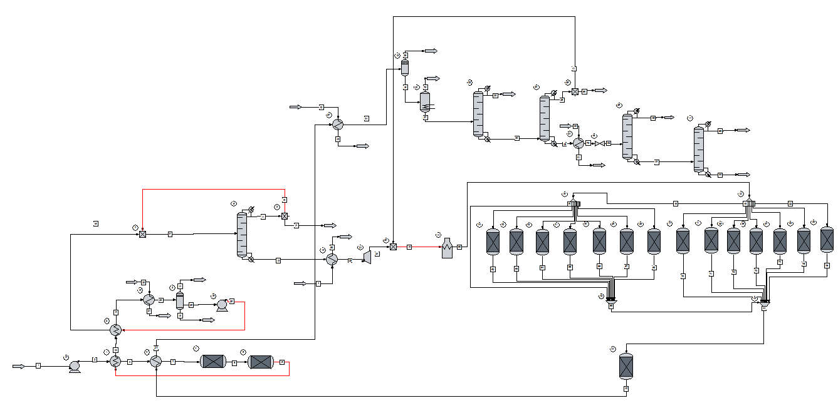

**Figure 3.1.** Overall schematic of ChemCAD simulation used.

Since the overall simulation is very large, the simulation has been broken down into sections for easier viewing (Figures 3.2 - 3.6). The figures follow the general flow of the process with Figure 3.2 representing the first reactor and its associated separation unit then Figure 3.3 representing the second reactor (reactive distillation), and so on. While forming the simulation, each section was ran independently as “simulation units” to ensure they converged on their own before introducing the recycle streams. Then, after the simulation units were confirmed to individually converge, two of them were ran together at a time, then three, and so on until the entire simulation converged. Each subsection converged for the default simulation tolerances of 0.001, but the overall simulation needed a tolerance of 0.01 for all the recycles to converge. The decreased precision was deemed to be acceptable for the scope of this project.

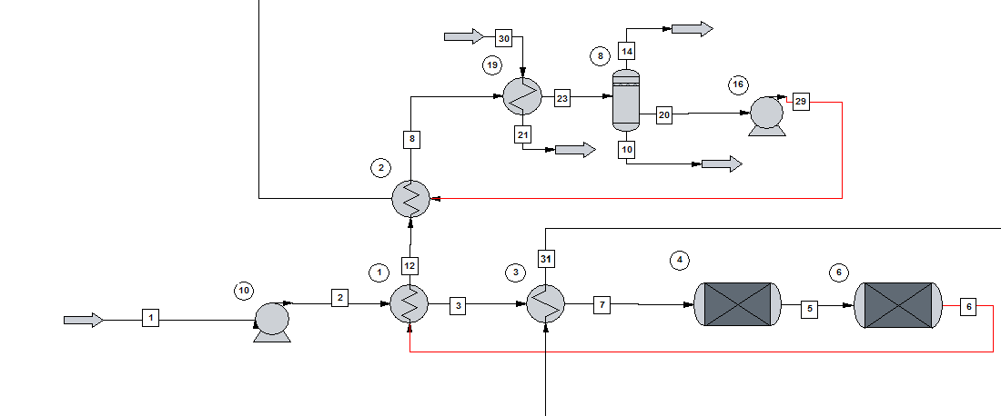

**Figure 3.2.** Simulation Section 1: First Reactor and LL Separation.

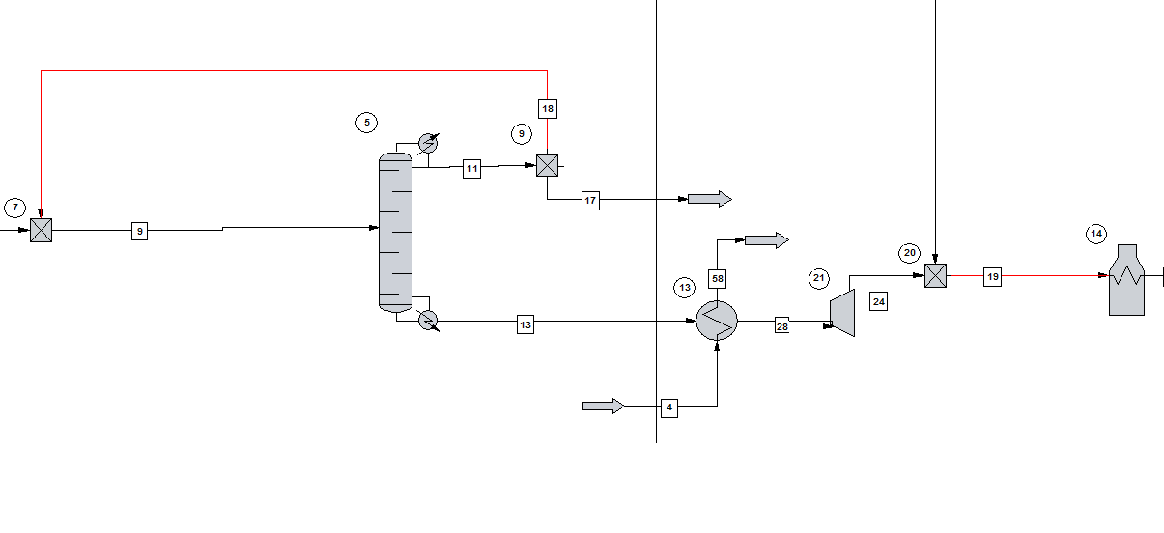

**Figure 3.3.** Simulation Section 2: Reactive Distillation

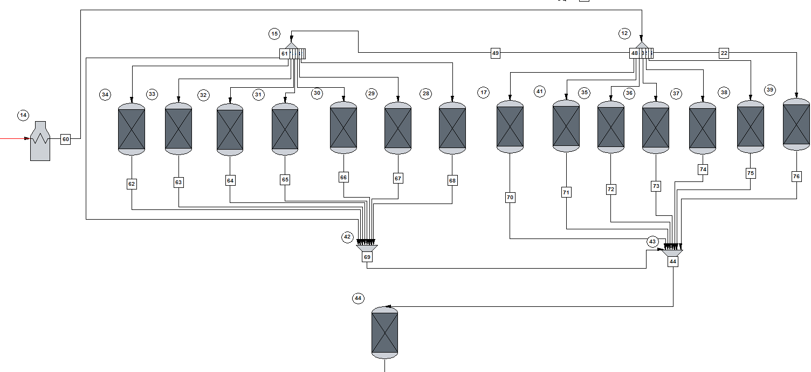

**Figure 3.4.** Simulation Section 3: Dehydrocyclization Reactor and Associated Side Products.

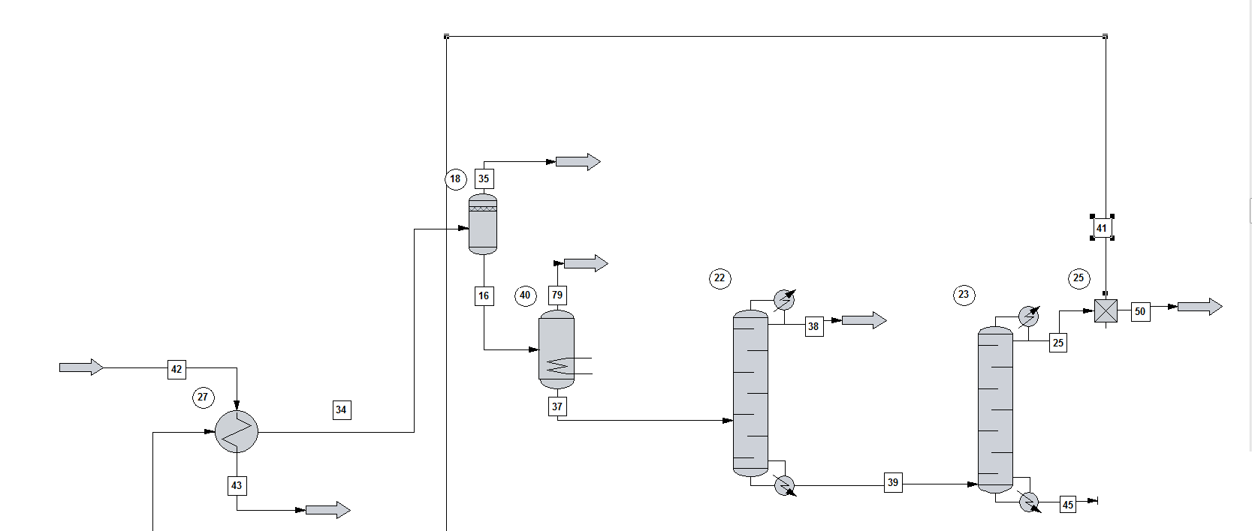

**Figure 3.5.** Simulation Section 4: Separation of Side Products and Di-Isobutene Recycle.

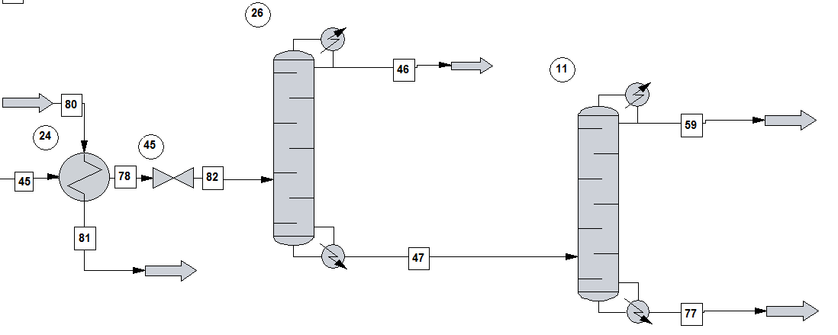

**Figure 3.6.** Simulation Section 5: Final P-xylene Purification Steps.

### 3.2. Selection of Thermodynamic Models

Multiple thermodynamic models were used in the simulation; local thermodynamic models were applied whenever necessary. The selection of thermodynamic models was done based on heuristics given in *Don’t Gamble with Physical Properties for Simulation* [20] seen in Figure 3.7. Although generally it is best practice to confirm the VLE data used in the simulation with experimental data, there were little to no resources on the VLE data of interest for the particular components involved (i.e. p-xylene and DIB VLE, p-xylene and TIB VLE, isobutene and DIB VLE, isobutene and p-xylene VLE, etc.). In general, there were not many studies performed on the VLE of isobutene or its oligomers.

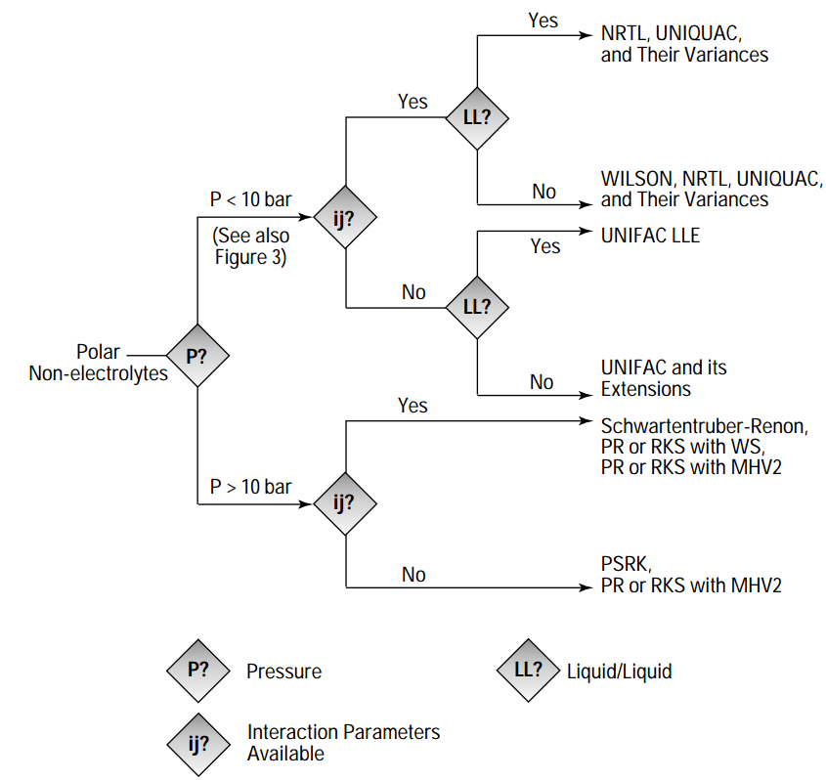=

**Figure 3.7.** Flowchart within *Don’t Gamble with Physical Properties for Simulation* used to decide simulation thermophysical models.

Since most of the process was run at 10 bar and was highly non-ideal, a global UNIFAC/LATE model was chosen. However, different models were chosen wherever appropriate. The reactive distillation column was run at 15 bar, and according to the heuristics PSRK outperform UNIFAC at higher pressures, so PSRK/LATE was chosen as a local thermodynamic model for the reactive distillation column. UNIFAC was unable to accurately reproduce the solubility of isobutene and water even with the water/hydrocarbon option selected as immiscible. Isobutene is known to be nearly insoluble in water [21], so clearly the UNIFAC model was inappropriate for the liquid-liquid separator. However, UNIFAC LLE is an extension of UNIFAC that has been developed by Mangussen et. al. [22] and is a model dedicated to modeling liquid liquid equilibrium. The use of this model led to the water and isobutene phases correctly partitioning in the separator. Furthermore, it is also the recommended model from [21] for liquid-liquid systems. The rest of the simulation was run using the global thermodynamic model.

### 3.3. Use of Component Separators

A component separator was used after flash tank V-102 in the simulation. The purpose of this component separator was to remove hydrogen and methane from the stream entering the subsequent distillation column. The reason for doing so is that there is virtually no hydrogen or methane left in the stream after the stream is flashed and continues on to (on the order of 1x10-6 mole fraction) enter the distillation column. However, if even this small amount is not separated, ChemCAD attempts to lower the temperature of the entire distillate stream to well below 0 °C in its attempt to condense the hydrogen and methane. This caused problems with convergence and greatly skewed the condenser and reboiler duty on the column, Simulation using a partial condenser on the distillation column, but the column had problems with convergence. In reality, it would not make much sense to attempt to condense hydrogen out of the stream, and hydrogen would be removed via flash, which is what is done in this process. The final decision was to remove the small amount of hydrogen and methane from the stream prior to it entering distillation column since the amount was so negligible relative to the flow rates of the rest of the components.

### 3.4. Simulation of Reactors

The simulation of the dehydration reactor (R-101) was done using two reactors. Kinetics for the formation of the butene side product were unable to be found. However, a paper studying the kinetics of isobutanol dehydration reported that the conversion of isobutanol was 99% and the selectivity was 95%. Besides isobutene, the major side product of the reaction is linear butenes, collectively represented by trans-2-butene in the simulation. This reaction is endothermic with a heat of reaction reported as 6.4 kcal/mol and an activation energy of 44 kcal/mol and a frequency factor of 7.2 x 1013 [23].

The SCDS column in ChemCAD with the reactive distillation option checked was used to simulate the reactive distillation of R-102. The di-isobutylenes formed in the reactive distillation tower were collectively represented by 1-di-isobutylene in ChemCAD. The SCDS column did not converge well for complex kinetic equations, so only two reactions were specified: a dimerization reaction and a trimerization reaction. The formation of tetramers was assumed to be negligible as described by a paper studying this oligomerization reaction. The frequency factor for the dimerization reaction was 0.014 (with units in terms of kmol) with an activation energy of 23.88 kJ while the trimerization reaction ad a frequency factor of 0.000302 (for units in terms in kmol) with an activation energy of 12.13 kJ. In reality, there are additional ongoing reactions involving the formation of tert-butyl alcohol from water with tert-butyl alcohol affecting the rate of the oligomerization reaction.

The direct kinetics of dehydrocyclization for diisobutylene (2,4,4-Trimethyl-1-Pentene) to p-xylene is not available. However, a similar kinetics for dehydrocyclization reaction for 2,4,4-Trimethyl-Pentane is used as shown below (3-1) [41]. The variable A represents the aromatic species being formed (p-xylene) and B represents the reactant (DIB). The paper reported the values of the constants as A1 = 613.5, A2 = 0, A3 = 1.23x10-4, A4 = 71.3 x 106, m=0.5, and n=1. The complex rate expression was simulated in a kinetic reactor by using the user defined VBA expression in ChemCAD.

|  |  |  |
| --- | --- | --- |
|  | $$r=\frac{kP_{A}-k^{'}P_{B}P_{H_{2}}}{{\left(\frac{P_{A}}{P_{H_{2}}^{0.5}}+\frac{A_{1}P_{B}}{P_{H_{2}}^{0.5}}+A_{2}P_{H_{2}}^{0.5}+A_{3}P_{A}{\left(\frac{A_{4}}{P_{H2}}\right)}^{0.5\left(n+1\right)}\right)}^{2m}}$$ | (3-1) |

From [24], half of the conversion from alkene or alkane under dehydrocyclization reaction would interconvert to each other, yield the other one. Therefore, utilizing 2,4,4-Trimethyl-Pentane dehydrocyclization reaction kinetics does not affect much on the result. Due to the harsh reaction condition (high temp 500°C and high pressure 10bar), the dehydrocyclization reaction involves the formation of numerous side products. The side products formed mainly due to the cracking reaction where high-carbon-number molecules cracks into low-carbon-number molecules and it is infeasible to simulate the kinetics of them all.

As the conversion data for dehydrocyclization reaction was found, a single stoichiometric reactor incorporating different stoichiometric coefficients to reach the desired conversion of side products in a single step did not work in ChemCAD. Instead, by knowing the conversion, 14 parallel stoichiometric reactors are used to first form the side products before the product entered the main-reaction reactor. For reaching the desired conversion, as the stoichiometric coefficient for each side reaction is fixed, a divider allocates the feed portion each reaction would react if all the reactions are in a single reactor. The allocated streams then enter stoichiometric reactors set with 100% conversion. The conversion of the products is pre-determined based on the ratio of the streams split. In this way, the formation of side products can be represented in ChemCAD simulation. Then, the streams from all the parallel reactors are combined and fed into a kinetic reactor which contains the rate law shown in (3-1). After optimizing and sizing the reactor using a kinetic reactor, the kinetic reactor was replaced with a stoichiometric reactor for full scale simulations. The simulations was not well behaved for large scale simulations when the kinetic reactor was used.

### 3.5. Results of Optimization

The first unit operation that was optimized in the process was the first reactor that converted isobutanol in to isobutylene. The variable that was tested first was the volume of the reactor; it was ranged from 100 to 2000 m3

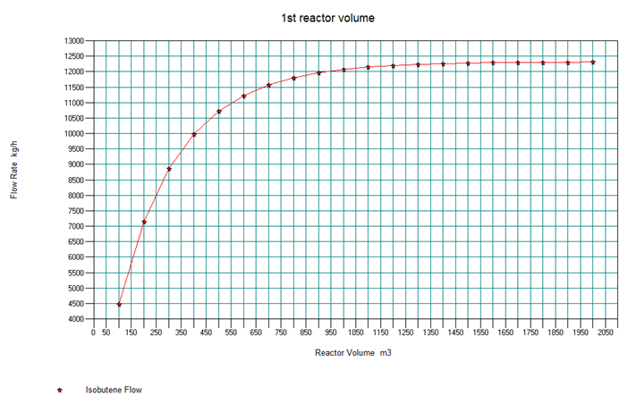

**Figure 3.8.** Optimization of volume of first reactor.

The plot shown in Figure 3.8 compares the flow rate of isobutylene leaving the reactor to the reactor volume. Isobutylene’s flow rate increases until around 1200 m3 where it starts leveling off. Thus the volume was decided to be kept at 750 m3. Any further increases in volume led to diminishing returns of isobutene formed. Next, the temperature the reactor was operating in was ranged from 200 to 400°C to see which temperature would be the most optimal to carry out the reaction.

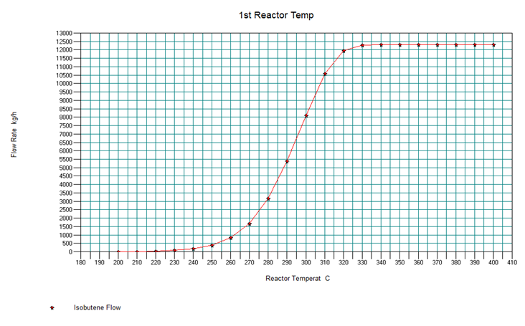

**Figure 3.9.** Optimization of Temperature of Dehydration Reactor R-101.

It can be seen in Figure 3.9 that right at 330°C the amount of isobutylene that is created in the reaction becomes fairly constant. Thus the original specified temperature of 325°C was kept, due to it being relatively close to that temperature while also being the value used in the paper source of the kinetics used 3.10. After optimizing temperature the pressure in the first reactor was ranged from 1 to 10 bar while also monitoring the amount of isobutylene being produced.

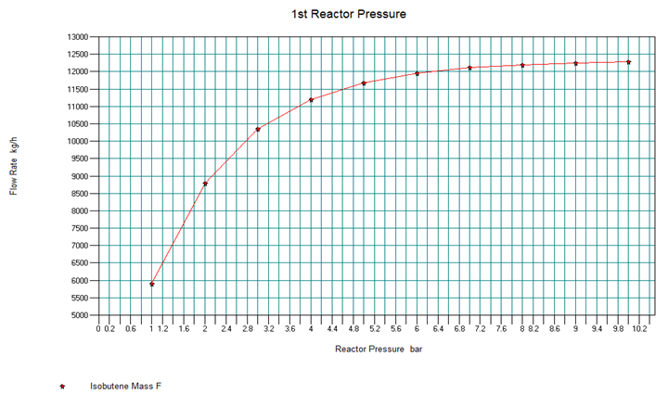

**Figure 3.10.** Optimization of Pressure in R-101.

As the plot in figure 3.10 shows, the amount of isobutylene was maximized around 8 to 10 bar. Since a heat exchanger within the simulation entered a pinch zone when it was 8 bar and the vapor fraction of the streams after the first heat exchanger does not changed between 9 and 10 bar, the optimal pressure was chosen to be 9 bar. After finding the optimal pressure for the first reactor this pressure was then inputted into the pump at the start of the simulation causing the pressure up until the next pump to be 9 bar as well. The higher pressure also served a separate purpose in ensuring the isobutene formed could be liquefied using cooling water for subsequent separation from water.

To minimize the area of the heat exchanger using the products of the first reactor to preheat the feed, the temperature out of the heat exchanger was mapped against the area per shell; however, since that heat exchanger’s out temperature would cause the heat exchanger before the liquid-liquid separator, labeled 19 in the simulation, using cooling water to increase in area and have increased cooling water flow, those two variables were monitored as well shown in Figure 3.11.

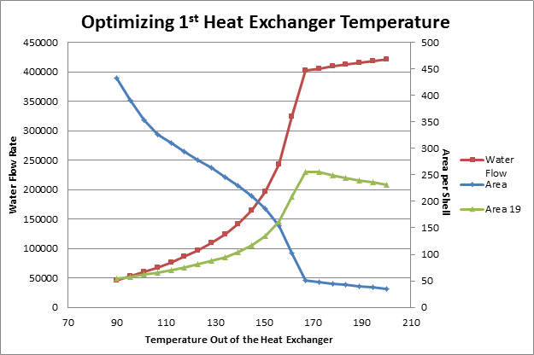

**Figure 3.11.** Optimization of E-101 Outlet Temperature in Stream 6.

Since the flow is a recurring cost for the life of the process, it was decided the optimal temperature would be before exponential increase in flow rate as it would continuously be a high cost while also including the increase in cost for the second heat exchanger. To capitalize on the initial steep decrease in area for the first heat exchanger before the flow increased too much, the optimal temperature was chosen to be 106°C. The heat exchanger that heats the initial feed into the first reactor and the heat exchanger that heats the stream leaving the liquid-liquid separator were not optimized due to them having to have set values, the temperatures for the reactions etc.

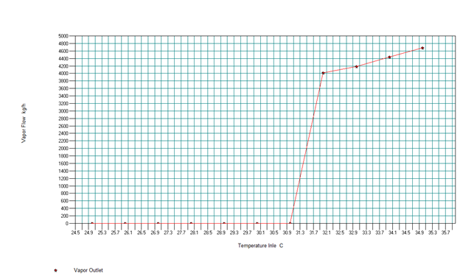

**Figure 3.12.** Optimization of V-102, the liquid -liquid separator.

The temperature entering the liquid-liquid separator was also optimized. The stream entering the liquid-liquid separator needed to be completely condensed. The liquid-liquid separator (decanter) in ChemCAD is modeled using the same unit as the Liquid-Liquid-Vapor flash, but the vapor stream should contain no flow. A sensitivity study was conducted to determine the highest inlet temperature at which the stream would still be completely liquid. The temperature of the stream feeding the decanter was gradually increased to determine when vapor was present in the outlet from the unit. From Figure 3.12 it can be seen that at temperatures above 31 °C there is vapor formation in the stream. To avoid operating at the maximum temperature and allow for temperature fluctuations, the stream was determined to be cooled to 30 °C at heat exchanger E-104.

After the liquid-liquid separator unit the stream enters the reactive distillation column used for the second reaction. The total number of stages used in the column was compared to how much isobutylene and di-isobutylene appeared in the bottoms; the maximum amount of di-isobutylene was desired, however the unreacted isobutylene needed to be recycled in order to create more di-isobutylene and not make the bottoms stream unnecessarily larger.

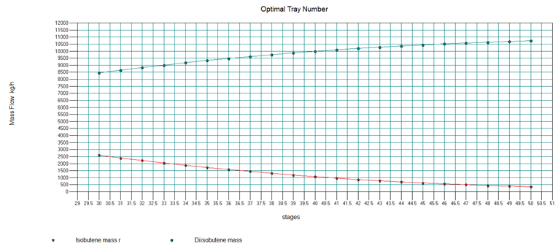

**Figure 3.13.** Plot for the optimization of the number of stages for R-102.

Figure 3.13 shows that as the number of stages in the column increase, the amount of isobutylene decreasing from the bottoms diminishes. At stage 47 the difference goes below 100 kg/h with both the amount of isobutylene and di-isobutylene leveling off and it was decided that around this number would be the optimal number of stages as anymore would not be worth buying; thus the total stages in the reactive distillation column was set at 46. After finding the total number of stages in the column, the location of the feed stage was found. This was done by again comparing how much isobutylene and di-isobutylene appeared in the bottoms.

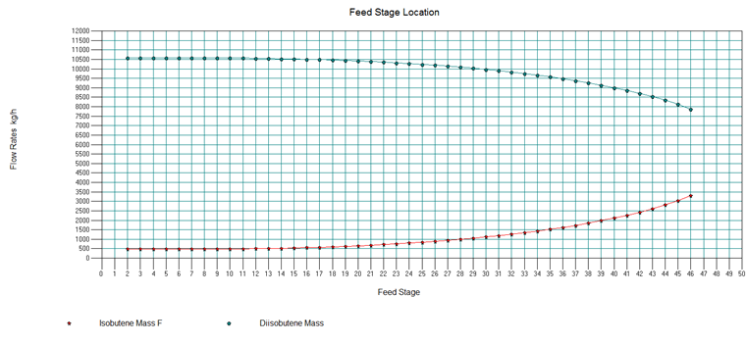

**Figure 3.14.**  Optimization plot of the feed stage location for R-102.

As seen in Figure 3.14, the values remain pretty steady with any feed stage located above stage 15, with a small amount of increase in di-isobutylene at stage 11; this lead to the placement of the feed stage to be at stage 11. The number of reactive stages present in the column was initially set at 3; additional stages were added while monitoring the amount of isobutylene and di-isobutylene present in the product streams. After various numbers of reactive stages were added the amount of both chemicals did not change, thus the number of reactive stages remained at 3. The placement of the reactive stages was also tested; it was seen that when the reactive stages were moved through the column the amount of each product for both streams did not change based on their placement. Then the volume of these reactive stages was changed between 100 liters and 2000 liters. Seen in Figures 3.15 and 3.16 the total flow rates of isobutylene and di-isobutylene (showing how much is being converted) and the flow rates in the distillate, stream 11 in the simulation, level off at around 1200 liters; this was then chosen to be the optimal volume.

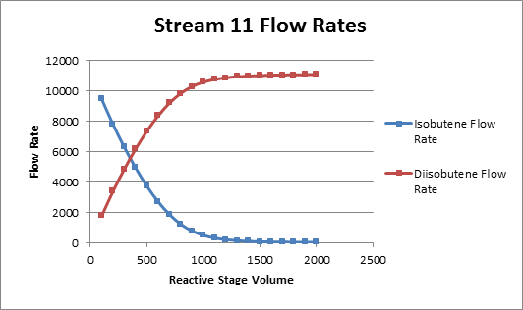

**Figure 3.15**. The flow rate of isobutylene and di-isobutylene in the distillate of R-102 as reactive stage volume changed.

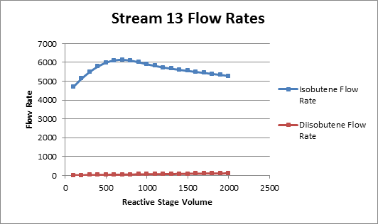

**Figure 3.16.** The flow rate of isobutylene and di-isobutylene in the bottoms of R-102 as reactive stage volume changed.

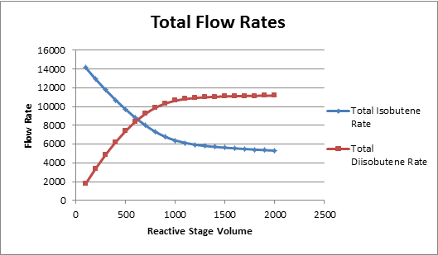

**Figure 3.17.** The total flow rate of isobutylene and di-isobutylene leaving R-102 as reactive stage volume changed.

The reflux ratio of the reactive distillation column was then changed from 2 to 10 and the graphs in Figures 3.18, 3.19, and 3.20 display di-isobutylene in the distillate stream and isobutylene in the bottoms stream start leveling off at around a reflux ratio of 5 or 6. Since overall there was not much change in the total di-isobutylene rates and the isobutylene rate in the distillate the reflux ratio was kept at 6 as it matched the specification of the paper much of the reactive distillation was based upon.

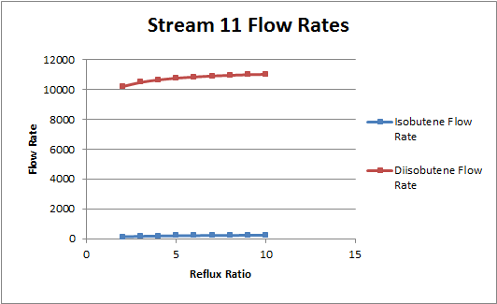

**Figure 3.18.** The flow rate of isobutylene and di-isobutylene in the distillate of R-102 as reflux ratio changed.

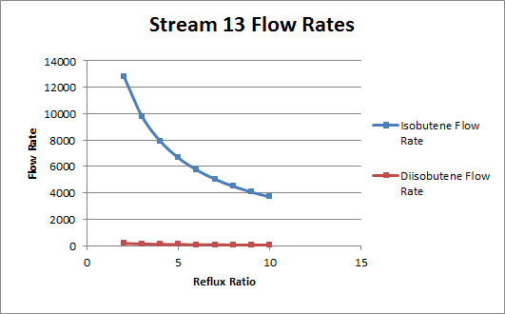

**Figure 3.19**. The flow rate of isobutylene and di-isobutylene in the bottoms of R-102 as reflux ratio changed.

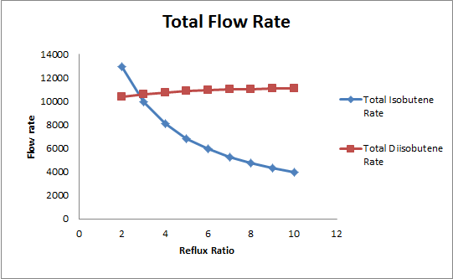

**Figure 3.20.** The total flow rate of isobutylene and di-isobutylene in R-102 as reflux ratio changed.

Finally the last variable in the distillation column that was optimized was the reboiler duty which value was ranged from 5000 to 10000 MJ/h while the mass flow rates of isobutylene and di-isobutylene were being monitored in both the top and bottom streams.

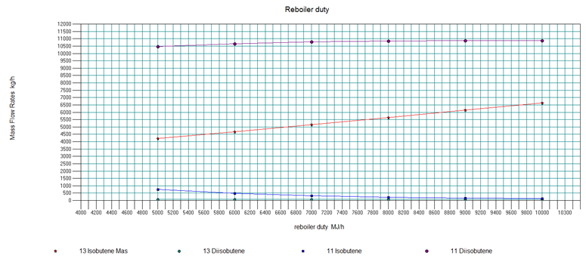

**Figure 3.21.** Plot of the flow rates of isobutylene and di-isobutylene out of R-102 as the reboiler duty changed for optimization.

Looking at Figure 3.21 it is seen that the di-isobutylene present in the bottom stream appear as if it is leveling off around 7000-8000 MJ/h with the isobutylene in the bottoms leveling off at around 8000 MJ/h. It was then decided that the optimal choice would be around 8000 MJ/h and since the value 8190 MJ/h is relatively close to that value while also being the value used in the paper it remained the optimized value for the reboiler duty.

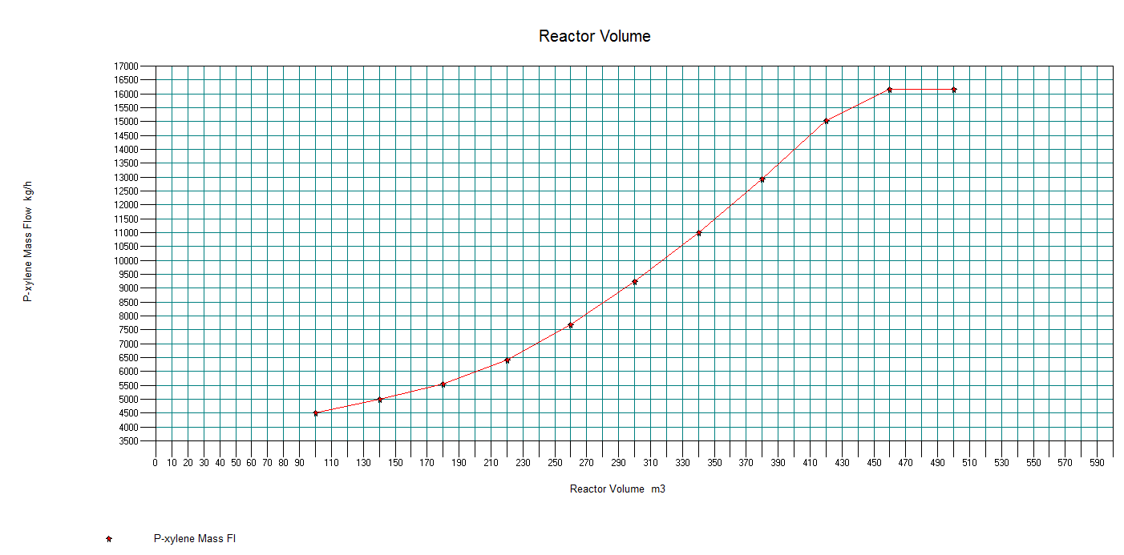

**Figure 3.22.** The relationship between reactor volume and p-xylene mass flow in third reactor used to optimize its volume.

A sensitivity study was ran on the dehydrocyclization reactor to determine the optimal reactor size to optimize the production of p-xylene. The rate constants for this reaction were found in literature given in terms of mass of catalyst. However, a catalyst weight is unable to specify in ChemCAD, so what was recorded in ChemCAD as “volume” is actually catalyst weight. Two factors were taken into consideration for the optimization of the reactor: the amount of p-xylene produced (i.e. leaving the recycle point and continuing to the rest of the process) and the total flow rate of the stream leaving the reactor. In a separate simulation, the conversion of the reactor was found to be 0.458.

After leaving the third reactor and passing the heat exchanger heating up the feed to the first reactor the stream goes through a heat exchanger that cools it down to flash the hydrogen and methane out of the stream. In Figure 3.24 and 3.25 the plot displays how the decrease in outlet stream temperature negatively affects the amount of cooling flow needed and area per shell in t the heat exchanger. At this stage of the process having more isobutylene in the product stream is not as important as increases in cost as the primary concern is the amount of p-xylene present. From the plot in Figure 3.23 it can be seen when the outlet temperature is at 40 °C the amount of p-xylene leaving the flash tank as a vapor is right before where it starts to negatively impact the flow significantly. As a result, the temperature chosen for the outlet stream of this heat exchanger was 40 °C.

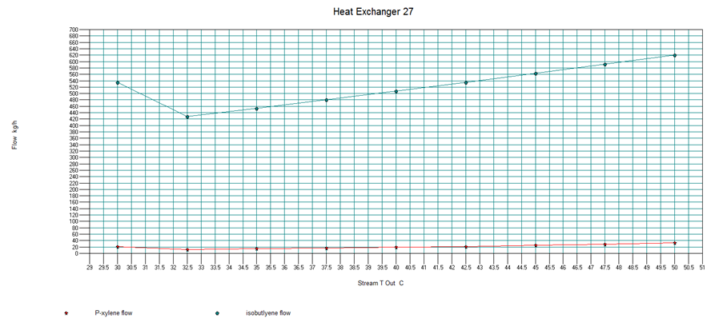

**Figure 3.23.** The amount of isobutylene and p-xylene leaving V-102 as the temperature of the stream entering it changes.

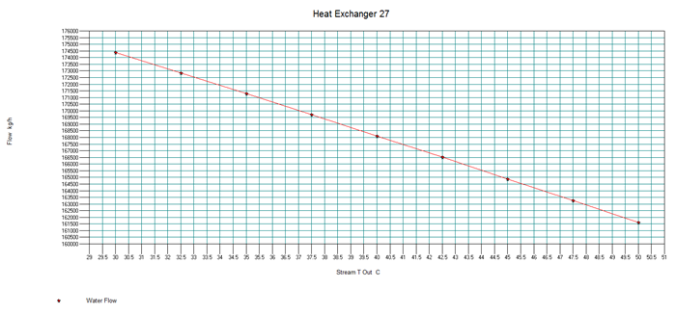

**Figure 3.24.** The amount of water flow through E-106 needed to reach the different outlet temperatures.

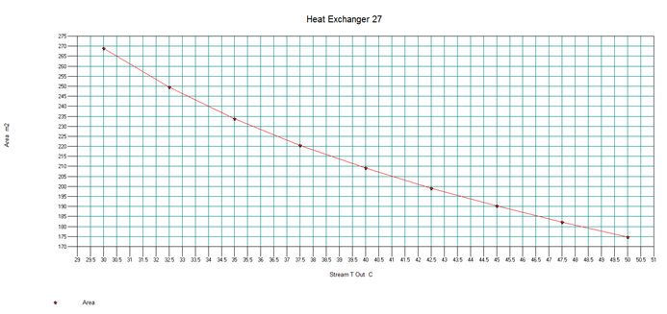

**Figure 3.25.** The area per shell of E-106 as the outlet temperature changes.

After going through the flash and component separator, it enter the distillation tower that was used to distill off the isobutylene in the product stream. It was optimized to maximize how much isobutylene was removed in the separation process. First the number of stages was compared to the amount of isobutylene and di-isobutylene leaving the bottom of the tower.

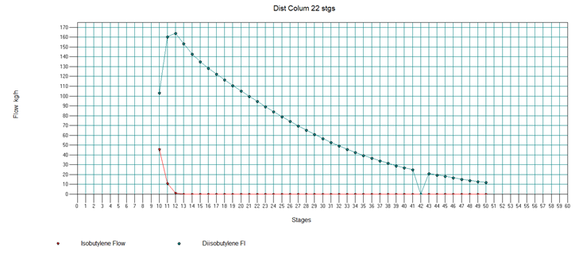

**Figure 3.26.** A plot of how much isobutylene and di-isobutylene left in the bottoms of T-101 at different number of total stages.

To maximize the amount of di-isobutylene while minimizing the amount of isobutylene in the bottoms, the number of stages was set to 13. This was done since that is when the isobutylene reached the consistent low value displayed in Figure 3.26 and di-isobutylene was still relatively close to its maximum. Next the location of the feed stages was tested against the same variables.

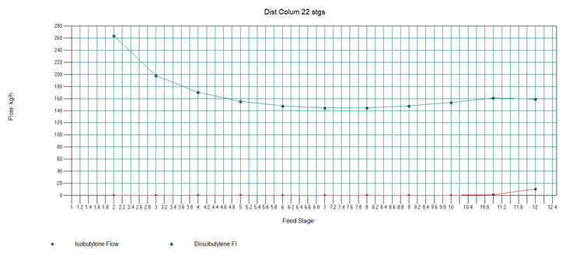**Figure 3.27.** Optimization plot of feed stage location effect on the amount of isobutylene and di-isobutylene present in the bottoms stream of T-101.

The plot in Figure 3.27 shows that the higher up the feed stage is in the distillation column the more di-isobutylene there is in the bottom stream; thus the feed stage was set to stage 2 to maximize the di-isobutylene. With the stages optimized, the reflux ratio was then examined against the same variables so the amount of di-isobutylene could be increased.

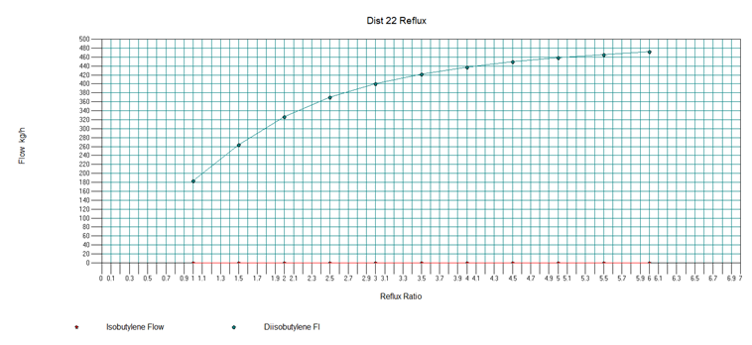

**Figure 3.28.** Plot relating the flow rates of isobutylene and di-isobutylene to the reflux ratio of T-101 for optimization.

The increase in the amount of di-isobutylene from having a larger reflux ratio, demonstrated in Figure 3.28, starts to diminish at a reflux ratio of 4.5; this was then chosen to be the value for the reflux ratio of this column. After the reflux ratio was optimized the Vapor/Bottoms mole flow ratio was tested against the specified flow rates.

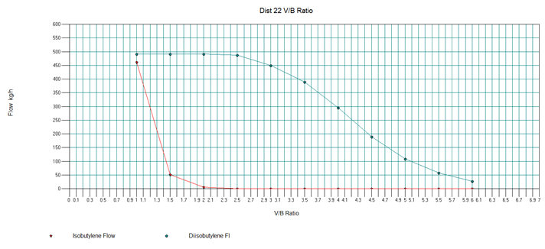

**Figure 3.29.** The effect the V/B ratio has on the flow rates of isobutylene and di-isobutylene in t the bottoms of T-101 in order for the ratio to be optimized.

With the di-isobutylene flow remaining relatively consistent in the beginning of the plot in Figure 3.29, the V/B ratio was set to 2.5 to minimize the amount of isobutylene in the bottoms while having the di-isobutylene near its maximum. After leaving the first distillation column the bottoms entered the second distillation column to have the di-isobutylene separated out in order for it to be recycled back into the process to the third reactor. Since the overall objective is to generate p-xylene, the amount of p-xylene leaving the bottoms was set to be 99 percent of the total p-xylene entering the column for the conditions of that situation would be known. Since o-xylene was not specified in the reboiler mode the amount in the top stream was monitored while looking at the amount of di-isobutylene in the bottoms stream. The first variable that was tested was the total number of stages in the column.

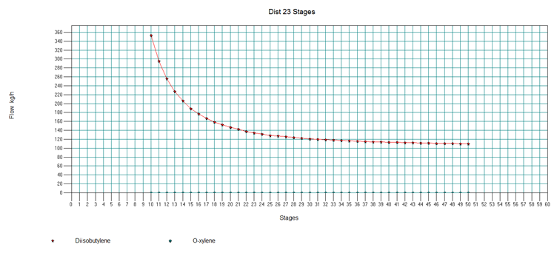

**Figure 3.30.** Plot showing how the flow of di-isobutylene in the bottoms and o-xylene in the distillate is effected by the total number of stages in T-102.

The total number of stages seemed to have no effect on the amount of o-xylene present in the top stream; it is seen in Figure 3.30 however the amount of di-isobutylene in the bottoms decreased as the number of stages increased. The amount that it deceases starts to slow down around stages 30, the amount it decreased was decided not worth the extra capital to purchase more stages, thus the number of stages was set to 30. After the total number of stages was decided upon, the location of the feed stage was tested.

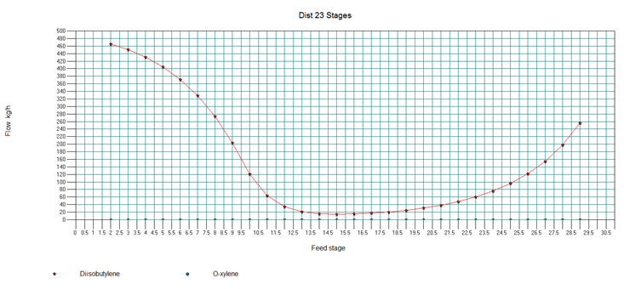

**Figure 3.31.** Optimization plot for feed stage location in T-102 and how it affects the flow rates of di-isobutylene in the bottoms and o-xylene in the distillate.

As with the total number of stages in the column, looking at Figure 3.31 it is seen that there were minimal effects on the o-xylene flow rate in the distillate. The lowest amount of di-isobutylene present in the bottoms stream was observed when it was at stage 15, which was then selected for the distillation column feed stage. Next the reflux ratio was varied between 1 and 8 to determine the optimal value.

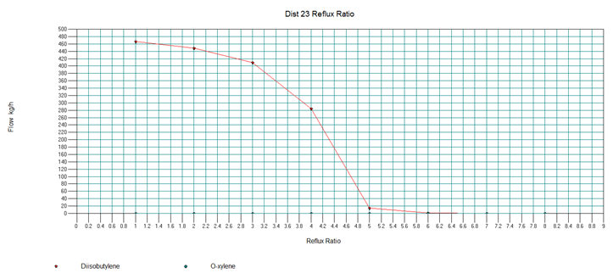

**Figure 3.32.** Relationship between the flow rates of o-xylene in the distillate and di-isobutylene in the bottoms in T-102 to the reflux ratio for optimization.

In order to get the minimum amount of di-isobutylene in the bottoms stream the reflux ratio was set to 6 as shown in Figure 3.32, anymore would not decrease the amount present in a significant manner. The next distillation column is in place to separate the most xylenes from the previous bottoms stream into the distillate of T-103 it can to get a bulk product of desired purity. The amount of p-xylene present in the distillate stream of T-103 was compared to the total number of stages for optimization.

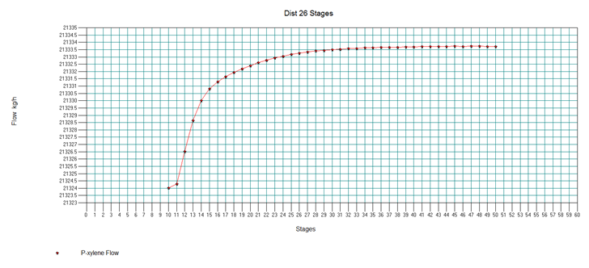

**Figure 3.33.** The effect of changing the total number of stages in T-103 on the flow rate of p-xylene in the distillate.

Displayed in Figure 3.33 is the plot showing how the amount of p-xylene starts to level off at around 30 stages, the number of stages was then set at that value. The feed stage location was the next variable optimized and plotted in Figure 3.34. When comparing to the amount of p-xylene it is seen that having the stage between 10 and 20 seem to result in the same p-xylene mole fraction (the large dips are from when the simulation did not converge). The feed stage was chosen to be at 13 which offered 0.000006 more pure p-xylene by mole fraction, although it would seem that this is probably smaller than a detectable difference in purity.

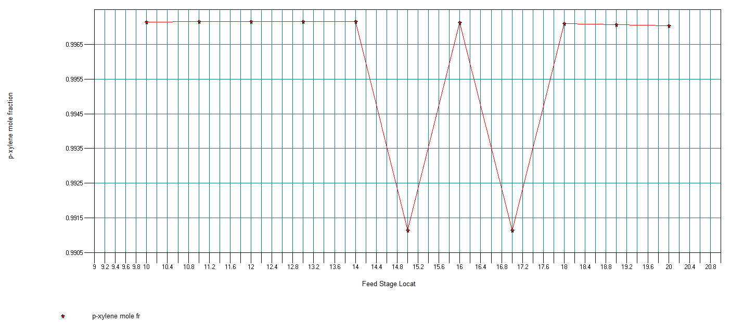

**Figure 3.34.** Optimization plot comparing the mole fraction of p-xylene in the distillate to the feed location in T-103.

The reflux ratio of the tower was optimized next; higher reflux ratios led to higher purity, but had increased reboiler and condenser heating duties. To select the desired purity, literature was consulted for “normal” purities of p-xylene from dedicated xylene separation processes. P-xylene separation processes based on crystallization have been reported to be 99.5% purity [25]. Zeolite based separations have been shown to produce purity of p-xylene from 99.7 to 99.9 % [26]. Thus, it was decided that a 99.7% pure p-xylene was to be produced, and the minimum reflux ratio that results in this purity was 2, so 2 was chosen as the reflux ratio (Figure 3.35). Note that in this case the mole fraction and p-xylene are almost identical (99.71% by weight and 99.7% by mole fraction). Of course, higher purities of p-xylene could be produced if the reflux ratio is increased enough, but there are diminishing returns in terms of the purity increase from a given increase in required heating duty.

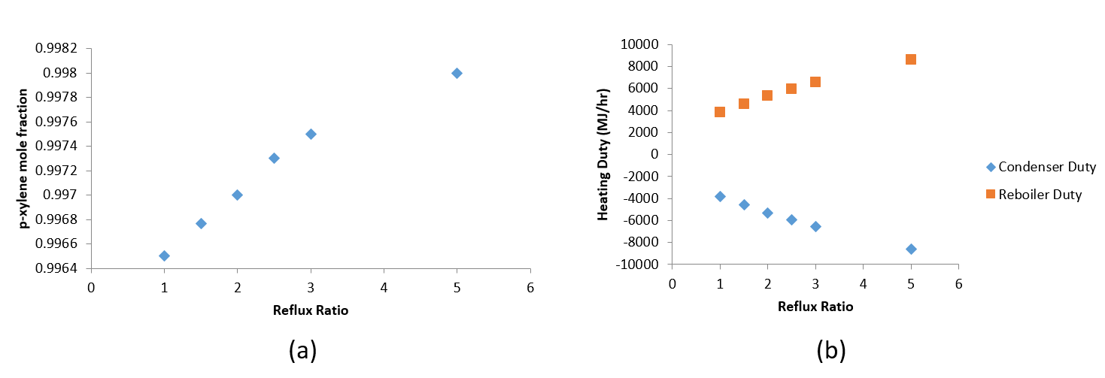

**Figure 3.35.** Optimization of T-103 Reflux Ratio (a) Increased reflux ratios led to higher p-xylene mole fraction in the distillate but higher condenser and reboiler duties (b).

The last distillation tower, T-104, was optimized next. Figure 3.36 shows the optimization of the number of trays. The figure shows a significant increase in the purity after the tray number is increased from 29 to 30. To examine the horizontal region, a second sensitivity study was performed to determine the effect of adding more trays. Figure 3.37 shows the result of this study. The purity of p-xylene indeed gradually increases with more stages. However, the increase is greatly exaggerated by the axis scaling in the figure. The effect of adding 16 more trays is a 0.0003 increase in the mole fraction of p-xylene. The cost of adding these trays is not worth the increase in p-xylene purity, so 30 stages (29 trays) was determined to be the number of stages for T-104.

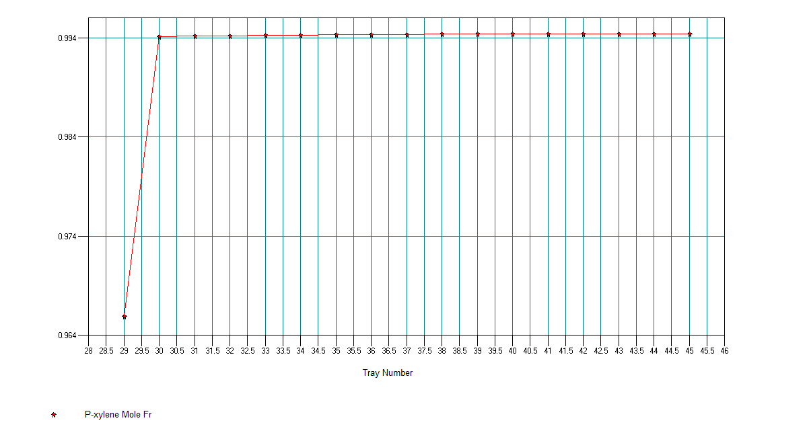

**Figure 3.36.** The effect the number of trays in T-104 had on the p-xylene mole fraction in the distillate.

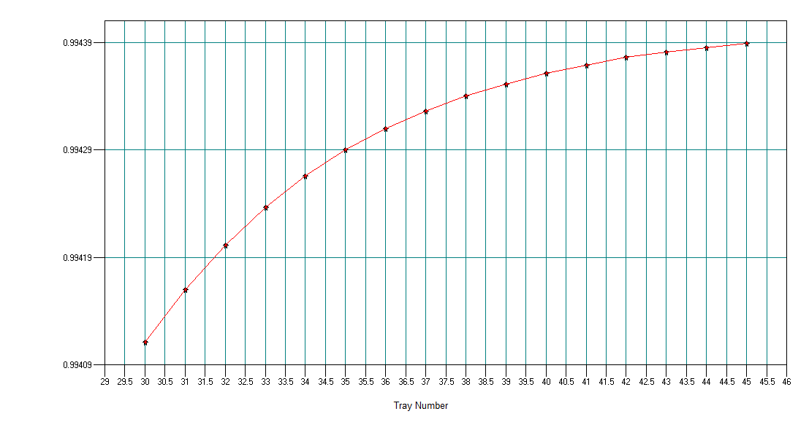

**Figure 3.37.** Plot focused more closely on increase of p-xylene mole fraction in the distillate of T-104 after the total number of stages increased above 30 stages.

The feed stage location was optimized next. The optimal feed stage location as seen in Figure 3.38 was found to be 15.

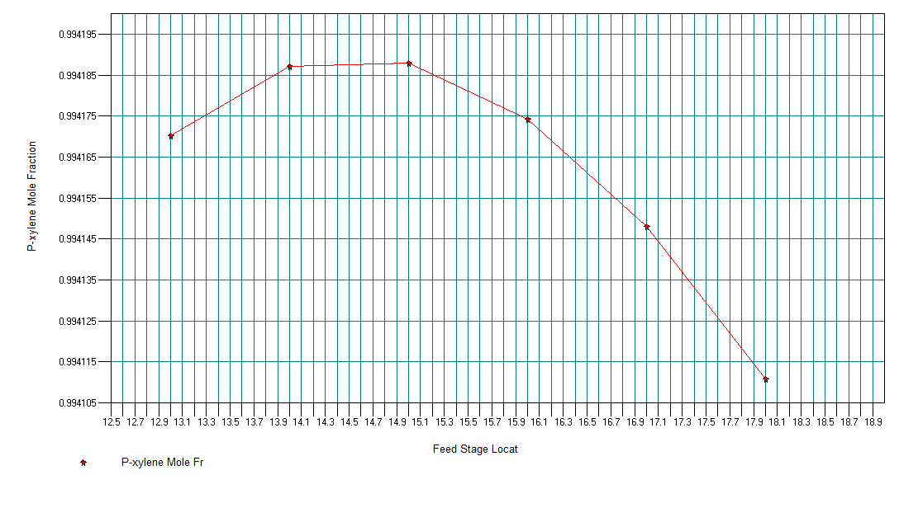

**Figure 3.38.** Optimization plot of feed stage location on T-104 based on the p-xylene mole fraction of the distillate.

Finally the reflux ratio was optimized and plotted in Figure 3.39. A 99.7% purity was possible if the reflux ratio was increased to 6.5. However, the increase in reflux ratio also lowered the flow rate of the p-xylene distillate. A 99.7 % purity stream was found to have a flow rate of approximately 900 kg/hr. In contrast, a 99.5 % purity p-xylene stream had a flow rate of 1200 kg/hr. Since 99.5 % is the purity of crystallization based methods, the reflux ratio was chosen to be 3.1 to produce 99.5 % p-xylene at a higher flow rate instead of 99.7 % p-xylene at a much lower flow rate. The TPA process requires p-xylene in relatively high purity, so if the 99.5% grade p-xylene is of insufficient purity for the production of TPA, then it can be sold as a separate product instead of feeding it into a second process.

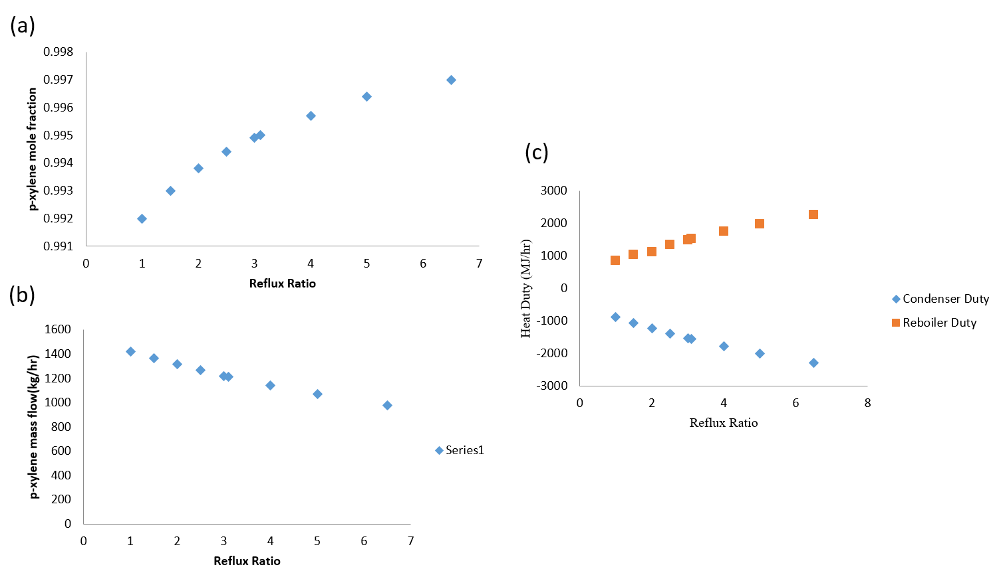

**Figure 3.39.** Optimization of T-104 Reflux Ratio (a) p-xylene mole fraction increased as reflux ratio increases (b) Flow rate of p-xylene decreased with increasing purity and reflux ratio (c) Increased reflux ratio led to higher condenser and reboiler duties

3.6 Sources of Error in Simulation

There were a few sources of error in these simulations. First, the lack of experimental VLE models means that the thermodynamic model choices were unable to be confirmed for the components present in the process. The VLE looked reasonable by eye, but that is not a valid way to justify the choice of a thermodynamic model. As a result, the results in the simulation may not be optimal or may even be untrustworthy. Nonetheless, the best thermodynamic models were selected using available information. Another source of error in the simulation was the faulty and incomplete kinetic data given for the dehydrocyclization reaction. The paper cited for the kinetics of the dehydrocyclization reaction only reported a rate constant and did not report an activation energy. Thus, an activation energy and frequency factor needed to be “guessed” in order to produce the same rate constant at the experimental reaction temperature. Of course, this method is not very accurate and since the reaction is running under adiabatic conditions, the activation energy actually plays a significant role in determining the conversion, unlike in an isothermal reactor where the rate constant would remain constant.

## **Chapter 4: Design Justification**

### 4.1. Summary of p-xylene to TPA Design

Because of time constraints, a detailed design could not be done on the p-xylene oxidation process to produce TPA (see Alternative Design 3). Here, a brief overview of the presentation of the work done on the process is given. The process that was chosen to be modified was the Amoco process; this was due to how widespread the process was in industry, due to the excellent yield and low solvent loss in a single reactor pass [8], and relative ease the modification could be implemented in the process. Figure 4.1 shows the preliminary PFD of a TPA production plant that was designed during the early stages of the project.

The oxidation reactor in the original process is typically a bubble reactor; this was replaced with a spray reactor, shown in Figure4.1, to increase the oxidation of p-xylene to TPA. This is because, in the original reactor, gas-to-liquid mass transfer limitation restricted the conversion due to the rapid oxidation rates. This causes oxygen starvation in the liquid phase containing the reactants. By having the liquid reactants enter the reactor as micro droplets the gas-liquid interfacial area is enhanced relative to the original reactor; if the oxygen around the droplets can effectively enter the droplets it has potential to completely oxidize it. This produces purer TPA as the diffusion time scale becomes shorter than the kinetic time scale. By implementing this change it is believed that the hydrogenation section used to purify the crude TPA can be removed from the process, as the resulting TPA from the oxidation reactor will have a low enough concentration of 4-CBA to produce PETE [27][28]. An additional spray reactor was introduced into the design to offset the downtime brought forth from having a semi-batch reactor.

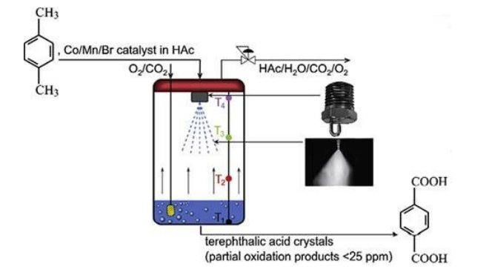

**Figure 4.1.** Basic conceptual design of spray reactor used to oxidize p-xylene [28].

For this oxidation the catalyst of choice was a mixture of cobalt, manganese, and bromide ions in acetic acid solvent, the same as catalyst in a typical Amoco process. These ions were produced from cobalt and manganese acetate, while the bromide ions were generated from hydrobromic acid. With the use of the ion catalyst, carbon steel became unsuitable as a material of construction for the equipment in contact with it resulting in the equipment having to be lined with titanium.

After the reactor, the process proceeds similarly to the regular Amoco process by running the TPA containing stream through a crystallizer, a centrifuge, and a dryer; afterwards however, instead of having the dried TPA continue on to a hydrogenation process in order to reduce the 4-CBA concentration, it is simply stored as is due to the TPA satisfying PETE purity standards. The mother liquor from the centrifuge, along with any condensed materials from the recycled vapor streams, mix with isobutyl acetate allowing azeotropic separation of the stream. The catalyst exists the in the bottoms along with some acetic acid where it heads towards catalyst recovery. If the bromide ions in the stream are not recovered they may trigger the formation of manganese 4+ ions, which will then precipitate out as manganese dioxide; this compound then in turn deactivates the catalyst creating an increase of carbon oxides and methyl group radicals that promote bromide ion loss creating a catalyst deactivation cycle. To prevent this catalyst loss bromide ions are recovered using sodium chloride.

### 4.2. Catalyst Selection for isobutanol to p-xylene

Based on literature and the availability of kinetic data, **γ-**alumina was chosen to be the catalyst for the dehydration reactor. **γ-**alumina is a commonly used catalyst for dehydration reactions and is readily available at low cost . The oligomerization reaction was to be carried out using Ni-Al2O3 as only sufficient kinetic data was available for this catalyst in literature [29]. In a similar manner, Pt supported on activated carbon was chosen as the catalyst for the dehydrocyclization reaction based on the availability of kinetic data. In reality, catalyst selection would be much more dependent on cost. The standard catalyst used for this dehydrocyclization reaction, for example, is chromium oxide supported on alumina. However, using a non-optimal catalyst means the economic results reported lean towards a “worst” case scenario, so if the process can turn a profit based on a sub-optimal case, then it will simply make even more profit in the optimal case.

### 4.3. Reactor Selection

A multi-tubular fixed bed reactor was chosen as the reactor type for the dehydration reactor. Packed bed reactors (PBR) are the standard reactors used when working with heterogeneous catalysts in the reaction. While it was desired to use a packed bed reactor in this case, due to them suffering from a lack of efficient heat transfer and the tendency to develop temperature gradients and hotspots it was not selected [30].

After the dehydration of isobutanol the resulting isobutylene will undergo an oligomerization reaction to produce di-isobutylene. A reactive distillation column was chosen for the reaction as it is able to separate out the di-isobutylene from the reactive site through distillation, preventing further reaction into more complex oligomers. This separation results in an overall increased selectivity for di-isobutylene and less formation of tri-isobutylene. The formation of little tri-isobutylene meant that little to no tetra-isobutylene would form, so it was ignored in simulation [29].

A fixed bed reactor was selected for the dehydrocyclization reactor. The reaction temperature was 500 °C which is difficult to maintain isothermally. Thus, the reactor was run adiabatically, so extensive surface area was not required so a multi-tubular fixed bed reactor was not chosen. Compared to moving bed reactors, catalysts do not degrade from shearing in fixed bed reactor. The catalyst used in this reactor is expensive, so degradation should be minimized by selecting a fixed bed reactor.

### 4.4. Material of Construction

No notable corrosive chemicals were present in the main process of converting isobutanol to p-xylene, thus most of the process was constructed using carbon steel. However with certain units operating at high temperatures and pressures, along with possible hydrogen embrittlement the use of carbon steel in these units would be incompatible. Copper and titanium is generally applicable for most hydrogen service applications [31]. Copper was chosen as the material of construction for the tube side of the heat exchanger that came into contact with hydrogen. Titanium was chosen as the material of construction for the flash tank V-102 that also comes into contact with hydrogen. Reactor R-103 was also to be made of titanium. The fired heater was to be made of stainless steel as carbon steel has low structural integrity at its operating temperatures.

### 4.5. Process Operating Conditions

The operating temperatures of the process were carefully selected using simulation to optimize heat integration. The reactor temperatures were effectively set based on the temperature ranges reported for each reaction. The dehydration reaction was reported to be carried out at 500 °C, so that was chosen as the temperature of R-101. Similarly, 85 °C was chosen to be the feed inlet temperature to the reactive distillation reactor (R-102) which was the midpoint temperature of a study done on reactive distillation of the oligomerization reaction [29]. The dehydration of isobutanol was reported to be independent of pressure [32] which was also confirmed during simulation. The pressure was optimized at 9 bars for the first section of the process by optimizing the stream temperature before V-101 such that the isobutene could be condensed at a high enough temperature such that cooling water could be used. Through simulation, the temperature of the streams before V-101 was optimized such that it was the highest temperature possible that could safely retain the stream as a liquid (i.e. 30 °C). Similarly, the temperature entering V-102 was made as high as possible without flashing off significant amounts of p-xylene with the methane and hydrogen. This temperature was optimized to be at 40 °C. The pressure entering reactor R-102 was chosen as 15 bar as this is the pressure for this reaction cited in literature [29]. The dehydrocyclization reaction is usually ran under near atmospheric pressure [33]. However, to avoid pressure swings in the process the dehydrocyclization reaction was run at 10 bar. A higher pressure for this reaction lowers the yield of product; there are more moles of product formed than reactant so operating at higher pressures drives the reaction to favor the reactant. Nonetheless, this effect was found to be minimal, and 10 bar was deemed an acceptable pressure to operate R-103. Finally, prior to T-103 and T-104, the pressure of the process was lowered to 2.75 bars. The temperature was first lowered to 180 °C to avoid flashing any of the material when the pressure was lowered. The lowered pressure was for in preparation for the next oxidation step of p-xylene. The optimized pressure for the oxidation reactor was 2.75 bars (Team 6).

4.6. Production of Value-Added Products

A consequence of running a high temperature reactor is the formation of many side products in addition to the main p-xylene product. The high temperature reactor tends to break C-C bonds and cause a wide spectra of products to form. Many of these products are not of high value (e.g. methane) and are used to fuel the fired heater. 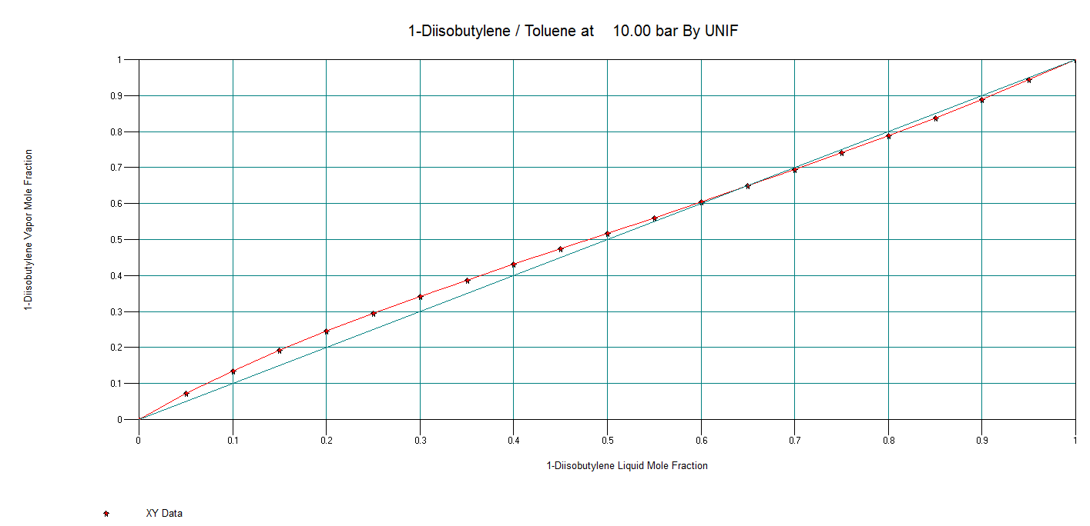

**Figure 4.2.** The XY plot of di-isobutylene and toluene at 10 bar.

Toluene is a valuable side product that is produced. However, the separation of toluene from di-isobutene is a very difficult separation (Figure 4.2) as the two have very similar boiling points and form an azeotrope. The amount of toluene is not significant enough to warrant an entire section dedicated to its purification. Thus, toluene was deemed unsuitable for sale. Stream 34 contains the majority of the toluene leaving the system, but it is low in purity and diluted in a majority of di-isobutylene.

Isobutene has uses in forming methyl-tert butyl ether and ethyl-tert-butyl ether. Di-isobutylene has uses in forming octylphenol resins that can be used as tackifiers and can also be used to form octylated diphenylamine which can act as a stabilizers [34]. The purge containing unreacted reactants in the recycle from R-102 contained 93 % purity isobutene, so this stream was collected and was to be sold as impure isobutene. The vapor stream coming off V-102 contained a large quantity of hydrogen (0.93 mole fraction), and was to be used as a fuel source for fired heater H-101. Stream 30 contains a large amount of impure isobutene (about 66%), so this was to be collected and sold as even lower grade isobutene. The distillate from T-102 contained large amounts of DIB, and the purge from the recycle was to be collected and sold as impure DIB. Finally, the bottoms stream from T-104 contained a large quantity of p-xylene (447 kg/hr), so this stream could be sold as impure p-xylene (91.3 % mole purity).

### 4.7. P-xylene Production Process Walkthrough

One of the first major design decisions made was the selection of a feed rate and composition.

The production of bio-isobutanol comes from a fermentation process. However, fermentation media is largely aqueous based in isobutanol is toxic to the microbes that produce it in high concentrations. Therefore, bio-based isobutanol is produced at very low concentrations and then undergoes subsequent purifications in order to be sold as a product. Kaminski estimated the isobutanol concentration in fermentation media to be about 3 % [35].

Isobutanol forms an azeotrope with water with a concentration that is 70 % by weight isobutanol. Thus, the feed was chosen to have a concentration less than 70 % weight isobutanol to lessen the burden of upstream separation and make the raw material of the feed cheaper. A 30 % mol fraction of isobutanol (63.8 % weight) of isobutanol was chosen as the feed composition. The feed rate was determined by setting a target production rate of 5 % of the current North America PETE production. The worldwide PETE supply was estimated to exceed 24.39 million tons a year in 2015 [3] of which 14 % was used by North America. This calculates to approximately 150,000,000 kg/year of PETE, so 150,000,000 kg/year (17123 kg/hr) of isobutanol seemed like a reasonable feed rate. Finally, since the isobutanol feed was only 0.638 of the weight of the feed stream, the total inlet feed was 26839 kg/hr where the extra mass is due to water.

For this entire process, shell and tube heat exchangers were the most suitable type of heat exchanger for the process because they are suited for high temperature and pressure operations [36]. Fouling may be a problem in the process, but plate and frame heat exchangers do not have a wide operating range of temperature and pressure [36], so although they are easier to clean, they would not be suitable for this process. Due to large differences in temperatures in the shell and tube side fluid, a floating tube sheet head was chosen instead of a stationary tube sheet to allow for differential expansion. Although single tube side pass is the most efficient due to true countercurrent flow, they break easily and are expensive to build. Therefore a two tube pass shell and tube heat exchanger was decided to be the heat exchanger design for all heat exchangers involved in the process. The cooling water used in this process was set at 20 °C and 5 bar. The maximum return temperature was set as 43 °C as higher temperatures increase the amount of fouling due to lowered solubility of calcium carbonate.

Much of the work done in this design was minimizing energy costs by using extensive heat integration techniques. The proposed reaction scheme to obtain p-xylene involves three reactions. However, the first and third reactions are at high temperatures while the second reaction is at a moderately low temperature. Heating and cooling and then heating the process stream again is a very inefficient way of going about this process as much energy will be lost this way.

The first reaction in the process is the dehydration of isobutanol. This temperature for the dehydration reactor has been cited in literature ranging from 300 to 350 °C. From simulation, the temperature was optimized to be 325 °C. The initial design of the process (see Alternative Design 1) involved the use of a product heat exchanger, but immediately after used a fired heater to preheat the feed to R-101. Instead of requiring the use of two fired heaters, a second product heat exchanger (E-102) was added instead. The hot fluid for this heat exchanger is the output of the dehydrocyclization reactor (R-103). The dehydrocylization reactor is run at 500 °C, but the stream needs to be cooled down for subsequent product separation, so instead of using a separate cooling source and heating source, a decision was made to implement a product heat exchanger to preheat the reactants entering the first reactor using the product stream from the third reactor. This reaction in R-101 is endothermic and requires a heating source to maintain its temperature. A thermal fluid system was designed provide heat to this reaction. As such, R-101 was designed as a multi-tubular packed bed reactor to increase surface area for heat exchange. As shown earlier, it was found that the required volume of the reaction was large enough such that the area of the tubes required for the volume vastly exceeded the amount required to maintain isothermal conditions under the assumed inlet and outlet temperatures of the process stream and the thermal oil.

After leaving reactor R-101, the product stream goes through three heat exchangers and is condensed into a liquid. The condensation is difficult due to the high volatility of isobutene (normal b.p. -6.9 °C), so the system is run at a higher pressure of 9 bar which allows the stream to condense at 30 °C. This is advantageous as it allows cooling water to be used a source of cooling for this stream instead of a refrigeration process. The isobutene-water stream was desired to be condensed into a liquid due to the near complete separation of isobutene and water due to them being nearly insoluble. In addition, the stream needed to be further pressurized to 15 bar, and it is much less energy intensive to pressurize a liquid stream with a pump than a gaseous stream with a compressor. Stream 13 which entered R-102 was required to be heated to 85 °C, but is at 30 °C after leaving the liquid liquid separator. After the isobutene product is separated from the water, it passes through E-103 where it is heated up by the product stream from R-101 while simultaneous cooling down the product stream to reduce the cooling water load on E-104.

Before entering the reactive distillation unit R-102, the stream 13 is combined with a recycle stream containing unreacted isobutene that were separated out in the distillation. The reactive distillation allows the separation of the C4 compounds from the C8 compounds and negates the need for a chain of flash drums for the separation as was proposed in Alternative Design 1. A reactive distillation was chosen for this reaction because it reduces the formation of trimers by actively removing dimers as they are formed. The high difference in boiling point between isobutene (normal -6.9 °C) and di-isobutene (normal bp 101 °C) makes this an easy separation. The top product is mostly recycled and fed back into the reactive trays while a small amount is collected in TK-102 to be sold as impure isobutene.

The bottoms product of R-102 (stream 16) then needed to be heated to 500 °C and have its pressure dropped to 10 bars before it entered R-103. The stream is first heated to the gaseous phase using high pressure steam, and then enters a gas turbine (J-101) where it generates electricity. The gaseous stream is combined with a recycle stream of DIB and together they enter a fired heater (H-101) where the stream is heated to 500 °C before it enters reactor R-103. The dehydrocyclization reaction is carried out in R-103 and results in many side products. The high temperature of the reaction makes it difficult to maintain isothermal conditions as 500 °C is beyond the operating temperatures of most thermal fluids and another heat transfer fluid such as molten NaCl would have to be used instead. However, instead of attempting an expensive process to maintain an isothermal reactions, R-103 was to be carried out as an adiabatic process instead. The reaction is endothermic, so the outlet temperature from R-103 is lower than 500 °C. From simulation, it was determined to be 370 °C for the amount of product that reacted. As mentioned earlier, this stream is then used to preheat the feed stream to R-101 to 325 °C at E-102. This reduces the need for a second fired heater as well allows cooling of the the stream from R-103.

The stream from R-103 needed to be cooled down in order to separate out the lighter gases (i.e. hydrogen and methane). However, the stream is initially all in the vapor phase, so flashing off the stream would also be flashing off the p-xylene product. Thus, it was necessary to condense the product as much as possible. The methane and hydrogen would not condense as their boiling points are well below that of any other component in the stream. The optimized temperature from simulation was 40 °C for this separation. Some isobutene is lost in the flash, but is unavoidable due to its volatile nature. The vapor stream from the flash vessel V-101 contains mostly combustible gases, so it is fed to the fired heater (H-101) as fuel.

The liquid outlet from V-101 then undergoes further separation at T-101. The purpose of T-101 is to distill off the isobutene, linear butenes, and other lighter hydrocarbons (C5 and less). The distillate product is then collected in TK-103 and will be sold as impure isobutene. The bottoms product from T-101 contains heavier hydrocarbons such as the p-xylene product, unreacted DIB, TIB, and toluene. T-102 separates off the DIB from the p-xylene and TIB. However, as mentioned earlier, the boiling point of DIB and toluene are very similar, so they are very difficult to separate from each other. Thus, the distillate contains both DIB and toluene with the vast majority of the stream being DIB. This reacted DIB is recycled back to mix with the feed to R-103. The purge stream from this reaction contains a high quantity of DIB which is then condensed at E-118 and collected at TK-104 to be sold as impure DIB.

The bottoms product from T-102 contains mostly p-xylene with trace amounts of o-xylene and TIB. To increase the purity of p-xylene by separating out the TIB, stream 31 (bottoms product of T-102) is fed into a third distillation unit (T-103). Before being fed to this unit, the temperature and pressure of the stream were dropped to the operating conditions specified for the oxidation reaction of p-xylene to form TPA in the downstream process (i.e. 180 °C and 2.75 bar). T-103 was optimized to produce p-xylene at 99.7% purity which is then collected and stored in TK-105, or could be used to feed into a downstream TPA production process. Both scenarios are considered in the economic analysis. The bottoms product contains a significant amount of p-xylene at mediocre purity of 97% mole fraction. A fourth distillation column is used to separate out the p-xylene from the DIB. This distillation column produces 99.5% pure p-xylene in the top stream and 91.3 % purity p-xylene in the bottoms stream. Although higher purity p-xylene could be produced in this column, an inverse relationship was found between the purity of the p-xylene product and the flow rate of the p-xylene recovered. If higher p-xylene was made in this unit, there would still be significant amount of p-xylene in the bottoms stream of T-104 making it perhaps necessary to install another distillation unit to recover that p-xylene. Thus, a 99.5 % purity was deemed acceptable (also for reasons discussed in the latter paragraph). This p-xylene is then stored in TK-106 or could be fed into a downstream TPA process depending on the configuration of the plant. Finally, the impure p-xylene stream (91.3%) is stored in TK-107 to be marketed as impure p-xylene.

The separation of p-xylene from o-xylene was deemed unnecessary for this process. The amount of o-xylene produced was very small, and after optimization of the process, streams of 99.7% and 99.5% by weight (and mole fraction) purity of p-xylene could be produced. For comparison, industrial grade p-xylene separation from o- and m-xylene via crystallization has a purity of 99.5 % [25] and 99.7 % via zeolite adsorption. At first glance it may seem strange that the process is able to produce p-xylene at a purity competitive with processes dedicated to xylene isomer separation. However this is because the xylene isomer separation processes are dealing with a mixture of xylene isomers that are all present in abundant quantities. In the designed process, however, o-xylene is produced in very small amounts as a side product and thus there was not much o-xylene present in the stream at all, making a dedicated xylene isomer separation unnecessary. The side products of the reaction did not include m-xylene as a product.

## **Chapter 5: Economic Analysis**

### 5.1. Equipment Sizing

**Flash Tanks**

The orientation of a flash tank is dependent on the ratio of the vapor and liquid flow rates entering it. In general, horizontal flash tanks are preferred when the stream that enters it has a very low vapor/liquid ratio. Vertical flash drums have a smaller diameter which would result in a higher liquid level which may result in inefficient separation and trapping of gas in the liquid stream. In this process, the stream entering flash vessel V-102 is composed largely of liquid and thus has a low vapor/liquid ratio. The use of a horizontal flash drum would result in a more stable liquid downstream flow leading to less foaming and less gassing.

Flash tank sizing according to the theoretical estimation formula from *Separation Process Engineering: Includes Mass Transfer Analysis [37]* where cross-section area follows formula 5-1

|  |  |  |
| --- | --- | --- |
|  | $$A_{c}=5×\frac{N_{vapor}MW_{vapor}}{u_{perm}\left(3600\right)ρ_{vapor}}=5×\frac{M_{vapor}}{u_{perm}\left(3600\right)ρ_{vapor}}$$ | (5-1) |

Where Ac is the estimated cross-section area in ft2 ; Nvapor is the molar flow rate of vapor in the flash tank under unit: lb-moles/hr; MWvapor is the equivalent molecular weight of vapor stream in the flash tank under unit: lbm/lb-mole; Mvapor is the mass flow rate of vapor stream under unit: lbm/hr; 3600 has unit sec/hr which convert 1 hour to 3600 seconds; ρvapor is the density of the vapor stream in flash tank has unit: lbm/ft3; uperm is the maximum permissible vapor velocity estimated by equation 5-2 under unit ft/sec.

|  |  |  |
| --- | --- | --- |
|  | $$u_{perm}=K_{drum}\sqrt{\frac{ρ_{liquid}-ρ_{vapor}}{ρ_{vapor}}}$$ | (5-2) |

Where ρliquid is the flash drum’s liquid stream density under unit lbm/ft3; ρvapor is the same unit mentioned previously in equation 5-1 which is the vapor stream density under unit lbm/ft3; Kdrum is a constant that follows equation 5-3:

|  |  |  |
| --- | --- | --- |
|  | $$K_{drum}={1.25e}^{A+B\ln{F_{lv}+C}{(\ln{F_{LV})}}^{2}+D{(\ln{F_{LV})}}^{3}+E{(\ln{F_{LV})}}^{4}}$$ | (5-3) |

A,B,C,D,E are all constants with no unit where A equals to -1.87747809; B equals to -0.8145804597; C equals to -0.1870744085; D equals to -0.0145228667; E equals to -0.0010148518 and FLV is a liquid-vapor flow factor with no unit which can be calculated using Equation 5-4.

|  |  |  |
| --- | --- | --- |
|  | $$F_{lv}=\frac{M_{liquid}}{M_{vapor}}\sqrt{\frac{ρ_{vapor}}{ρ_{liquid}}}$$ | (5-4) |

Where Mliquid is the liquid stream mass flow rate under unit lbm/hr; Mvapor is the vapor stream mass flow rate under unit lbm/hr; ρliquid is the flash drum’s liquid stream density under unit lbm/ft3; ρvapor is the vapor stream density under unit lbm/ft3. Combine Equation 5A, 5B, 5C, 5D, Equation 5E is built up.

$$D_{horizontal}=\sqrt{\frac{20M{}_{vapor}}{{1.25e}^{A+B\ln\left(\frac{M_{liquid}}{M_{vapor}}\sqrt{\frac{ρ_{vapor}}{ρ_{liquid}}}\right)+C{(\ln{(\frac{M_{liquid}}{M_{vapor}}\sqrt{\frac{ρ_{vapor}}{ρ_{liquid}}}))}}^{2}+D{(\ln{(\frac{M_{liquid}}{M_{vapor}}\sqrt{\frac{ρ_{vapor}}{ρ_{liquid}}}))}}^{3}+E{(\ln{(\frac{M_{liquid}}{M_{vapor}}\sqrt{\frac{ρ_{vapor}}{ρ_{liquid}}}))}}^{4}}×\sqrt{\frac{ρ_{liquid}-ρ_{vapor}}{ρ_{vapor}}}× 3600×ρ_{vapor}×π}}$$

(5-5)

This concludes that in order to estimate cross-section area of the flash rank requiring mass flow rate of the vapor stream and liquid stream Mvapor, Mliquid; density of the vapor and liquid stream ρliquid, ρvapor. All four values can be accessed via ChemCAD simulation as ChemCAD predict the stream properties.

As the cross-section area is estimated, assuming cyclic shape of the cross section, thus, diameter of the cross-section area is:

|  |  |  |
| --- | --- | --- |
|  | $$D_{horizontal}=\sqrt{\frac{4A_{c}}{π}}$$ | (5-6) |

Where Dhorizontal is the diameter of the cross-section area under unit ft; Ac is the cross-section area estimated via equation 5E under unit ft2.

According to *Separation Process Engineering: Includes Mass Transfer Analysis [37]* There is a rule of thumb that ratio between height of flash tank and cross-section diameter ranges from 3.0 to 5.0, ratio of 4 which lies in the middle is picked for sizing. Therefore, the height of flash tank is:

|  |  |  |
| --- | --- | --- |
|  | $h_{total}=k_{flash}×D_{horizontal}$ | (5-7) |

Where htotal is the total height of the flash tank under unit ft; Dhorizontal is the radius estimated from Equation 5-6; kflash is a constant with no unit has value 4.

**Distillation Columns**

The cost of the distillation column was estimated with the assumption that the reflux drum and pump were worth 30 % of the vessel and tray cost. It was determined that the vapor flow rates within the columns were adequate enough to keep liquid from flowing through the holes of the sieve trays, the primary concern in using them, allowing all columns to use sieve trays. No corrosive chemicals were separated in any of the distillation columns and none of the distillation columns were run at high temperature, so the column and tray material of construction are all to be made from carbon steel.

The diameter of distillation column according to *Dr. Vogel’s Separation System Design,* the diameter of the distillation column can be estimated via equation 5-8:

|  |  |  |
| --- | --- | --- |
|  | $$D_{c}=\sqrt{\frac{4M_{vapor}}{πρ_{vapor}u_{f}f_{flood}\left(1-\frac{A_{d}}{A}\right)}}$$ | (5-8) |

Dc is the estimated diameter of the column with units m; Mvapor is the mass flow rate of the vapor stream in the column with units kg/sec; ρvapor is the vapor stream density with unit kg/m3; uf is the flooding velocity of the column has unit m/sec; fflood is the flooding factor indicate the ratio between operating velocity and flooding velocity. Normally, operating velocity would account for 75% to 85% of the flooding velocity. In this case, 85% of the flooding factor is chosen. Flooding factor has expression of Equation 5-9. Ad is the area of down-comers, A is the total area, Ad/A gives a down-comers to total area ratio. The down-comers/total area ratio usually ranges from 0.1 to 0.2, in this case, 0.15 is used for down-comer/total area ratio. uf is the flooding velocity with unit m/sec as it is the flow velocity of vapor stream inside a distillation would cause flooding conditions of the column. The flooding velocity can be estimated via Equation 5-10.

|  |  |  |
| --- | --- | --- |
|  | $$f_{flood}=\frac{u_{operating}}{u_{f}}$$ | (5-9) |

|  |  |  |
| --- | --- | --- |
|  |  | (5-10) |

In Equation 5-9, fflood is the flooding factor, uoperating is the operating vapor stream flow velocity inside the column, uf is the flooding vapor stream flow velocity. fflood equals 0.85 is used for sizing. In equation 5-10, for estimating flooding velocity, uf is the flooding velocity with unit m/sec; ρvapor is the density of vapor stream inside the column with unit kg/m3;ρliquid is the density of liquid stream inside the column with unit kg/m3; k1,adjusted is a constant factor with units m/sec which can be calculated through Equation 5K:

|  |  |  |
| --- | --- | --- |
|  | $$k_{1,adjusted}=k_{1}{\left[\frac{σ}{0.02}\right]}^{0.2}$$ | (5-11) |

Where σ is the surface tension of the stream with unit N/m; k1 is a capacity factor correlated by *James Fair*. The value of k1 with unit m/sec can be pinpointed through Figure 5.1 by knowing the spacing of the plates, the height of between each tray, htray with unit m and liquid-vapor flow factor calculated using Equation 5-4.

All the equations combined to Equation 5-12 to calculate the diameter of the distillation column.

|  |  |  |
| --- | --- | --- |
|  | $$D_{c}=\sqrt{\frac{4M_{vapor}}{πρ_{vapor}k_{1}{\left[\frac{σ}{0.02}\right]}^{0.2}{\left(\frac{ρ_{liquid}-ρ_{vapor}}{ρ_{vapor}}\right)}^{\frac{1}{2}}f_{flood}\left(1-\frac{A_{d}}{A}\right)}}$$ | (5-12) |

From equation 5-12, diameter of the column depends on mass flow rate of vapor stream Mvapor, density of vapor stream and density of liquid stream ρvapor, ρliquid, surface tension σ of the entering stream. K1 is depend on height of each tray htray and liquid-vapor flow factor FLV. Liquid-vapor flow factor FLV depends additionally on mass flow rate of liquid stream Mliquid. fflood is picked to be 0.85 and Ad/A is picked to be 0.15. To sum all the variables u, the diameter of the column depends on Mvapor, Mliquid, ρvapor, ρliquid, σ and htray. All of the variables except htray are stream physical properties which can be accessed from ChemCAD simulation.

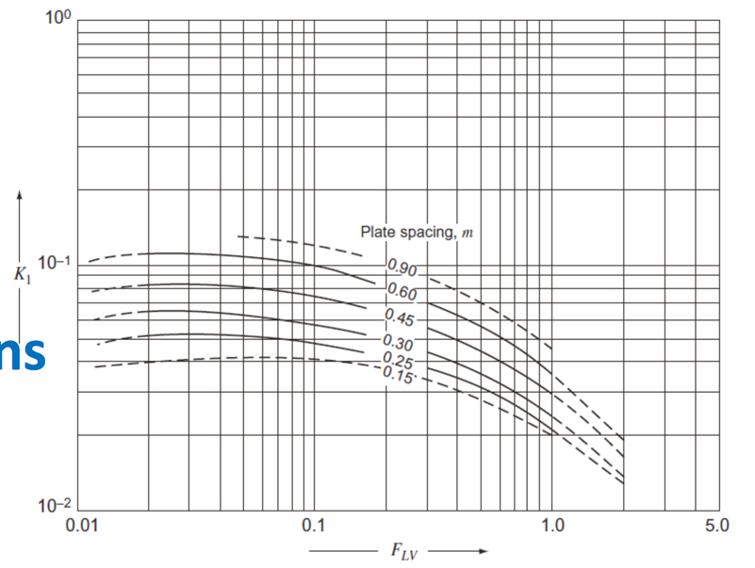

**Figure 5.1.** Correlation between k1 and plate spacing and FLV.

The height between each trays, htray, based on rule of thumb [38], often has the magnitude of 2ft. With an additional 20%~25% off region, 2.4ft~2.5ft tray spacing which is equivalent to 0.73m to 0.76m is the range for picking tray spacing. 0.75m is chosen for all the distillation column in this design.

The total height of the distillation column hdistillation can be calculated through Equation 5-13.

|  |  |  |
| --- | --- | --- |
|  | $$h_{distillation}=N_{tray}*h_{tray}+h_{top}+h_{liquid}+h_{reboiler}+h_{skirt}$$ | (5-13) |

Ntray is number of trays presented in the column, htray is the tray spacing in unit m; htop is the spacing height for vapor disengagement with unit m; hliquid is the spacing height with unit m for holding liquid in the column; hreboiler is the height for reboiler return in unit m; hskirt is the height of the skirt added to the column.

The rule of thumb [38] for height of vapor disengagement htop is that it is larger than 4ft. 8ft which is equivalent to 2.44m is picked for htop. The height for reboiler return hreboiler based on rule of thumb is that hreboiler is at least 0.91m. 20% of the buffer region is applied thus 1.1m of reboiler return height is used. The column is normally raised up by a skirt around 15ft which is equivalent to 4.57m, therefore hskirt has value 4.57. Height of the liquid holding up has the rule of thumb that the volume normally can hold up of 5 min of liquid flow. Thus, hliquid can be calculated via Equation 5-14.

|  |  |  |
| --- | --- | --- |
|  | $$h_{liquid}=\frac{\frac{M_{liquid}}{ρ_{liquid}}×\frac{5min}{60min}}{π{\left(\frac{D_{c}}{2}\right)}^{2}}$$ | (5-14) |

Where Mliquid is the mass flow rate of liquid stream with unit kg/hr; ρliquid is the density of liquid stream in the column with unit kg/m3; Dc is the diameter of the column which was calculated via Equation 5-12. All the variables for calculating hliquid are accessible from ChemCAD simulation, thus, hliquid can be calculated. Therefore, all the factors affect height of distillation hdistillation can be calculated or estimated.

**Heat Exchanger**

To determine the size of the heat exchanger, heat transfer coefficients were first determined for each of the shell/tube side fluid pairings by consulting a table found at EngineersEdge[39] as shown in Table 5.1. Heat transfer coefficients were estimated by taking the average of the heat transfer coefficient range.

After determining the appropriate estimate for the heat transfer coefficient, ChemCAD was used to calculate the area required for the heat exchangers. However, the value outputted by ChemCAD assumes true countercurrent flow which is not accurate for a two pass shell and tube heat exchanger. To correct for this, an F factor of 0.8 was used. The final heat exchanger area was determined by dividing the area calculated by ChemCAD by the F factor and then multiplying by 1.1 to allow for 10 % fluctuations in the process. The areas of the distillation heat exchangers were sized by ChemCAD using the sizing tool which only required defining utitlies.

*Table 5.1*. Heat exchanger heat transfer coefficient

|  |  |  |  |  |  |
| --- | --- | --- | --- | --- | --- |
| **Heat Exchanger** | **Material of Construction(T/S)** | **Shell Side Fluid** | **Tube Side Fluid** | **Type of Heat Transfer** | **Heat Transfer Coefficient (W/m2 K)** |
| E-101 | Carbon Steel/Carbon Steel | Isobutanol/Water | Organic Vapors | Gas at high pressure inside and liquid outside tubes | 300 |
| E-102 | Copper/Carbon Steel | Isobutanol/Water | Organic Vapors | Gas at high pressure inside and outside tubes | 325 |
| E-103 | arbon Steel/Carbon Steel | Isobutene/Water | Isobutene | Gas at high pressure inside and liquid outside tubes | 300 |
| E-104 | Carbon Steel/Carbon Steel | Cooling Water | Isobutene/Water | Gas at high pressure inside and liquid outside tubes | 300 |
| E-105 | Carbon Steel/Carbon Steel | High Pressure Steam | DIB | Steam outside and low viscous liquid inside tubes, natural circulation | 1150 |
| E-106 | Copper/Carbon Steel | Cooling Water | P-xylene/DIB | Gas at high pressure inside and liquid outside tubes | 300 |
| E-107 | Carbon Steel/Carbon Steel | Cooling Water | P-xylene | Gas at high pressure inside and liquid outside tubes | 300 |
| E-118 | Carbon Steel/Carbon Steel | Cooling Water | DIB | Gas at high pressure inside and liquid outside tubes | 300 |

The tube shell fluid was generally chosen as the fluid that had the higher temperature or pressure or contained organics. Steam was placed in the shell of the heat exchangers due to problems with having water condensation in the tubes where the flow velocity is higher.

*Table 5.2*. Reasoning for selection of Shell and Tube side fluids

|  |  |
| --- | --- |
| **Heat Exchanger** | **Reasoning** |
| E-101 | Put high pressure vapor inside tubes, also easier to clean |
| E-102 | Put hot fluid inside tubes |
| E-103 | Put higher pressure isobutene inside tubes |
| E-104 | Put higher pressure isobutene/water stream in tubes\ |
| E-105 | DIB inside tubes for easier cleaning |
| E-106 | Put high pressure/temperature process stream inside tubes |
| E-107 | Put lps outside tubes and higher T and pressure p-xylene stream inside tubes |
| E-118 | Put DIB inside tubes for easier cleaning |

**Reactors**

R-101

The cost of reactors was determined by determining an appropriate vessel size and then costing the amount of catalyst required to charge it with the assumption that half the catalyst would be required to be replaced yearly. The cost of the reactor was the cost of the vessel plus the cost of catalyst required to charge it for the first time. Then, the additional catalyst required was costed as an annual catalyst replacement “utility”.

The first requirement for sizing the first reactor is to ensure that there is sufficient area for heat transfer from the hot oil to the reactor to keep the reaction isothermal. If one assumes that Dowtherm A (the thermal fluid used) has a temperature of 360 °C, and the difference between the inlet and outlet temperature to the reactor can differ by no more than 0.1 % (i.e. a temperature difference of 0.325), and the hot fluid return is at 330 °C, then the amount of area required to achieve this heat exchange can be calculated using (5-15) and (5-16)

|  |  |  |
| --- | --- | --- |
|  | $$Q=UAΔT_{LM}$$ | (5-15) |
|  | $$ΔT_{LM}=\frac{\left(ΔT_{A}-ΔT_{B}\right)}{\ln{\frac{ΔT_{A}}{ΔT_{B}}}}$$ | (5-16) |

The heat duty required is given by ChemCAD (6169 MJ/hr). For a high pressure gas on the inside of the “tubes” and a hot fluid on the outside the heat transfer coefficient is 300 W/m2K [39]. Calculating the area required yields 847 m2. The total heat exchange area must equal the surface area of all the individual tubes. If it is assumed there are 100 tubes, then the length of the reactor calculated using (5-17) is 2.70 m.

|  |  |  |
| --- | --- | --- |
|  | $$A=NA_{tube}=NπDL$$ | (5-17) |

Finally, the total volumes of the tubes is given by 5-18.

|  |  |  |
| --- | --- | --- |
|  | $$V_{tubes}=Nπ{\left(\frac{D}{2}\right)}^{2}L$$ | (5-18) |

When calculated with a diameter of 1 m and a length of 2.7 m, the total tube volume is 212 m3. From earlier, the size of the reactor required is 750 m3. Thus, the surface area for heat exchange is not a limiting factor in sizing this reactor but rather the volume of the tubes. If the tubes are still assumed to have a diameter of 1 meter and a length of 2.7 meters, then the number of tubes required to reach a volume of 750 m3 is approximately 354 tubes (2.12 m3 each). The arrangement of this many tubes can be done in a triangular configuration shown in Figure 5.2.

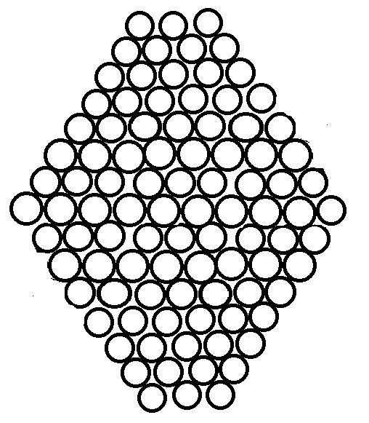

**Figure 5.2**. Triangular based configuration of tubes in multitubular reactor.

To fit 354 tubes in this configuration, the tubes need to start at 3 on the top, with a maximum row of 19 and back to a row of three tubes. The diameter of a vessel to contain such a configuration would need to be at least 19 m. To account for head space within the reactor vessel, a vessel diameter of 25 m (20% more) was chosen to contain the tubes. Similarly, the vessel length of 3.2 m was chosen. Finally, the cost of the catalyst was added to the reactor. The amount of catalyst required was calculated by finding the amount of catalyst that would fit in the volume of the tubes assuming a bed packing density of 0.6 (bed porosity of 0.4) and a catalyst porosity of 0.6 in equation 5-19.

|  |  |  |
| --- | --- | --- |
|  | $$m_{catalyst}=V_{Cat}ρ_{cat}(1-ϵ_{cat})=\left(1-ϵ_{bed}\right)V_{tube}ρ_{cat}{(1-ϵ}_{cat})$$ | (5-19) |

The density of alumina is 3650 kg/m3 [40]. The calculated mass of alumina needed is thus 438,000 kg of catalyst. The cost of the catalyst is $15.6/kg making for a total catalyst cost of $ 6,832,800. This initial cost is added to the cost of the reactor but is counted as an annual cost later in calculations with the assumption that half the catalyst will need to be replaced every year. The vessel for the reactor was priced in CAPCOST as a shell and tube heat exchanger with an area equal to the area of the 354 tubes (3000 m2 area).

The reactive distillation column was sized as a normal distillation column. However, the diameter of the column was then increased by 10% in order to accommodate the volume of catalyst and had the cost of catalyst added to its cost.

R-103

For sizing the reactor 3, from ChemCAD simulation, mass of the total amount of catalyst required to carry out desired reaction is provided. In our design, 310kg of catalyst is required. The commercially available catalyst bead has characteristics of 0.6mm (0.0006m) diameter [41] with porosity 0.69 [42]. 20% of the volume is made of platinum and 80% of the volume is made of activated carbon [41]. Thus, the mass of each catalyst bead can be calculated via Equation 5-20:

|  |  |  |
| --- | --- | --- |
|  | $$m_{bead}=ρ_{Pt}\frac{4}{3} π{\left(\frac{D_{bead}}{2}\right)}^{3}*\left(1-ϵ_{bead}\right)*S_{Pt}+ρ_{carbon}\frac{4}{3} π{\left(\frac{D_{bead}}{2}\right)}^{3}*\left(1-ϵ_{bead}\right)*S_{carbon}$$ | (5-20) |

Where mbead is the mass of one bead with unit kg; ρPt is the density of Platinum which is 21450 kg/m3; ρcarbon is the density of activated carbon which is 2100 kg/m3; ϵbead is porosity of the bead which is 0.69; SPt is the volumetric fraction of Platinum in the beads equals to 0.2; Scarbon is the volumetric fraction of activated carbon in the beads equals to 0.8. As the mass of each bead is calculated via Equation 5-20, volume of unpacked catalyst beads can be calculated via Equation 5-21:

|  |  |  |
| --- | --- | --- |
|  | $$V_{cat}=\frac{M_{cat}}{m_{bead}}*\frac{4}{3} π{\left(\frac{D_{bead}}{2}\right)}^{3}$$ | (5-21) |

Where Vcat is the unpacked volume of total catalyst with unit m3; Mcat is total mass of the catalyst required, in this case is 310 kg; mbead is the mass of each catalyst bead calculated via equation 5-20; and Dbead is the diameter of the bead equals to 0.0006m.

Assuming the third reactor is in cylindrical shape, in order to select the best diameter and length of reactor, diameters from 0.2m to 10m with increment of 0.1m are evaluated. Estimation method of catalyst beads packing is recorded by *A.S. Pushnov[43]* to determine the porosity of the bed following Equation 5-22.

|  |  |  |
| --- | --- | --- |
|  | $$ϵ_{bed}={\left(\frac{D_{vessel}}{D_{bead}}\right)}^{-2}+0.375$$ | (5-22) |

Where ϵbed is the calculated porosity of the bed; Dvessel is the diameter of the reactor with unit m. Figure 5.3 illustrates the porosity of the packed bed in the reactor with the increase of diameter.

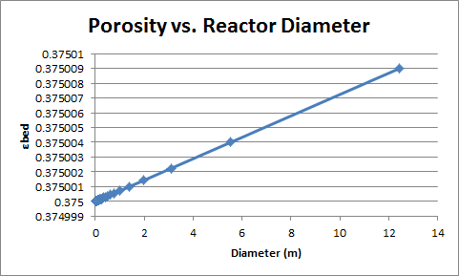

**Figure 5.3.** Porosity of the catalyst bed vs. Diameter of the reactor Dvessel

After knowing εbed, the volume packed catalyst required, Vpac in unit m3 can be calculated via Equation 5-23

|  |  |  |
| --- | --- | --- |
|  | $$V_{pac}=\frac{V_{cat}}{1-ϵ_{bed}}$$ | (5-23) |

Vpac changes respect to diameter is illustrate in Figure 5.5.

According to Ergun Equation (Equation 5-24), pressure drop per length can be estimated. Additionally, based on rule of thumb [44], total pressure drop of one reactor should be limited to 10% of its inlet pressure. The inlet stream in this design carries pressure of 10 bar (1000000 Pa), therefore, the pressure drop of the reactor should be less than 1 bar (100000 Pa). As for sizing the reactor, sizing up the reactor is more preferred as it gives the maximum limit value, thus, total pressure drop of 1 bar is set for this reactor. Ratio of total pressure drop and pressure drop per length would provide details on the length of reactor.

|  |  |  |
| --- | --- | --- |
|  |  | (5-24) |

Where dP is the change of pressure with respect of change of reactor length with unit Pa/m. Δpvessel is the total pressure drop over the reactor with unit Pa in this case 100000 Pa; Lvessel which is the length of the reactor with unit m, is the variable that we want to find out. μ is the dynamic viscosity of the stream entering the reactor with unit Pa*sec. Εbed is the catalyst packing porosity with no unit. Dbead is the diameter of catalyst bead with unit m. us is the superficial velocity which is would be the velocity entering the reactor without any catalyst packing. Superficial velocity us can be calculated via Equation 5-25:

|  |  |  |
| --- | --- | --- |
|  | $$u_{s}=\frac{v_{stream}}{π{\left(\frac{D_{vessel}}{2}\right)}^{2}}$$ | (5-25) |

Where vstream is the volumetric flow rate of the reactor entering stream with unit m3/sec. Volumetric flow rate vstream can be assessed from ChemCAD simulation as ChemCAD predict the volumetric flow rate of the stream. Dvessel is the diameter of the cross-section of the reactor.

Combining Equation 5-24 and 5-25, we have Equation 5-26:

|  |  |  |
| --- | --- | --- |
|  | $$\frac{∆p_{vessel}}{L_{vessel}}=dP=\frac{150μ}{D_{bead}^{2}}\frac{{\left(1-ϵ_{bed}\right)}^{2} }{ϵ_{bed}^{3}} \frac{v_{stream}}{π{\left(\frac{D_{vessel}}{2}\right)}^{2}}+\frac{1.75ρ}{D_{bead}}\frac{1-ϵ_{bed}}{ϵ_{bed}^{3}} {\left(\frac{v_{stream}}{π{\left(\frac{D_{vessel}}{2}\right)}^{2}}\right)}^{2}$$ | (5-26) |

With all the dependent variables known, length of the reactor is calculated. FIgure 5.4 illustrates the length of the reactor with respect to different diameters.

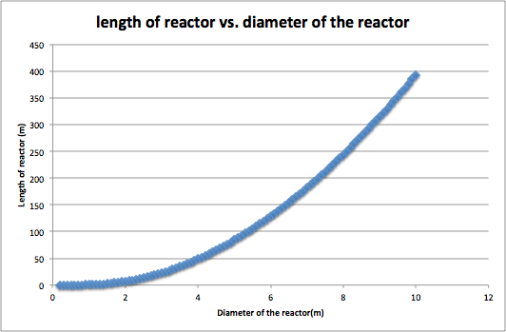

**Figure 5.4**: Length of reactor vs. diameter of the reactor.

After calculating length of the reactor at each different diameter, the total volume of the reactor can be calculated via Equation 5-27:

|  |  |  |
| --- | --- | --- |
|  | 5U $V_{vessel}=π{\left(\frac{D_{vessel}}{2}\right)}^{2}*L_{vessel}$ | (5-27) |

The total volume of the reactor and the volume packed catalyst required are plotted against diameter of the reactor in Figure 5.5:

From Figure 5.5, as the difference between two line cannot been clearly seen. Difference between catalyst required volumes and reactor volume is plotted against diameter from 0.2m to 1.1 m in Figure 5.6:

From Figure 5.6, the reactor volume starts to be larger than catalyst volume required as the diameter of the reactor is larger than 0.9m (reactor with 0.9m diameter still has less volume than catalyst required). Thus, the smallest possible reactor that met the requirement would be the diameter is 1m, and length is 0.6m. For the final sizing of the vessel, a 50% larger dimensions on reactor 3 for head space of reactor.

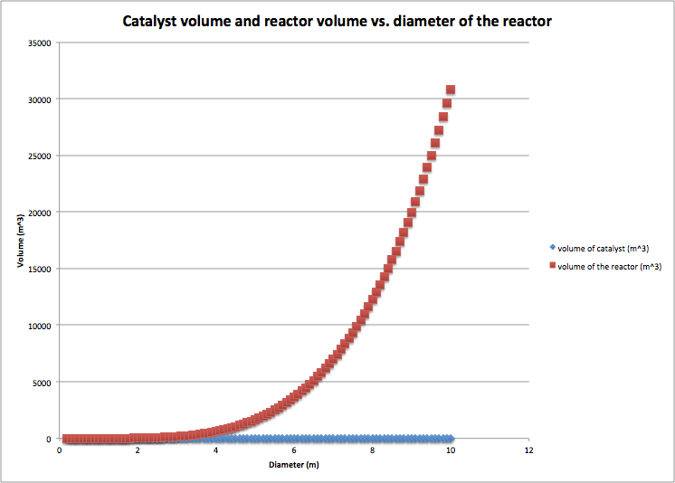

**Figure 5.5**: Volume of the catalyst required and maximum volume of the reactor changed with different diameter.

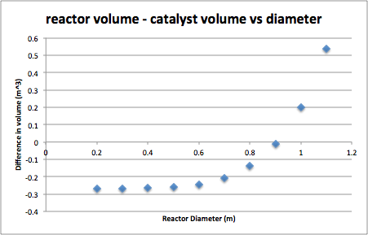

**Figure 5.6.** Volume difference between catalyst and reactor vs. diameter.

**Pumps**

Pumps were sized based on the power output calculated by ChemCAD multiplied by 20 %. P-102 was then sized up again by 50 %. The increase in pump size is to account for pressure drops in the system. These pumps will work harder and “over” pressurize the system such that the system is operating at the intended pressure after accounting for pressure drops.

**Fired Heater**

The cost of the fired heater was determined by using the heat duty output by ChemCAD and costed with CAPCOST. In addition, a thermal transfer system using diphenyl oil was costed. This unit is to be built as an extension to H-101 and will be used to heat R-101 to keep it isothermal. DowTherm A fluid was chosen as the thermal medium as it is stable under 360°C [50]. DowTherm A fluid used to heat reactor R-101, and to generate the steam required at various parts in the process. Since the fired heater is not 100 % efficient, it was sized to be 25 % larger to account for process fluctuations, ambient heat loss, and inefficient heat transfer. DowThermA is a biphenyl based fluid.

**Decanter**

For sizing the decanter, according to *Handbook of Chemical Engineering Calculations [45],* the total volume of the decanter is expressed through Equation 5-28.

|  |  |  |
| --- | --- | --- |
|  | $$V_{decanter}=τ_{holding}*v_{heavy}$$ | (5-28) |

Where Vdecanter is the volume of the decanter in m3; vheavy is the volumetric flow rate of heavy phase liquid under unit m3/min; 𝛕holding is the decanter holding time under unit min which can be estimated [46] via Equation 5-29:

|  |  |  |
| --- | --- | --- |
|  | $$τ_{holding}=\frac{0.1(hr)}{60 (\frac{hr}{min})} [\frac{μ}{{(ρ}_{H}/ρ_{L})-1}]$$ | (5-29) |

μ is the kinetic viscosity of the entering stream under unit mPa*sec; ⍴H is the density of heavy liquid phase at decanter with unit kg/m3; ⍴L is the density of light liquid phase at decanter with unit kg/m3. The combined Equation for estimating decanter volume is illustrated in Equation 5-30

|  |  |  |
| --- | --- | --- |
|  | $$V_{decanter}=\frac{0.1(hr)}{60 (\frac{hr}{min})} [\frac{μ}{{(ρ}_{H}/ρ_{L})-1}]*v_{heavy}$$ | (5-30) |

All the variable in Equation 5-30 is predicted by Chemcad simulation, thus, the volume of the decanter can be estimated.

By assuming the decanter is a cylindrical shape with diameter Ddecanter and length Hdecanter, according to [47], the length to diameter ratio usually ranges from 3.5 to 5. As up-scaling the equipment is more prefered, length to diameter ratio equals to 5 is chosen. The diameter of the decanter Ddecanter with unit m can be calculated via Equation 5-31:

|  |  |  |
| --- | --- | --- |
|  | $$D_{decanter}=\sqrt[3]{\frac{4V_{decanter}}{5π}}$$ | (5-31) |

And length Hdecanter with unit can be estimated via Equation 5-32:

|  |  |  |
| --- | --- | --- |
|  | $$H_{decanter}=5×D_{decanter}$$ | (5-32) |

**Storage Tanks**

The volume of the storage tanks required were sized based on the production capacity for 36 hours of the plant. If it is assumed new shipments of isobutanol arrive each 24 hour period and product is collected every 24 hours, then it is necessary for the tank to be larger than the 24-hour production capacity so that there is no down time during collection; if a 24-hour production capacity tank was used then there would be a point in the day where there is no isobutanol left as the storage tank is refilled and similarly a point where there is no room to store excess product before it is removed. The volumetric flow rates of the feed and product streams were determined using ChemCAD. CAPCOST was then used to assign a cost to the volume of the storage tank required. Fixed roofs were chosen for smaller volume tanks while floating roofs were used for larger storage tanks.

### 5.2. Overall Capital Investment

The overall capital investment was calculated by totaling the cost of all the equipment (Appendix D), including the initial amount of catalyst. The cost of equipment was determined using CAPCOST and the sizes determined as described in section 5.1. A sample calculation is shown in Appendix C. A CEPCI of 537 was used, which the 2015 annual CEPCI was given by Chemical Engineering Magazine. Land costs were assumed to be $450,000, where the build time was 2 years with 60% of the FCI at year 1 and 40% at year 2.

The major considerations in the estimation of the economic cost of a chemical process are the capital costs and cost of manufacturing involved. For this design the capital cost will fall under the category of a preliminary design estimate [54]. In this type of estimate, a PFD is required and generally accurate equipment sizes are required. Utilities, piping, instrumentation, electricity, and an approximate plant layout are also included in this level of estimation. These estimates tend to be 2 to 6 times accurate relative to the final cost of the plant [54].

Since the proposed process is very novel, it will likely be unable to be built as an extension to an existing process and will likely need to be located in a location with large swaths of arable land. As such, a grass roots costing approach will be used.

From Turton, the cost of a grass roots facility can be calculated as follows (5-33). This model provides a 15 % allowance for contingency costs and 3% for fees.

|  |  |  |
| --- | --- | --- |
|  | $$C_{GR}=1.18\sum_{i=1}^{n}{C_{BM_{i}}}+0.50\sum_{i=1}^{n}{C_{BM_{i}}^{°}}$$ | (5-33) |

There are both direct and indirect costs to consider for equipment costing. The direct costs include costs for equipment, materials, and labor while indirect costs involve transportation costs for the materials, fringe benefits for employees, and contractor engineering expenses [54]. To completely calculate this cost, the purchase cost $C_{p,i}^{°}$ must be multiplied by a multitude of factors. From Turton, there is a factor for each of materials, labor, freight, overhead, and engineering costs which are represented by $α_{M},α_{L},α_{FIT},α_{0},{and α}_{E}$ respectively. Then the bare module cost is related to the $C_{p,i}^{°}$ by (5-34). The materials factor includes all piping, insulation, fireproofing, electrical instrumentation, and structural supports in the process [54].

|  |  |  |
| --- | --- | --- |
|  | $$C_{BM}^{°}=\left(1+α_{M}\right)\left(1+α_{L}+α_{FIT}+α_{L}α_{O}+α_{E}\right)C_{p,i}^{°}$$ | (5-34) |

The term in front of $C_{p,i}^{°}$ can be simplified as a single factor which has already been estimated for a large number of equipment. The bare module cost CBM  for the ith  equipment is defined as shown in (5-35) while the base bare module cost $C_{BM_{i}}^{°}$ is defined in (5-36).

|  |  |  |
| --- | --- | --- |
|  | $$C_{BM_{i}}=F_{BM,i}C_{p,i}^{°}$$ | (5-35) |
|  | $$C_{BM_{i}}^{°}=F_{BM_{i}}^{°}C_{p,i}^{°}$$ | (5-36) |

Where $F_{BM_{i}}^{°}$ is $F_{BM}$ where $F_{M}$ and $F_{P}$ are both equal to one.

The pressure factor is calculated using two methods – one for vessels and one for other equipment. The equation for the pressure factor of a vessel is given by 5-37. In this equation, D is the vessel diameter in meters, P is the operating gauge pressure in bars, CA is the corrosion allowance, and tmin is the minimum vessel thickness.

|  |  |  |
| --- | --- | --- |
|  | $$F_{p,vessel}=\frac{\frac{\left(P+1\right)D}{\left(2\right)\left(944\right)\left(0.9\right)-1.2\left(P+1\right)}+CA}{t_{min} }$$ | (5-37) |

The standard minimum thickness is 0.0032 m (1/8 inch) which is the standard minimum manufacturer plate thickness Turton provides a correlation for the pressure factor of other equipment [54]. This correlation is shown in equation 5-38 where P represents the operating pressure and the constants C are found in Appendix A in Turton.

|  |  |  |
| --- | --- | --- |
|  | $$\log{F_{P}=C_{1}+C_{2}\log{P+C_{3}({\log{P)}}^{2}}}$$ | (5-38) |

The material construction factor FM was calculated using Appendix A in Turton [5-38].

5.3. Cost of Manufacturing

**Assessing Manufacturing Costs**

In addition to simply buying and installing the equipment required for the process, the cost of every day operations also needs to be assessed. These costs are collectively termed the cost of manufacturing (COM) and include the costs of raw materials, utilities, operating labor, and waste treatment.

**Operator cost**

For our process P is 0 as it does not involve the handling of solids. Therefore equation (5-39) can be simplified to (5-40)

|  |  |  |
| --- | --- | --- |
|  | $$N_{OL}={\left(6.29+31.7P^{2}+0.23N_{np}\right)}^{0.5}$$ | (5-39) |

Where Nnp represents the number of processing units which are defined as compressors, towers, reactors, heaters, and exchangers.

|  |  |  |
| --- | --- | --- |
|  | $$N_{OL}={\left(6.29+0.23N_{np}\right)}^{0.5}$$ | (5-40) |

The number of processing units in the proposed process is 16 and thus it follows that 3.16 which rounds to 4 positions being required to be manned at any given time. If it is assumed that each operator works 8 hours a day, for 5 shifts a week, and for 49 weeks a year then for each operator position required there will need to be 4.5 operators required to be hired. Thus, the total number of operators required is 18. The Illinois Bureau of Labor and Statistics reports an annual median wage of $55,690 for a system operator [56] so the annual wage paid to operators is $1,002,420.

This calculation assumes 365 working days a year (8760 hours) which is more than the assumption given of 8500 operating hours per year. Nonetheless, the 4.5 heuristic is used anyway, but one should note that the operating labor cost will be slightly more than it would be if the plant was only operated for 8500 hours a year.

### **Utility Costing**

Unit V-101 will have some residual organics in the water stream that needs to be treated. This wastewater treatment will be done off site. The pricing of waste stream was done using CAPCOST and was labeled as non-hazardous waste as the waste is over 99.5 % water. However, the remainder is isobutene and isobutanol which will need to be treated. The cost of steam, cooling water, and electricity was also determined using CAPCOST by inputting the heat duty obtained from ChemCAD. The heat duty of the fired heater was also factored into utility, but closer inspection of the fuel stream coming off of V-102 showed that this stream provided more than enough energy if it was combusted. Thus, the utility of the fired heater was not included in the utility costs as the fuel could be completely self-supplied.

### **Chemical Costing**

The prices of the different chemicals involved in this process were found using various sources. However it should be noted that some of the data was old. This old data was corrected to 2016 prices by adjusting for inflation. Although CEPCI represents the inflation of process equipment, it was nonetheless used to estimate present day prices of chemicals. In addition, some of the catalyst costs may have been much more expensive than they would have been in reality since the prices used for the Pt on activated carbon and Ni-Al2O3 were taken from small scale laboratory stores which are known to have much higher prices when compared to industrial sources. Table 5.3 shows a summary of the prices used for each chemical

*Table 5.3*. Cost of Chemicals and Catalyst

|  |  |  |  |
| --- | --- | --- | --- |
| **Chemical** | **2006 Price ($/kg)** | **Projected 2016 Price ($/kg)** | **Source** |
| Isobutanol [48] | - | $1.15-$1.48/kg | GEVO |
| Terepthalic Acid [8] | 0.925 | 1.066 | ICIS |
| P-xylene [8] | 1.43 | 1.53 | ICIS |
| Ni-Al2O3 [58]  (1% by mass Ni loading) | - | $4272/ kg | RiogenInc |
| **γ-**alumina [59] | - | 15.60 | AdvancedMaterials |
| Platinum on Carbon [60] | - |  | RiogenInc |
| Isobutylene [8] | 0.70 | 0.752 | ICIS |
| Di-isobutylene [61] | - | 1.25 | Zauba |

The sale price of impure product streams was determined by first scaling the cost of the chemical by the weight fraction of that chemical in the impure stream and then multiplying by an additional factor of 0.8.

### 5.4 Profitability Analysis

A discount rate of 10 % and hurdle rate of 18 % were assumed when calculating the profitability of this process. A MACRS depreciation over 7 years was used. The plant was assumed to operate for 8500 hours a year, and profitability was assessed over 15 years. A salvage value of 0 was used for calculations. These parameters were all input into CAPCOST to generate the cumulative cash flow diagram.

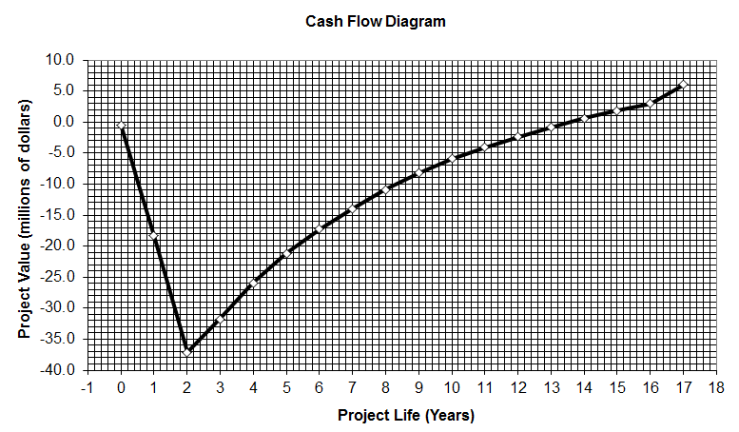

**Figure 5.7** Cumulative Cash Flow diagram assuming no catalyst required to be recovered.

Figure 5.7 above shows that the process can be profitable over the lifespan of the project if the catalyst cost is (unrealistically) assumed to be a one time purchase. Since this is unrealistic, a new cash flow diagram was generated with the assumption that half the catalyst must be replaced every year (Figure 5.8). This figure shows that the project does not start making money until the end of the lifetime of the project meaning that this project is not profitable in the 15 year scope and certainly does not meet the hurdle rate of 18 %. In fact, even when the cost of catalyst is assumed to be a one time purchase, the rate of return on investment is still only 12 %.

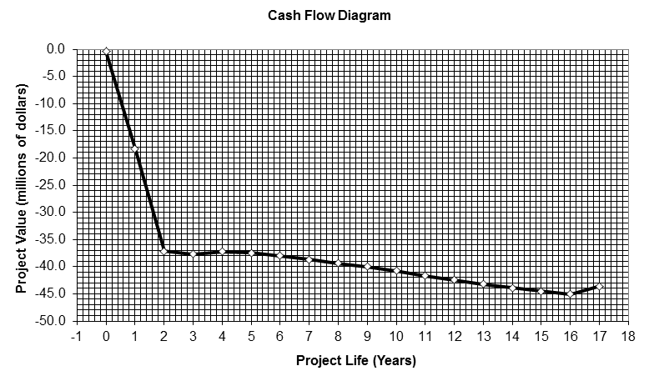

## **Figure 5.8** CCF assuming half of catalyst must be replaced every year.

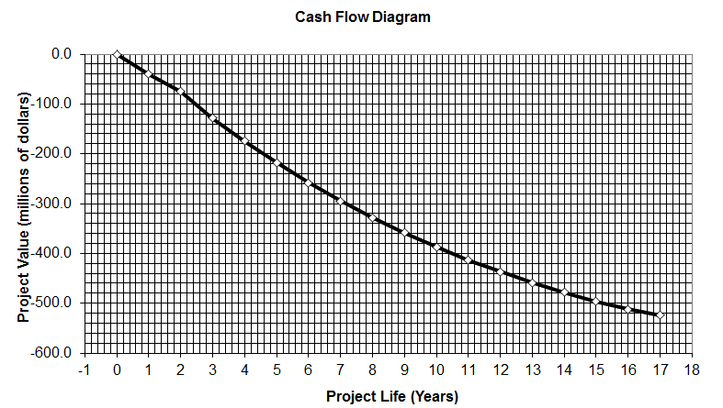

**Figure 5.9** CCF of isobutanol to TPA process using data from Team 5

The profitability of connecting this process with a p-xylene oxidation process and selling TPA as the product was also considered. The FCI and COM from Team 5 were taken. They reported for an inlet feed of 10522 kg/hr of p-xylene a FCI of 61.7 million and a COM of 159 million and produced 70,000,000 kg/year. Their COM without a p-xylene input was 89 million which is the value required for this analysis as the feed material is isobutanol. Their numbers were scaled to the production of p-xylene from this process (6894 kg/hr assuming 99.5 % and above purity p-xylene was sufficient) using a simple direct proportionality. The adjusted FCI was 40 million, adjusted COM was 58.3 million, and adjusted TPA amount produced was 45.8 million kg per year.

Using CAPCOST as it was set up assuming replacing catalysts every half year, hypothetical p-xylene prices were inputted into the COM summary resulting in various revenue from sales which changed the cumulative discounted cash flow. By slightly changing the price of p-xylene it was determined that at a price above $1.77 per kg of p-xylene is where the cumulative discounted cash flow broke even and started to make money. The cumulative cash flow diagrams for $1.77 per kg of p-xylene and for $1.78 per kg of p-xylene are displayed in Figure 5.12 and 5.13.

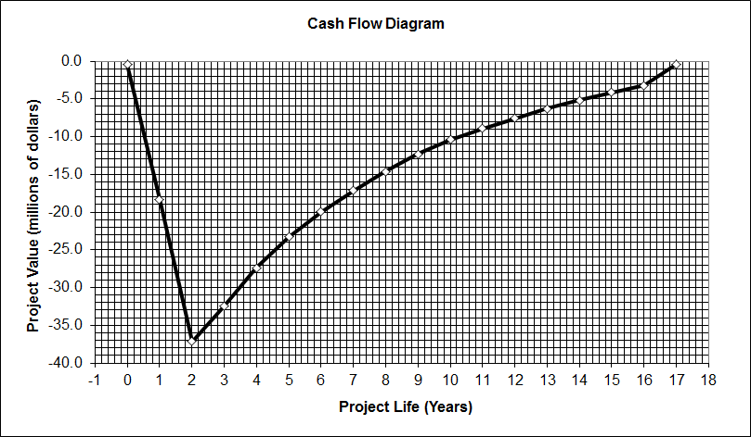

**Figure 5.10.** Cash flow diagram when the price of p-xylene is $1.77 per kg.

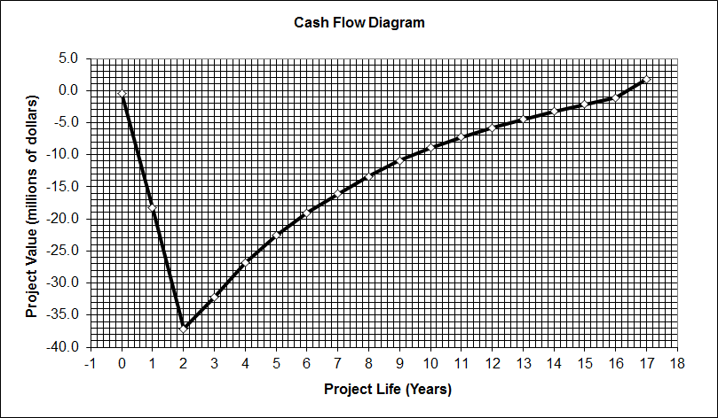

**Figure 5.11** Cash flow diagram when p-xylene price is 1.78 per kg resulting in a positive discounted cumulative cash flow.

Similarly, hypothetical prices for isobutanol were inserted into CAPCOST in order to see at what price of isobutanol would make this process profitable. The changes in price caused the raw materials cost to changed resulting in a different cumulative discounted cash flow. It was found that having a pure isobutanol price lower than $0.37 /kg would make the process profitable. This can be seen in Figures 5.12 and 5.13 when the price was set at 0.37/kg and 0.36/kg

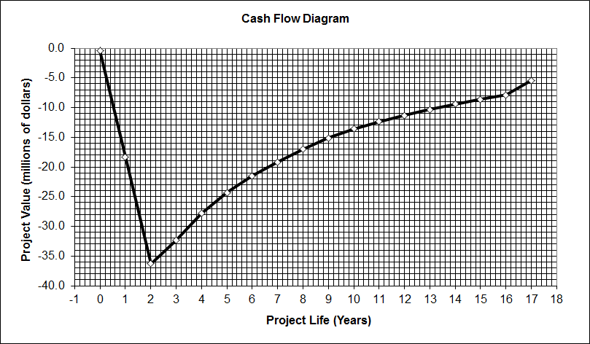

**Figure 5.12.** The cash flow diagram when the price of pure isobutanol is $0.37 per kg.

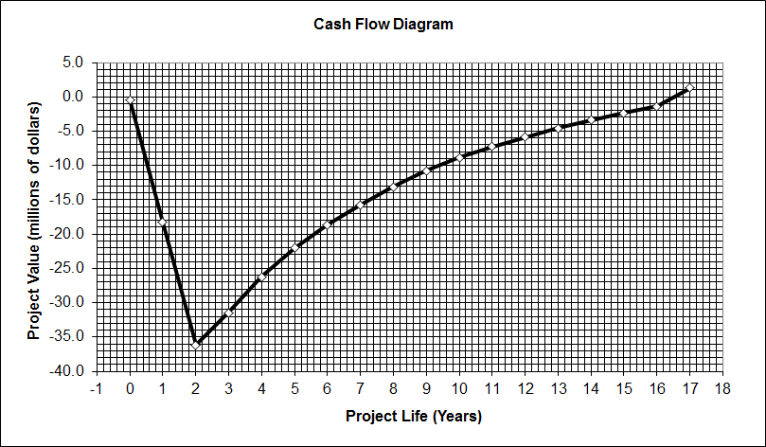

**Figure 5.13.** The cash flow diagram when pure isobutanol is priced $0.36 per kg resulting in a positive discounted cumulative cash flow.

**Chapter 6: Environmental, Health, and Safety Concerns**

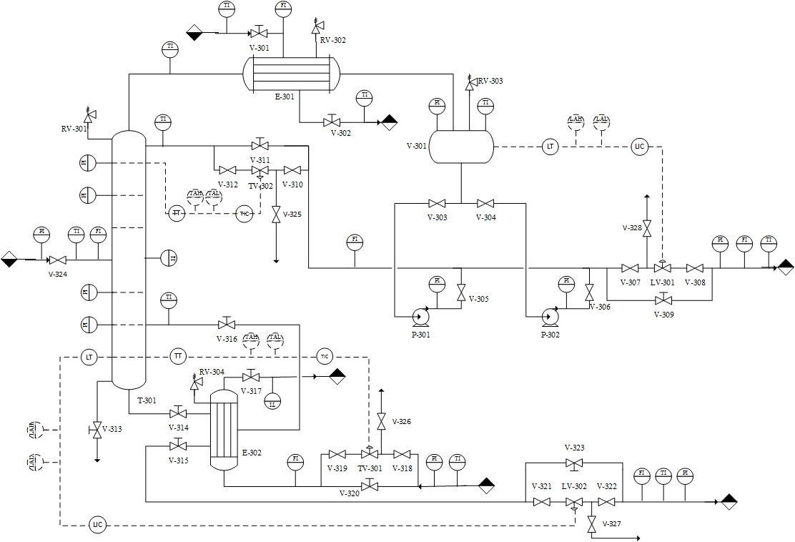

**Figure 6.1.** P & ID of Distillation Column T-103.

This piping and instrument diagram of distillation column is designed for the separation process between xylenes and C8s. The inlet stream containing the mixture is feed to the column. The top stream is total condensed to liquid with a shell and tube heat exchanger. The flow rate of top product stream is controlled by a level indicator controller in the reflux drum. The remaining flow is pumped back to control the temperature of the column with a temperature indicator controller. The flow rate of steam feeding to the reboiler is controlled by the bottom temperature of the column. The bottom stream is partially reboiled and the flow rate of bottom product stream is controlled by the level indicator controller at the bottom of the column.

Temperature indicators and pressure indicators surrounding the column are designed to monitor the conditions in the column. Double block and bleed valve systems are installed for every controlling valves to serve back up and easy maintenance. Relief valves are set to prevent flooding and over pressure in the column and heat exchangers.

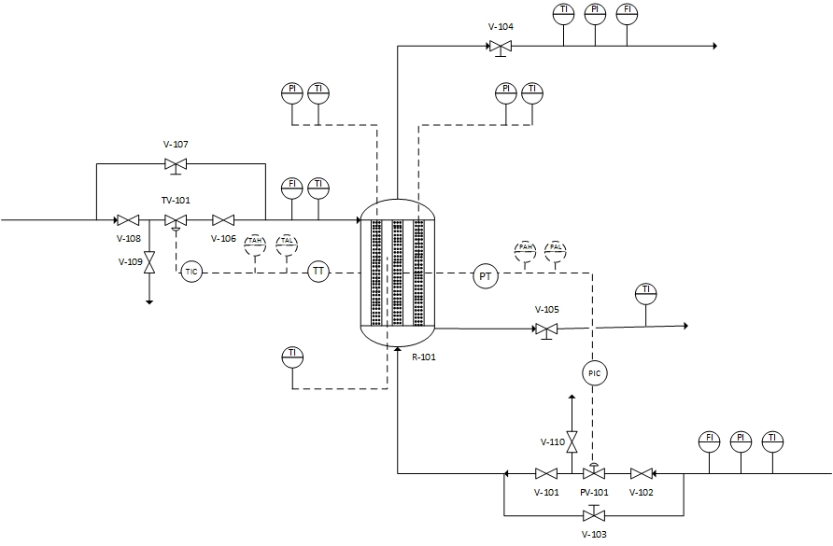

**Figure. 6.2** P&ID of Reactor R-101.

This piping and instrument diagram of reactor is designed for the reaction process from isobutanol to isobutylene. The inlet stream containing the isobutanol is fed to the multi tube fixed bed reactor. The flow rate of the inlet stream is controlled by a pressure indicator controller in the reactor. A thermal oil system is designed to regulate the reactor in isothermal condition. The flow rate of thermal oil is controlled by the temperature indicator controller in the shell and tube exchanger. Temperature indicators and pressure indicators surrounding the reactor are designed to monitor the reactor condition. Double block and bleed valve systems are installed for every controlling valves to serve back up and easy maintenance. Relief valves are set to prevent over pressure in the reactor.

*Table. 6.1* HAZOP of Distillation Column T-103 & Reactor R-101

|  |  |  |  |  |  |  |
| --- | --- | --- | --- | --- | --- | --- |
| **Equipment Reference and Operating Conditions** | **Deviation from Operating Conditions** | **Causes of Deviation** | **Consequence of Deviation under consideration** | **Additional Implications of Consequence** | **Process Indications** | **Notes and Questions** |
| **Distillation Column T-103** | Flow More | Flow of feed stream is increased. | Flooding in the column. | Impurity of product stream is increased. | V-324 | Check flow indicator.  Check valve operation. |
|  | Flow Less | Flow of feed stream is decreased. | Dripping in the column. | Impurity of product stream is increased. | V-324 | Check flow indicator.  Check valve operation. |
|  |  | Leakage of piping system | Distillation column malfunction | Impurity of product stream is increased. |  | Check piping system.  Check draining valve |
|  | Flow No | Valve malfunction | Distillation column malfunction | No product |  | Check valve operation. |
|  |  |  |  |  |  |  |
|  | Temperature High | Top stream is insufficiently condensed in the heat exchanger. | More heavy key reagents are vaporized. | Impurity of product stream is increased. | V-301  V-302  RV-302 | Check valve operation  Check relief valve.  Check cooling reagent temperature |
|  |  | Bottom stream is over heated in the reboiler. | More heavy key reagents are vaporized. | Impurity of product stream is increased. | TV-301  V-316 | Check control valve set point  Check valve operation  Check steam temperature. |
|  |  |  |  |  |  |  |
|  | Temperate Low | Top stream is over condensed in the heat exchanger. | More light key reagents are condensed. | Impurity of product stream is increased. | V-301  V-302 | Check valve operation  Check relief valve.  Check cooling reagent temperature |
|  |  | Bottom stream is insufficiently heated in the reboiler. | More light key reagents are condensed. | Impurity of product stream is increased. | TV-301  V-316 | Check control valve set point  Check valve operation  Check steam temperature |
|  |  |  |  |  |  |  |
|  | Pressure High | Temperature is increased. | Boiling points of reagents become lower. | Impurity of product stream is increased. | RV-301  RV-303  TV-301 | Check control valve set point  Check valve operation  Check steam temperature |
|  |  | Pump power is increased. | Boiling points of reagents become lower. | Impurity of product stream is increased. | P-301  P-302 | Check pumps operation.  Check pump pressure indicator |
|  |  |  |  |  |  |  |
|  | Level High | Accumulation in the reflux drum | Column temperature is increased | Impurity of product stream is increased. | LV-301 | Check control valve set point.  Check valve operation.  Check block |
|  |  | Accumulation in the column | Column temperature is decreased | Impurity of product stream is increased. | LV-302 | Check control valve set point.  Check valve operation.  Check block |
|  | Level Low | Leakage  Decreased flow of feed stream. | Column temperature is decreased | Impurity of product stream is increased. | LV-302  V-313 | Check control valve set point.  Check valve operation.  Check piping system |
|  |  |  |  |  |  |  |
|  | Pressure Low | Temperature is decreased. | Boiling points of reagents become higher. | Impurity of product stream is increased. | RV-301  RV-303  TV-301 | Check valve operation  Check relief valve.  Check cooling reagent temperature |
|  |  | Pump power is decreased. | Boiling points of reagents become higher. | Impurity of product stream is increased. | P-301  P-302 | Check pumps operation.  Check pump pressure indicator |
|  |  |  |  |  |  |  |
|  |  |  |  |  |  |  |
| **Reactor R-101** | Pressure High | Increased flow of feed stream | Potential Reactor Rupture |  | PV-101 | Check controller set point.  Check valve operation. |
|  |  | Accumulation of the product stream | Potential Reactor Rupture |  | V-104 | Check valve operation. |
|  |  |  |  |  |  |  |
|  | Pressure Low | Decreased flow of feed stream | Decreased conversion |  | PV-101 | Check controller set point.  Check valve operation. |
|  |  | Leakage of the piping system | Reactor malfunction | Decreased conversion | V-110 | Check piping connection  Check bleed valve  Check reactor wall |
|  |  |  |  |  |  |  |
|  | Temperature High | Increased temperature of thermal oil | Increased reactor pressure | Potential Reactor Rupture | TIC | Check controller set point.  Check indicator operation.  Check temperature indicator. |
|  |  | Increased flow of thermal oil | Increased reactor pressure | Potential Reactor Rupture | TV-101 | Check controller set point.  Check valve operation. |
|  |  |  |  |  |  |  |
|  | Temperature Low | Decreased temperature of thermal oil | More reaction time | Decreased conversion | TIC | Check controller set point.  Check indicator operation.  Check temperature indicator. |
|  |  | Decreased flow of thermal oil | More reaction time | Decreased conversion | TV-101 | Check controller set point.  Check valve operation. |
|  |  |  |  |  |  |  |

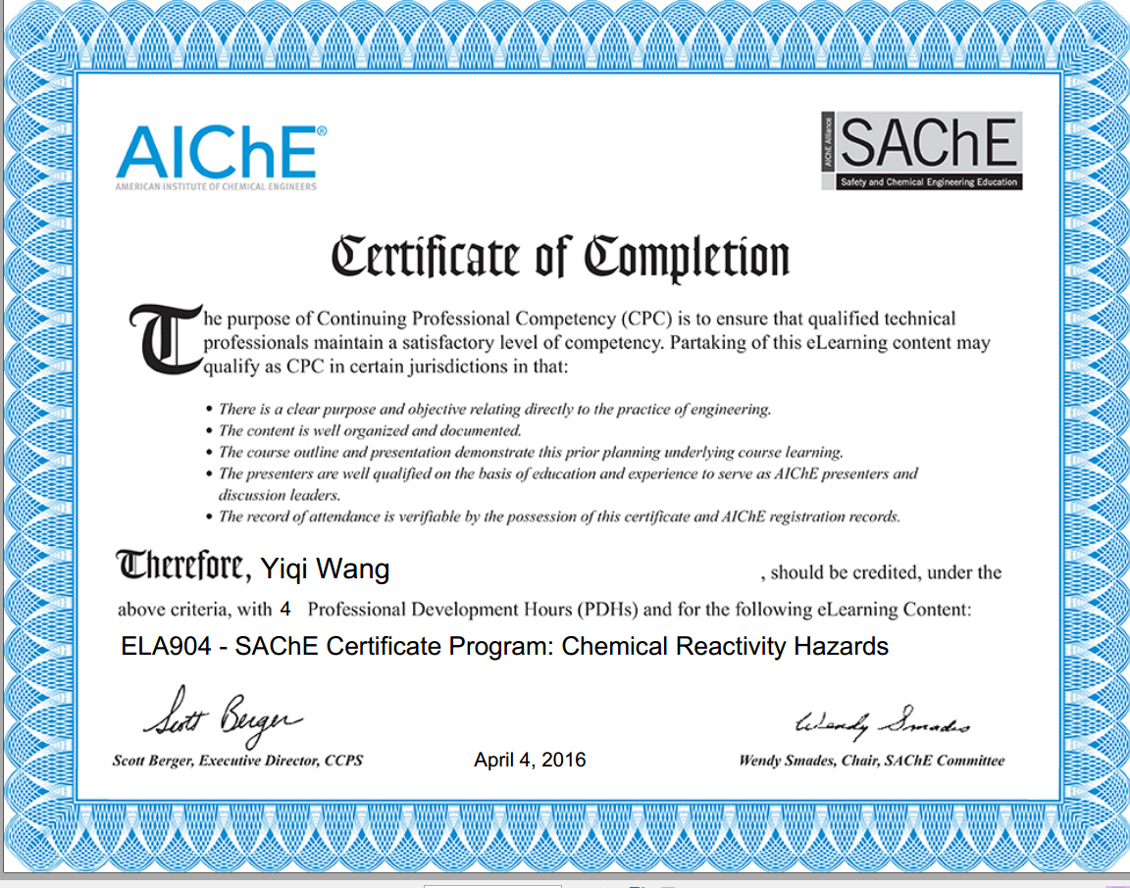

**Figure 6.3** Chemical Reactivity Hazards Certification

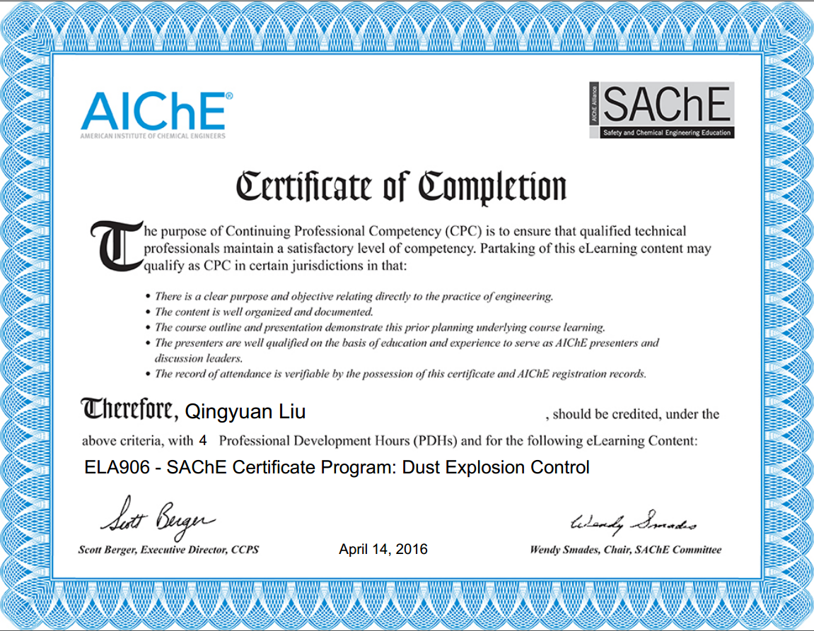

**Figure 6.4** Dust Explosion Control Safety Certification

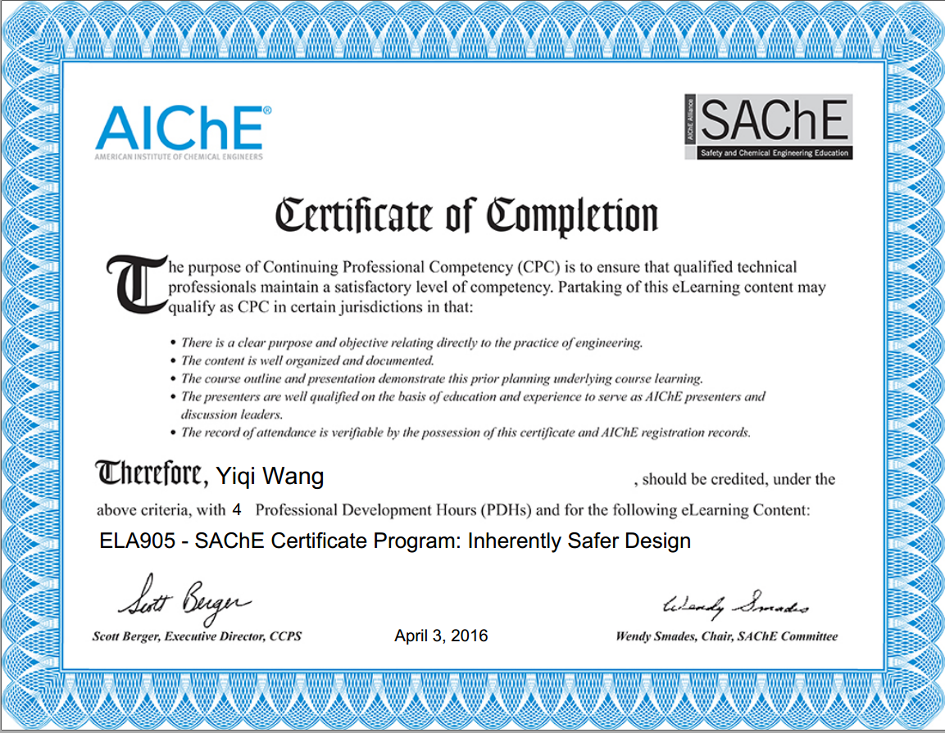

**Figure 6.5** Inherently Safer Design Safety Certification

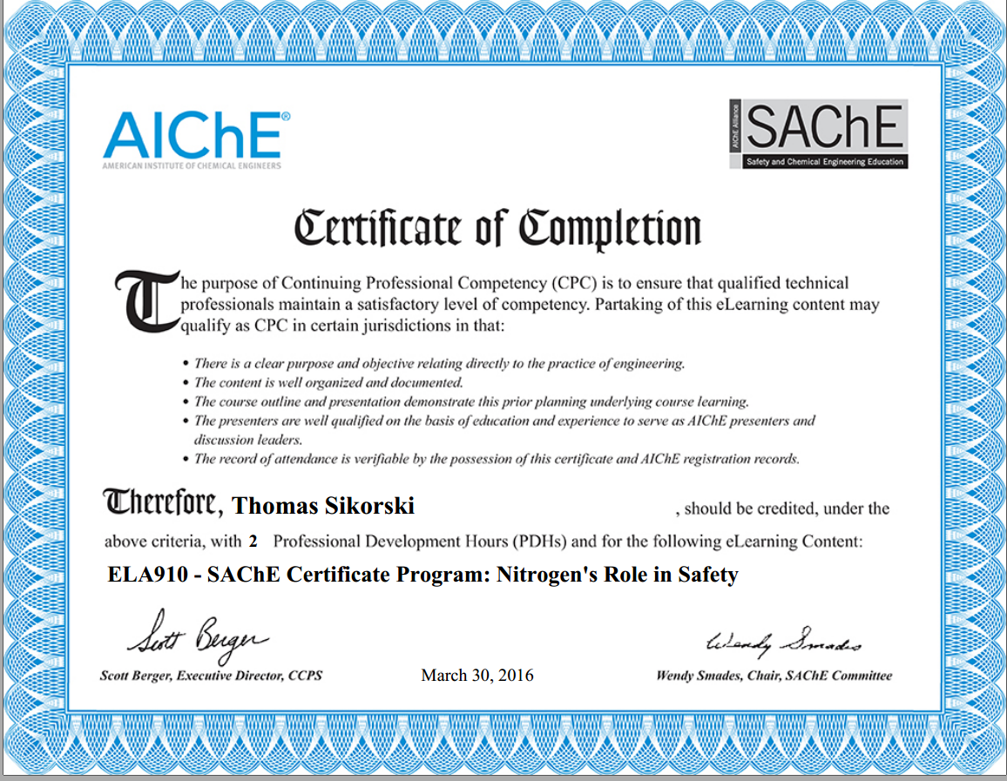

**Figure 6.6** Nitrogen’s Role in Safety Certification

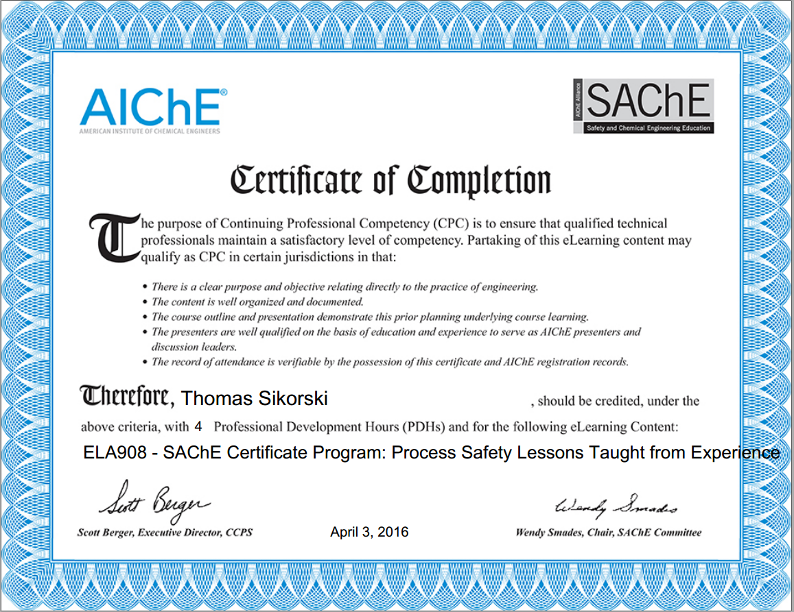

**Figure 6.7** Process Safety Lessons Taught from Experience Certification

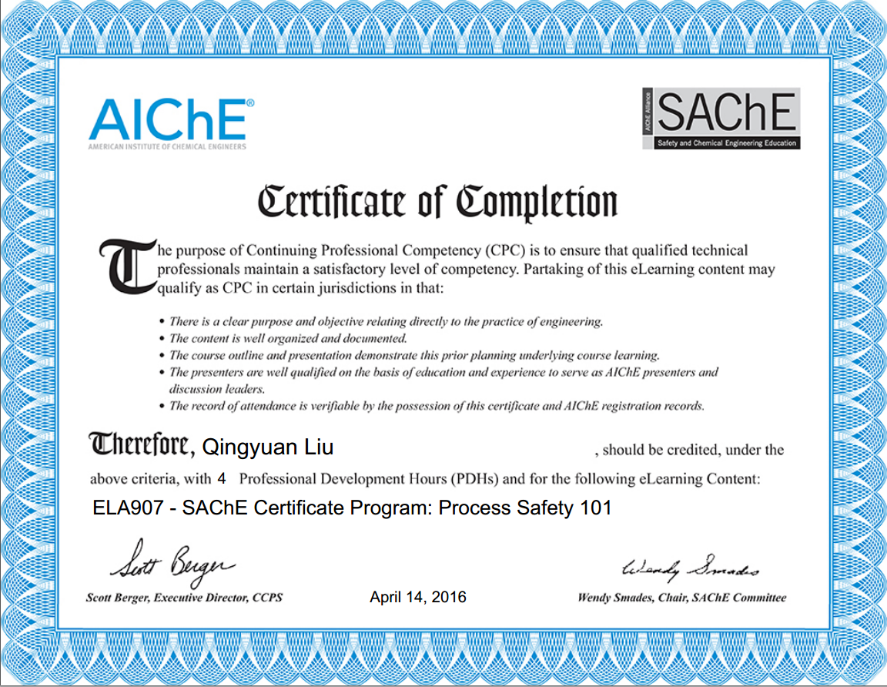

**Figure 6.8** Process Safety 101 Certification

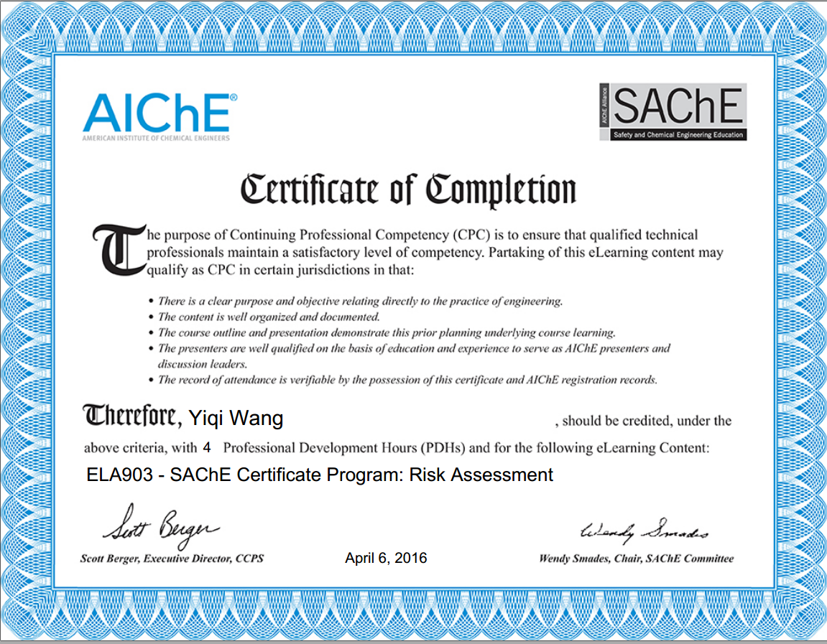

**Figure 6.9** Risk Assessment Certification

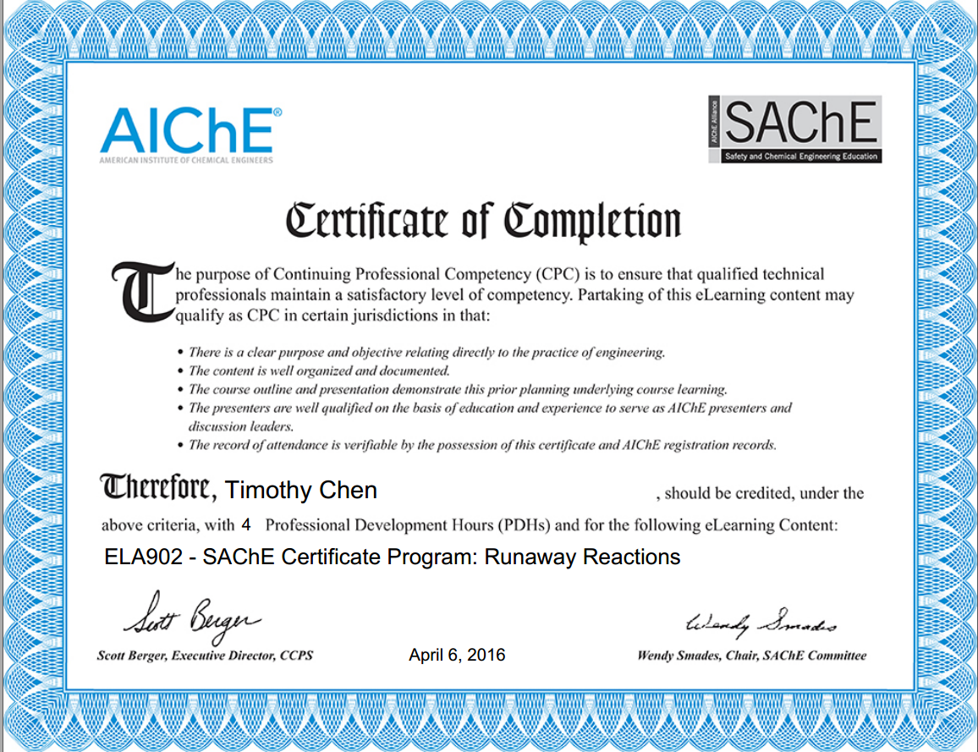

**Figure 6.10** Runaway Reactions Certification

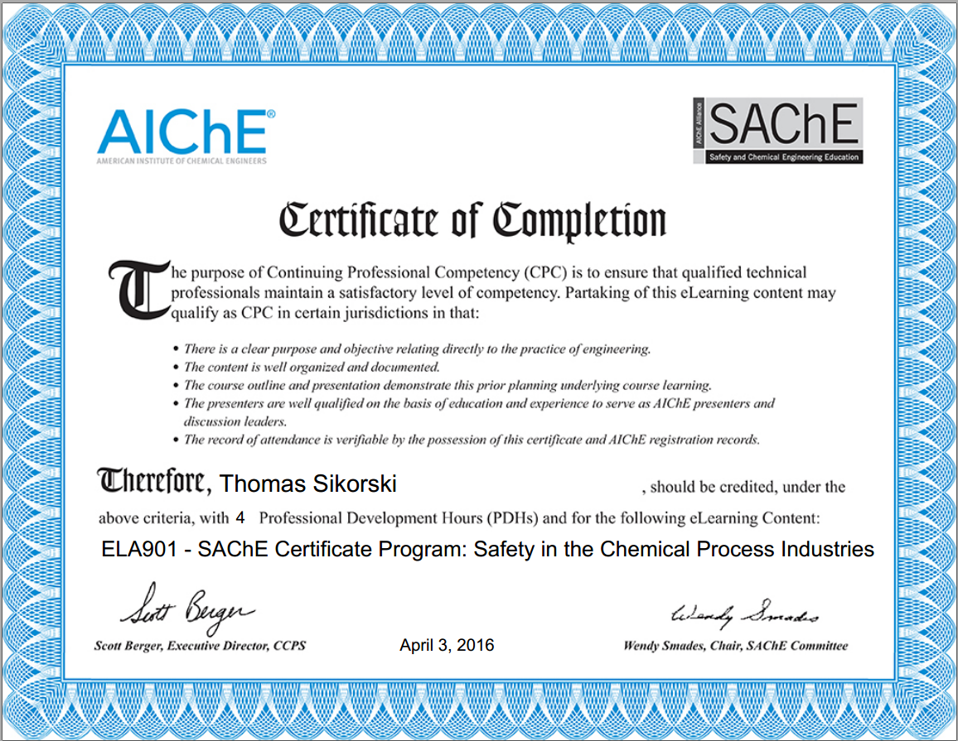

**Figure 6.11** Safety in Chemical Process Industries Certification

During the entire process of production of para xylene from isobutanol, all reagents engaged in the reactions are highly flammable, except water. According to the material safety data sheet provided by Science Lab, there are no corrosive chemicals involved in the production. However, most organic compound may cause irritation to skin and eyes. In case of inhalation and ingestion, some chemicals will cause breathing difficulty and central nervous system depression. In case of contact, immediately flush skin and eyes with plenty of water. Remove to fresh air if inhaled. Keep all the chemicals away from heat and sources of ignition. All flammable liquids and gases should be stored in appropriate area, cool and well- ventilated. Keep containers tightly closed and sealed. Avoid all possible sources of ignition such as spark or flame. Most organics compounds have acute hazards to the aquatic environment, demonstrating toxic to the aquatic organism. In this case of production of para xylene, large flow rates of organics, such as para xylene, isobutanol and diisobutylene, is crucial to be monitored to prevent leakage and invalid release to the environment. Waste must be disposed appropriately, complying with federal, state and local environmental control regulations, but will be sourced to an outside waste treatment plant.

## **Chapter 7: Sustainability**

Creation of TPA, and thus PETE, from petroleum based p-xylene is not a sustainable production method going into the future. As previously stated, the amount of fossil fuels available to extract for use is a finite amount and resource demand is only increasing; combined with the possible influences from political turmoil, the continued use of petroleum based p-xylene unappealing. Even if a source of fossil fuels was uncovered that was large enough to provide for the foreseeable future, other environmental factors threaten the use of petroleum based production. The primary factor that would impact fossil fuel processes is the rise in concern about the effects the industry has on the planet.

Somewhat recently the attitude that people collectively need to be more conscious of nature has become more widespread, with people calling for more environmentally friendly behavior. We can see this trend with the many countries vocally endorsing practices and policies that reduce the impact on the planet. This is further demonstrated through the green products that have begun to gain a foothold in the marketplace for example the increase in solar panel popularity and electric cars like Tesla. Adopting greener production methods like the one presented in this report will not only help the company with its environmental sustainability, its activities that can continue for an extended time without serious harm to the environment, but also help increase the positive portrayal of the company; not only will the company benefit from the recognition of being environmentally conscious, by creating a green process for an integral commodity it will be creating a differentiated product in a uniform market, thus linking to how this concept can support economic sustainability, or the continued production of this product profitably.

Currently, this process is hindered by the relatively high cost of isobutanol, the current uncharacteristically low cost of oil, and the inefficient dehydrocyclization of di-isobutene to p-xylene. Looking to the future, all three of these obstacles are beginning to lessen as technology improves and oil costs increase. Isobutanol is an important platform chemical which has the potential to replace petroleum based raw materials in the future industrial processes. Gevo Inc. , who commenced production of the first commercial scale bio-isobutanol plant in 2012 converting sugars from multiple renewable feedstocks [13], are gaining financial support through partnerships with large corporations like Coca-Cola. As more of this technology for bio-isobutanol production is comprehensively optimized to commercial scale, the price of isobutanol has the potential to bring in approximately $0.50 to $1.00 per gallon in profit margins, making it competitive with petroleum based isobutanol [49] and thus create economic sustainability.

**Chapter 8: Conclusion**

A process for the green production of TPA was designed. The promise of a sustainable method of PETE production is necessary due to the lack of fossil fuels in the future. The synthesis of PETE requires TPA as a monomer but due to time constraints it was not possible to design the entire process for the synthesis of TPA from p-xylene. Instead, a process for the green production of p-xylene was designed. Based on a literature review of green synthesis pathways, the most promising pathway was the synthesis of p-xylene from isobutanol, so a design was proposed for this synthesis pathway. Extensive simulation were ran to optimize the process. The final process converts an input 26839 kg/hr stream of 30 w.t. % isobutanol to 5684 kg/hr of 99.7% purity p-xylene and 1211 kg/hr of 99.5 % purity p-xylene, with both purities being competitive with dedicated p-xylene purification processes.

Based on the proposed process, the project operates at a net loss of money and would not be a wise choice for investment. The net present value of this project was assessed to be - $52.31 million with the assumption that p-xylene is sold as the product and - $524.31 million when TPA is sold as the product. The largest contributing cost to the loss of money is the cost of replacing catalysts. If catalyst costs can be minimized, then the process could be profitable. Selling p-xylene as a product turns out to be more profitable than TPA. Despite the apparent negative returns, the process is expected to be profitable when fossil fuel supplies dwindle in the future. When isobutanol prices are lower than $0.37/kg or p-xylene prices is above $1.77 /kg then the proposed project breaks even and could potentially be implemented.

**Appendix A:** PFD Review Summary 03/18/2016

The main design problem that was talked about in the PFD review was the existence of large temperature and pressure swings throughout the process. The temperature was increased vastly in the beginning and the end of the the process while the middle had a more average increase in temperature; the pressures in the system followed the inverse of this. Possible solutions discussed were looking into alternative sources that had more similar values and possible ways that to save energy through unit integration. Some minor things brought up for improvements was the formating of the PFD to avoid confusion, and to consider how pure raw materials needed to be. In addition, there was a discussion of the use of the liquid-liquid separator to separate isobutene from water due to the difficulty in condensing isobutene.

**Appendix B:** Alternative Designs

Alternative Design 1:

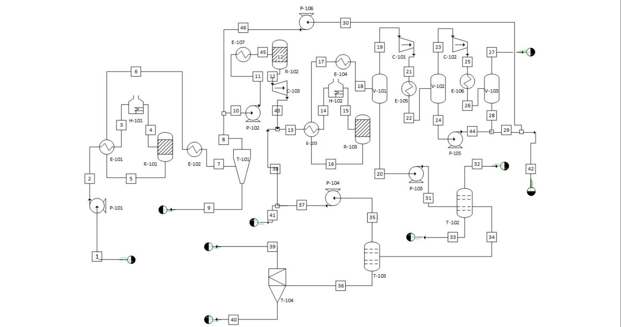

Alternative Design 2:

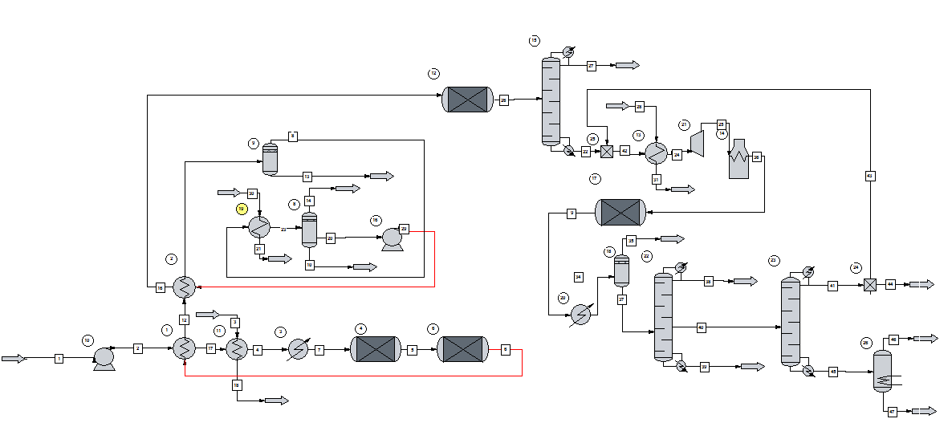

Alternative Design 3

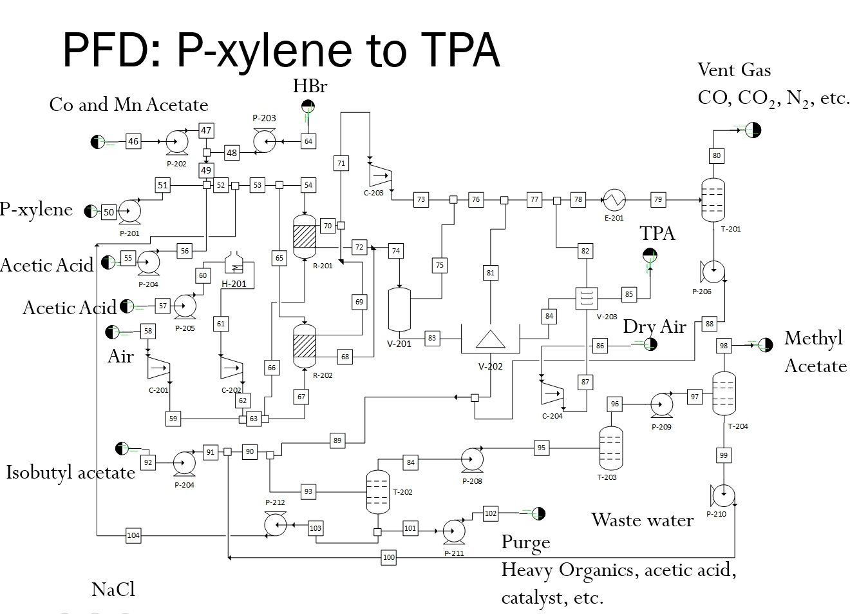

**Appendix C.** Sample Calculation of Equipment Size

Equipment Costing

P-101 + spare

2 Pumps: Centrifugal, 8.33kW, carbon steel construction, discharge pressure 9 bar

**Appendix D.** Equipment Costs

|  |  |  |
| --- | --- | --- |
| **Exchangers** | **Purchased Equipment Cost ($)** | **Bare Module Cost ($)** |
| E-101 | 88500 | 293000 |
| E-102 | 52200 | 204000 |
| E-103 | 28500 | 96100 |
| E-104 | 101800 | 336000 |
| E-105 | 27900 | 101100 |
| E-106 | 62500 | 243000 |
| E-107 | 26900 | 88900 |
| E-108 | 43900 | 146000 |
| E-109 | 84500 | 306000 |
| E-110 | 35300 | 117000 |
| E-111 | 65100 | 236000 |
| E-112 | 25200 | 83200 |
| E-113 | 43400 | 157000 |
| E-114 | 24800 | 81500 |
| E-115 | 33300 | 121000 |
| E-116 | 26900 | 88500 |
| E-117 | 29100 | 105000 |
| E-118 | 26,900 | 88,900 |
|  |  |  |
| **Fired Heaters** | **Purchased Equipment Cost** | **Bare Module Cost** |
| H-101 | 875000 | 2440000 |
|  | 145000 | 315000 |
|  |  |  |
| **Towers** | **Purchased Equipment Cost** | **Bare Module Cost** |
| T-101 | 63400 | 375700 |
| T-102 | 191000 | 1055600 |
| T-103 | 72400 | 240500 |
| T-104 | 47900 | 141700 |
|  |  |  |
|  |  |  |
| **Turbines** | **Purchased Equipment Cost** | **Bare Module Cost** |
| J-101 | 203000 | 709000 |
|  |  |  |
| V-101 | 6400 | 19400 |
| V-102 | 2650 | 51300 |
|  |  |  |
| **Pumps (with drives)** | **Purchased Equipment Cost** | **Bare Module Cost** |
| P-101 | 9450 | 37600 |
| P-102 | 7960 | 34600 |
|  |  |  |
|  |  |  |
| **Reactors** | **Purchased Equipment Cost** | **Bare Module Cost** |
| R-101 | 312000 | 7872800 |
| R-102 | 175000 | 10574000 |
| R-103 | 5290 | 5158000 |
| **Storage Tanks** | **Purchased Equipment Cost** | **Bare Module Cost** |
| Tk-101 | 252000 | 277000 |
| Tk-102 | 108000 | 119000 |
| Tk-103 | 61000 | 67100 |
| Tk-104 | 57200 | 62900 |
| Tk-105 | 256000 | 282000 |
| Tk-106 | 57200 | 62900 |
| Tk-107 | 57200 | 62900 |

## 

## **Appendix E.** MSDS of Chemicals Used [58] [59]

|  |  |  |  |  |
| --- | --- | --- | --- | --- |
| **Name** | **Molecular Weight (g/mol)** | **Boiling Point (C)** | **Melting Point (C)** | **Hazard** |
| Isobutanol | 74.12 | 108 | -108 | Hazardous in case of skin contact (irritant), of eye contact (irritant), of ingestion, of inhalation. |
| Water | 18.02 | 100 | 0 | Non-corrosive, non-irritant, non-sensitizer, non-permeator, and non-hazardous. |
| Isobutylene | 56.12 | -140.4 | -6.9 | Extremely flammable. Cause irritation and central nervous system depression at high concentrations. |
| Di-isobutylene | 112.22 | 102 | -101 | Highly flammable |
| Tri-isobutylene | 168.32 | 177 | N/A | Flammable. |
| Toluene | 92.14 | 110.6 | -95 | Hazardous in case of skin contact (irritant), of eye contact (irritant), of ingestion, of inhalation. Slightly hazardous in case of skin contact (permeator). |
| Hydrogen | 2.02 | -252.8 | -259.2 | Flammable |
| Methane | 6.04 | -161.5 | -182.5 | Flammable, nontoxic. |
| P-xylene | 106.17 | 138 | 12 | Very hazardous in case of skin contact (irritant), of eye contact (irritant). Slightly hazardous in case of skin contact (permeator), of ingestion, of inhalation. Inflammation of the eye is characterized by redness, watering, and itching. Skin inflammation is characterized by itching, scaling, reddening, or, occasionally, blistering. |
| O-xylene | 106.17 | 144.4 | -25 | Hazardous in case of skin contact (irritant, permeator), of eye contact (irritant), of ingestion, of inhalation. |
| Trans-2-Butene | 56.11 | 0.9 | -106 | Flammable, cause central nervous system depression and breathing difficulty |
| Propene | 42.08 | -47.7 | -185.25 | Flammable, cause central nervous system depression and breathing difficulty |
| 2-methyl-1-butene | 70.13 | 31 | -138 | Flammable liquid and gas. irritation, symptoms of drunkenness |
| 2-methyl-1-pentene | 84.15 | 62 | -136 | Highly flammable, irritation |
| 1-heptene | 98.19 | 96 | -137 | Flammable, cause central nervous system depression |
| 2,3-dimethyl-1-hexene | 112.21 | 111 | N/A | Irritant, flammable, aspiration hazard, narcotic effects |

## **References**

[1] Pet Resin Association. <http://www.petresin.org/aboutpet.asp>

[2] Whinfield, J.R.; Dickson, J.; Polymeric linear terephthalic esters. US 2465319A, Mar. 22, 1949.

[3] Merchant Research & Consulting, Ltd. <http://mcgroup.co.uk/news/20140117/global-pet-supply-exceed-2439-mln-tonnes-2015.html>

[4] U.S. Environmental Protection Agency, “Compilation of Air Pollutant Emission Factors,” Publication AP-42, <https://www3.epa.gov/ttnchie1/ap42/ch06/final/c06s06-2.pdf>, EPA, Office of Air Quality Planning and Standards, Research Triangle Park, NC (Jan. 1995).

[5] Polymers**.** <http://chemistry2.csudh.edu/rpendarvis/Polymer.html>

[6] Paraxylene. Chevron Phillips Chemical. <http://www.cpchem.com/bl/aromatics/en-us/Pages/Paraxylene.aspx>

[7] Tomas, R. A. F., Bordado, J. C. M., and Gomes, J. F. P. p‑Xylene Oxidation to Terephthalic Acid: A Literature Review Oriented toward Process Optimization and Development. *Chem. Rev*., **2013**, *113* (10), pp 7421–7469. <http://pubs.acs.org/doi/pdf/10.1021/cr300298j>

[8] Sheehan, R.J.Terephthalic Acid, Dimethyl Terephthalate, and Isophthalic Acid. *Ullmann's Encyclopedia of Industrial Chemistry.* 15 OCT 2011. <http://onlinelibrary.wiley.com/doi/10.1002/14356007.a26_193.pub2/full?a26_193-eo-2001>

[9] Terephthalic Acid. Organic Chemical Process Industry. Environmental Protection Agency. <http://www3.epa.gov/ttnchie1/ap42/ch06/final/c06s11.pdf>

[10] Zein, R., Konswa, A.M., Ibrahim, M., El-mittiny, E., Abdullah, H., Saeed, M. PET

[11] BP.com. “BP Statistical Review ofWorld Energy June 2015”. 4/29/2016. <https://www.bp.com/content/dam/bp/pdf/energy-economics/statistical-review-2015/bp-statistical-review-of-world-energy-2015-full-report.pdf>

[12] Taylor, J.D.; Jenni, M.M.; Peters, M.W.; Dehydration of Fermented Isobutanol for the Production of Renewable Chemicals and Fuels. *Top Catal*. **2010**, *53*, 1224-1230.

[13]Fletcher, Michael. "Gevo Production of Isobutanol." *Fuels Of The Future*. 30 Oct. 2012. Web. 26 Apr. 2016.

[14]Cheng, Y.; Wang, Z.; Gilbert, C.J.; Fan, W.; Huber, G.W.; Production of p-Xylene from Biomass by Catalytic Fast Pyrolysis Using ZSM-5 Catalysts with Reduced Pore Openings. *Angewandte Chem.* 2012, *51*, 11097-11100.

[15] Pang, J.; et. al.; Synthesis of ethylene glycol and terephthalic acid from biomass for producing PET. *Green Chem.* **2016**, *18*, 342.

[16]Lyons, T.W.; Guironnet, D.; Findlater, M.; Brookhart, M; Synthesis of p-xylene from Ethylene. *JACS*. **2012**, *134*, 15708-15711.

[17] Alternative Fuels Data Center. <http://www.afdc.energy.gov/laws/8502>

[18] Krause, O., I., Honkela, M., L.; Kinetic Modeling of the Dimerization of Isobutene. *Ind. Eng. Chem. Res.*, 2004, 43(13), pp 3251-3260.

[19]Aromatization and Dehydroisomerization of Branched C&S Hydrocarbons over “Nonacidic” Chromia-Alumina Catalyst t HERMAN PINES AND SIGMUND M. CSICSERY$

[20]Carlson, E. *Don’t Gamble with Physical Properties for Simulation*. Chemical Engineering Progress. **1996**.

[21] Isobutene. Evonik Industries. <http://finechemicals.panpage.de/DIN4/En/IC_Oxeno_Marl/ID_4606.pdf>

[22] Guptet, P. A.; Danner, R. P.; Prediction of Liquid-Liquid Equilibria with UNIFAC: A Critical Evaluation. <http://pubs.acs.org/doi/pdf/10.1021/ie00070a018>

[23] Dehydration of isobutanol to isobutene in a slurry reactor (Technical Report) | SciTech Connect. <http://www.osti.gov/scitech/biblio/171265>

[24] Pines, H. Alumina: Catalyst And Support. XVI *1, *2Aromatization and Dehydroisomerization of Branched C6$z.Sbnd;C8 Hydrocarbons over ?Nonacidic? Chromia-Alumina Catalyst. *Journal of Catalysis*. **1962**, *1*, 313–328.

[25] Lima, R.M.; Grossman, I.E.; Optimal synthesis of p-xylene separation processes based on crystallization technology. **2008**.

[26] Kulprathipanja, S.; Zeolites in Industrial Separation and Catalysis. Wiley. **2010**.

[27] Li M.; Ruddy, T.; Fahey, D.; Busch, D. H. Subramaniam, B; Terephthalic Acid Production via Greener Spray Process: Comparative Economic and Environmental Impact Assessments with Mid-Century Process. *ACS Sustainable Chem. Eng.* 2014, 2 (4), 823–835.

<http://pubs.acs.org/doi/abs/10.1021/sc4004778>

[28] Li, M., Niu, F., Zuo, X., Metelski, P. D., Busch, D. H., Subramaniam, B. A spray reactor concept for catalytic oxidation of *p*-xylene to produce high-purity terephthalic acid. *Chemical Engineering Science*. Dec 2013, 104, 93-102. [*http://www.sciencedirect.com/science/article/pii/S0009250913006179*](http://www.sciencedirect.com/science/article/pii/S0009250913006179)

[29] Chen, L., Qi, Z., Tong, L., Ye, Y. Kinetic studies on the dimerization of isobutene with Ni/Al2O3 as a catalyst for reactive distillation process. Mar 2014. <http://www.sciencedirect.com/science/article/pii/S1004954114003309>

[30] Packed Bed Reactors (PBRs).

[31] Gillette, J .L., and R. L Kolpa. *Overview of Interstate Hydrogen Pipeline Systems.* United States: N. p., 2008. Web. doi:10.2172/924391. <http://corridoreis.anl.gov/documents/docs/technical/APT_61012_EVS_TM_08_2.pdf> <http://www.umich.edu/~elements/5e/asyLearn/bits/pbr/index.htm>

[32] Rosado-Reyes, CM.; Tsang, W.; Dehydration of Isobutanol and Elimination of Water from Fuel Alcohols. *J. Phys. Chem. A.* **2013**, *117*, 6724-6736.

[33] Peters, M.W.; Integrated Process to Selectively Convert Renewable Isobutanol to P-xylene. US 20110087000A1.

[34] lyondellbasell. “Global Product Strategy (GPS) Safety Summary”. 4/29/2016 <https://www.lyondellbasell.com/globalassets/documents/safety-summaries/diisobutylene1.pdf?id=15702>

[35] Kaminski, W.; et. al.; Biobutanol - Production and Purification Methods. *Ecological Chemistry and Engineers*. **2011**, *18*, 31-37.

[36] KLM Technology Group. “HEAT EXCHANGER SELECTION AND SIZING (ENGINEERING DESIGN GUIDELINE)” . 4/28/2016. <http://kolmetz.com/pdf/EGD2/ENGINEERING_DESIGN_GUIDELINES_heat_exchangers_sizing_and_selection_rev_web.pdf>

Production. Feb 2010.<https://www.researchgate.net/publication/265112530_PET_Production>

[37] Wankat, P. C. *Separation Process Engineering: Includes Mass Transfer Analysis*; Prentice Hall: Upper Saddle River, NJ, 2012.

[38] Dr. Vogel separation system design. <https://compass2g.illinois.edu/webapps/blackboard/content/listContent.jsp?course_id=_23869_1&content_id=_1957146_1>

[39] <http://www.engineersedge.com/thermodynamics/overall_heat_transfer-table.htm>

[40] Gamma Alumina Powder, Ultrapure Grade, High Surface Area Coarse Powder.

<http://www.advancedmaterials.us/26R-0842UPGG.htm>

[41] Krasavin, S. A.; Kharson, M. S.; Kostyukovskii, M. M.; Bragin, O. V.; Kiperman, S. L. Kinetic And Mechanistic Study of Reaction of C5-Dehydro-Cyclization of 2,2,4-Trimethylpentane on Platinized Carbon. *Bulletin of the Academy of Sciences of the USSR Division of Chemical Science Russ Chem Bull*. **1982**, *31*, 1093–1099.

[42] Clements, M.; Haarhoff, J. Practical Experiences with Granular Activated Carbon (GAC) at the Rietvlei Water Treatment Plant. *Water SA WSA*. **2004**, *30*.

[43] Pushnov, A. S. Calculation Of Average Bed Porosity. *Chem Petrol Eng Chemical and Petroleum Engineering*. **2006**, *42*, 14–17.

[44] Hesketh, R. P. Conversion Reactors: HYSYS - Rowan University. Conversion Reactors: HYSYS - Rowan University, http://users.rowan.edu/~hesketh/0906-316/handouts/catalytic rates&delp.pdf (accessed Apr 29, 2016).

[45] *Handbook Of Chemical Engineering Calculations, Fourth Edition*; McGraw-Hill Professional.

[46] Aerstin, F.; Street, G. *Applied Chemical Process Design*; Plenum Press: New York, 1978.

[47] BRANAN, C. R. *Rules Of Thumb for Chemical Engineers: a Manual of Quick, Accurate Solutions to Everyday Process Engineering Problems*; Elsevier: Amsterdam, 2005.

[48] "Investor Relations | Gevo." *Gevo*. Web. 26 Apr. 2016.

<http://ir.gevo.com/phoenix.zhtml?c=238618&p=RssLanding&cat=news&id=2089814>

[49]"Isobutanol Expansion | Gevo." *Gevo*. Web. 26 Apr. 2016. <http://www.gevo.com/about/company-overview/isobutanol-expansion/>

[50] Dow. “DOWTHERM* A heat transfer fluid”. 4/29/2016. (<http://msdssearch.dow.com/PublishedLiteratureDOWCOM/dh_0030/0901b803800303cd.pdf?filepath=/heattrans/pdfs/noreg/176-01337.pdf&fromPage=GetDoc>)

[51] Integrated Process to Selectively Convert Renewable Isobutanol to P-Xylene

US 20110087000 A1

[52] Zhao, H.; ChBE 478 Lecture 1 Notes. **2016**.

[53] Z. Lin; V. Nikolakis; M. Ieraptetritou, *Ind. Eng. Chem. Res.*, **2014,** *53*, 10688-10699.

[54] TURTON, Richard, Richard C. BAILIE, Wallace B. WHITING, and Joseph A. SHAEIWITZ. *ANALYSIS, Synthesis, and Design of Chemical Processes*. Upper Saddle River, NJ: Prentice-Hall, 1998. Print.

[55] ICIS. “Indicative Chemical Prices A-Z” <http://www.icis.com/chemicals/channel-info-chemicals-a-z/>

[56] U.S. Bureau of Labor Statistics. <http://www.bls.gov/oes/current/oes_il.htm>

[57] Global PET Supply to Exceed 24.39 Mln Tonnes in 2015. Merchant Research and Consuling ltd. **2014**. Web. <https://mcgroup.co.uk/news/20140117/global-pet-supply-exceed-2439-mln-tonnes-2015.html>

[58] Safety Data Sheet, Material Safety Data Sheet. Science Lab. Web. 28 Apr. 2016.

[59] Safety Data Sheet, Material Safety Data Sheet. Fisher Science. Web. 28 Apr. 2016.